The Riggs Report March 2017
Mike and Tammy Riggs, Missionaries to Peru
Mike and Tammy Riggs are teachers and conference speakers who distribute Bibles and train church leaders in the country of Peru.
This is the church with the strange Bible.
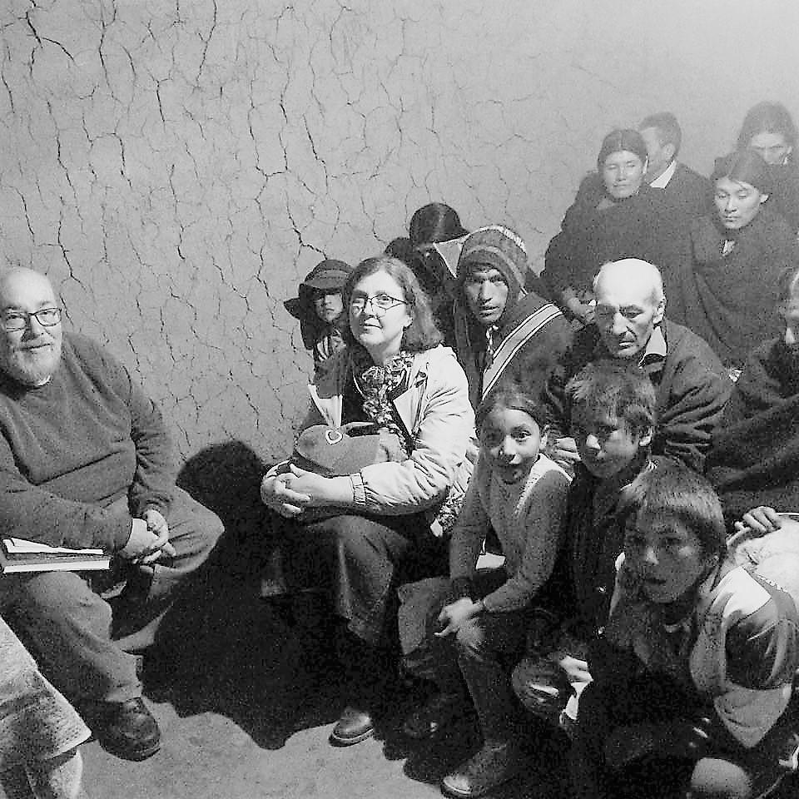

Let me tell you a story.
We went to a little one-room country church. It was a 15-minute climb from the end of the road, and it was stuffed with people from the surrounding area to hear Mike, Paco Laos, (our Peruvian coordinator), and me. Mike kicked off preaching, then Paco. I told a story, and Russ Fleetwood, the missionary who brought us there, wrapped up.

This attraction brought people walking in the dark over the mountains to crowd into a little adobe room with wooden benches. People even sat outside the door to listen.

I sat next to an adorable kid who might have been eleven. (He’s in the bottom right corner of the photo.) He was poring over a big black Bible. When preaching started, he marked his spot by drawing a line, got scolded by his mother, and returned the Bible to its table up front. Paco picked up the Bible and started leafing through it. It had a Mormon imprint on the front, but a quick glance at the index showed the regular Bible books. UNTIL you looked more closely. Further on was a second index showing where Mormon books had been inserted between the others. At the bottom of most pages was a Mormon interpretation of the Biblical texts.

So Paco stopped the service and explained to them that a lot of misleading stuff in this Bible was muddying up God’s Word. We replaced it with an easy-to-read Bible Russ had brought along.

These people touched all of our hearts. So eager to learn, yet without a clue about what is God’s Word and what is not. Paco told some people in Lima, and God moved them to give Bibles, including children’s Bibles, for the church. We will be following up, too. Our team is collecting school supplies to take to the kids up there, and we are planning more conferences in the area.

That’s how our ministry works. We mobilize churches to help under-resourced churches, so both groups can participate in the Great Commission. Sometimes it’s in the form of Bibles and physical relief. Sometimes it’s teaching or getting missionaries matched up with people who need them.

Our team is small, but we are a networking mission. Sure, we teach. It is our passion. But we are multiplying our efforts by getting God’s people on board and reaching out.

Why we are here
“All the euphoria and self-congratulation at growth will be for naught if believers slide into nominalism, remain immature or are picked off by cults.” ( Operation World 7th Edition)

Throughout Peru, God’s people are crippled by nominalism and immaturity. Those that “have” won’t reach out to those who don’t. Christians mistake conformity to rules for discipleship.

So how are we helping?
Three ways:
- Distributing Bibles and teaching people to understand what they say.
- Educating church leaders in the Word of God.
- Distributing school supplies, blankets and warm clothing, and Christmas gifts - along with the gospel - to children in the poorest communities.

God has moved us to ramp up those three things by:
Bible Conference attendees
- Training Peruvian Bible teachers to do the Bible Conferences.
- Recruiting and training teachers and church teams from the better off parts of Peru to go out into the country to teach and to care for physical needs.
- Recruiting US missionaries and teams to do the same.

A quick update.
Last year we came back to Peru after a year in the US. Here’s what we did once we got here.

- Gave out study Bibles and a new easy-to-read translation.
- Re-started a neighborhood Bible study.
- Gave three Bible conferences, two in the poorer sections of Lima and one in the mountainous region of Ancash.
- Met with church leaders around Peru, and spoke at churches around Peru.
- Started forming our new ministry organization, Por Su Amor, putting together the teaching and helping ministries we are involved in.
- Recruited team members and trained potential team members.
- Raised funds for blanket and Christmas box distributions.
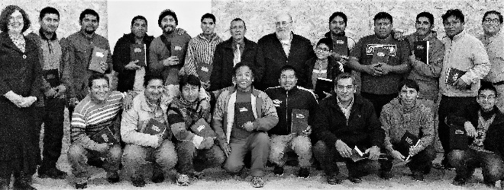
- Wrote teaching materials.

How you can be involved.
For real. Why not you? We’re mobilizing God’s people. Get active in the Great Commission.

PRAY for us
- For us and our team’s health and safety.
- For God to move people with a desire to learn His Word instead of religious traditions.
- For location of a central training facility.
- For adequate funds.
- For us and our team to be models of service and integrity, to the glory of God.
- For us to present practical and Biblical teaching and help to God’s people.

GIVE to needs
- Pledge to give monthly. We need to pay a Peruvian secretary, travel, produce materials, and pay legal fees for starting an organization. All of these are ongoing expenses.
- Give a special donation for:
  - BIBLES. One dozen easy to read Bibles with handbook & cover costs $20. Childrens Bibles $30.
  - 1 BOX=1 SMILE. Whether blankets, school supplies, or Christmas gifts, $10 can mean a lot to a needy child.

JOIN THE TEAM

If you would like to visit and help out there two ways you can do that.

- Come along on one of the trips to aid needy children. These are in March, July or August, and December. It is not necessary to speak Spanish, but you must be in good enough physical condition to go to high altitude places.

- Come and teach a conference. This needs a dynamic Spanish speaker with some experience in teaching who is in good condition to go to high altitude.
Virtual Missionary Opportunities No need to go to high altitude when you do these!

- If you know New Testament Greek and Spanish as well, contact us about work on the Greek Book Project.

- If you are a qualified Spanish translator we could use your help in producing materials.

- If you have theological training and speak Spanish, we would love for you to write conference materials!

Contact us for information on any of these opportunities.

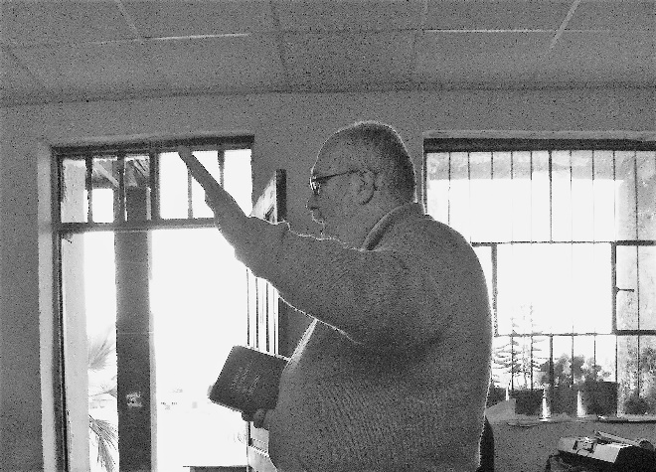
Mike addressing graduates in Ayacucho seminary

How to contact Mike and Tammy Riggs

Peru Address: Jr. Chincha 1160, José Gálvez, Villa María del Triunfo, Lima 35, Perú
Christmas Box kids at program

US Forwarding address: 2885 Sanford Ave. SW, #36320, Grandville, MI 49418

E-Mail Address: mikentammy@riggsreport.org Website: www.riggsreport.org Facebook: Mike Riggs, Tammy Meeker Riggs Twitter: @TammyRiggs8

Supporting Agency Information
FOR TAX DEDUCTIBLE GIFTS:
DONATE ONLINE!
www.WorldOutreach.org/donations
(follow the prompts)

MAIL CHECKS TO -
World Outreach Ministries, Inc.
P.O. Box B
Marietta, GA 30061
(add #400 Riggs in the memo)

BILL PAY - via your online banking
World Outreach Ministries, Inc.
P.O. Box B
Marietta, GA 30061
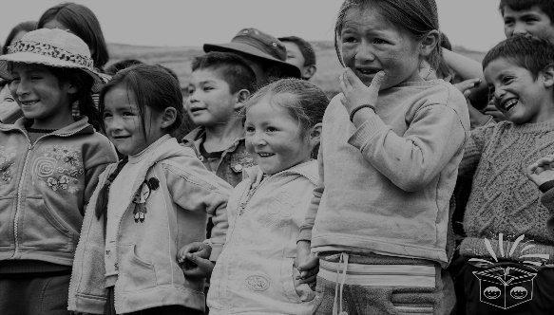
(add #400 Riggs in the memo)

Why Are You Getting This Newsletter?
You signed up or you were signed up as friends or fellow church members when we went to the field in 2004.
If you no longer want to receive this newsletter, please let us know by calling 205-677-5570 and leaving a message or sending a note to the return address of this letter.
You are on our list for one mailing a year.
You can sign up for email news on our website and receive more frequent updates.
If you would like more frequent mailings, not email, let us know.

