Presentation

The Innolift portable self-loading forklift is the newest break-through in vehicle loading technology. It is designed and manufactured to the highest quality European Standards. While the Innolift is often compared to a lift-gate, it is in fact, far superior to a lift-gate as a vehicle cargo loading solution. The Innolift lifts cargo into your vehicle and then it lifts itself into the vehicle as well. The Innolift is a mobile liftgate & pallet jack in one machine.

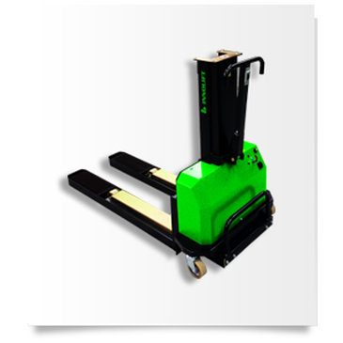

Innolift Small

​Fits in Ford Econoline, Chevrolet Express, Ford Transit Connect, Dodge Ram Promaster, Mercedes Sprinter, and some MINI VANS! *
- Ideal For Salesmen Hauling Heavy Items
- Ideal For Couriers
- Lifts 1325lbs
- Order One Now, Save Your Back!
​

Making Your Load A Little Easier

Comparable lift-gates that can lift the amount of weight that the Innolift can, sell from between $4,500.00-$8,800.00 and that doesn't include installation charges. They are permanently attached to your vehicle. If your vehicle breaks down and requires service, your lift-gate is out of service too. If you have an Innolift you simply move it to your replacement vehicle and off you go.

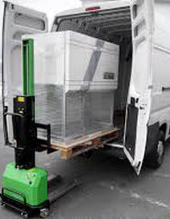

The Innolift can be used to raise skids to waist height or higher for easy unloading of your cargo from the skid. This eliminates bending & stooping by the employees. The Innolift does the lifting so your employees don't have to. Innolift will automate your deliveries increasing your deliveries per hour. It will make your delivery drivers more productive by reducing their fatigue also increasing their sales stops per day. The Innolift will increase your sales.
The Innolift will reduce your expenses because you can move more product per delivery vehicle. In many cases companies can get by with one or two Innolifts that float back and forth between vehicles rather than buying and affixing a lift-gate to each vehicle. Ask any purchaser how much he or she gets for a vehicle when they need to sell it when it has a lift-gate attached. That $7000.00 investment will only get you back $1700.00 in resale value. If you have an Innolift you just move it to the next vehicle.
Lift Gate Vs. Innolift
- Lift Gates are Permanently Attached - Innolift is Portable and Mobile
- Lift Gates are Exposed to the Weather- Innolift Rides Inside the Vehicle
- Lift Gates Function as One Device -Innolift is the Lift Gate & Pallet Jack
- A Driver Can Fall Off a Lift Gate-A Driver Won't Leave the Ground With Innolift
- The Innolift Can Travel Inside Buildings- A Lift Gate Can't Do That
- If Your Truck or Van is in For Service, Your Lift Gate is Down Too-Not With Innolift
- A Lift Gate Can Weigh over 2000lbs-Innolift Weighs 430lbs or Less. =Fuel Savings!
- Innolift is Very Low Maintenance! Lift Gates Need Constant Lubrication & Service

​ And The Winner By Knockout.....Innolift in The First Round.
It Wasn't Even Close

Making Your Load A Little Easier

Lift-gates are a maintenance nightmare and are always exposed to rain, sleet, snow, heat, salt, and other climate conditions. They rust easily and do not work well in the cold. The Innolift is stored inside your vehicle and is kept away from the elements. The Innolift will reduce your expenses

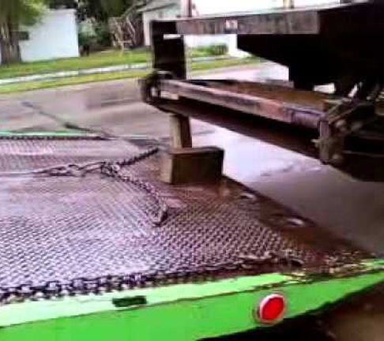

As we talk about reducing expenses, an on the job injury due to a fall off a lift-gate would cost in the thousands of dollars in employee medical expenses, lost time from work, increased workers compensation premiums and on and on. An employee doesn't leave the ground when loading or unloading with an Innolift.
Report-Cost of a Work Place Injury-Click Here

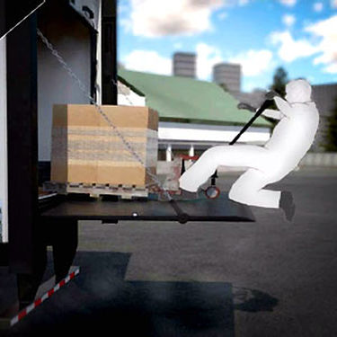
In 2005 The US Department of Labor Estimated the Average Loss Incurred as a Result of a Work Place Accident Was $38,000.00 (12 years ago
<------Don't Let This Happen To Your Employees!

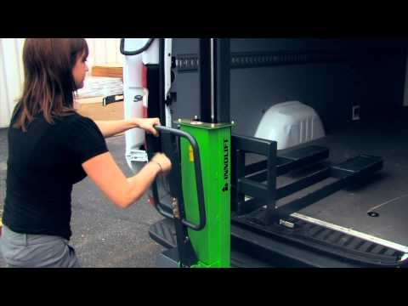

Buy Them an Innolift.

Jessica Learned How To Use It in 5 Minutes

Making Your Load A Little Easier
Jessica Demonstrates Innolift Medium
The Innolift is rapidly replacing the lift-gate as the solution of choice for commercial vehicle loading and unloading. Purchase an Innolift today. It will pay for itself by increasing your revenue and reducing your expenses. You can make your employees safer all while promoting a green energy product that you can write off at less than $7.00 / day. Call today at 502-298-2572 and let us help you solve your lifting problems.
Thanks for your time,
​Mike Golata
President
Innolift USA

