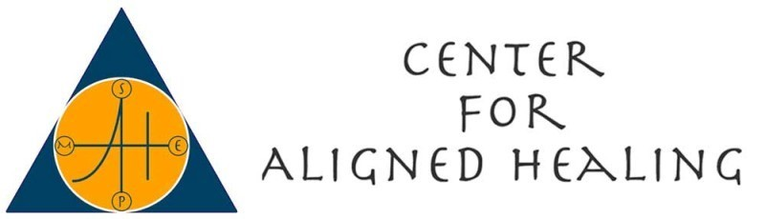

Soul Filled Kids Summer Program Registration Form
Dates: July 18th - 22nd, 2016 9:30 am to 6:30 pm
Location: 175 King Street Chappaqua, New York 10514 (51 minutes from NYC)

Child’s Name: ________________________________ Age/DOB _____________
Child’s Name: ________________________________ Age/DOB _____________
Child’s Name: ________________________________ Age/DOB _____________

Parent/Guardian’s Name:
_________________________________________________________________
Parent/Guardian’s Phone:
_________________________________________________________________
Email address:
_________________________________________________________________
Address:
_________________________________________________________________
City, State, Zip:
_________________________________________________________________

Emergency contact information:

Emergency Phone:
_________________________________________________________________
Contact:
_________________________________________________________________
Pediatrician’s Name:
_________________________________________________________________
Pediatrician’s Phone:
_________________________________________________________________
Any allergies?
_________________________________________________________________

Additional comments or information:
_________________________________________________________________
_________________________________________________________________
_________________________________________________________________

Photo Release: I give permission for my child to be photographed at the Soul-Filled Kids Series. I understand and agree that all rights to these photographs are reserved by and shall become the property of Soul-Filled Kids Series, and may be used for promotion and publicity by Soul-Filled Kids Series only, including on the website, in print media, on television, or online. No children’s names will be associated with photos.

Signature of parent/guardian:
_________________________________________________________________
Date:
_________________________________________________________________

Waiver of Liability: I am the parent/legal guardian of the children named below. I give permission and accept full responsibility for the children to participate in the activities at the Soul-Filled Kids Series. I understand that my children will be participating in various activities during the Soul-Filled Kids Series. I am solely responsible for the decision to allow my children to participate in this series and its activities. I hereby release and waive, any and all legal claims, known and unknown, that the children or I may have against the Soul-Filled Kids Series, its practitioners, its directors or the Center for Aligned Healing.

Signature of parent/guardian:
_________________________________________________________________
Date:
_________________________________________________________________

Child’s Name: ________________________________
Child’s Name: ________________________________
Child’s Name: ________________________________

For further information or to register please contact: Rayna Sassano at 914-804-1866 or raynasas@gmail.com or visit www.thecenterforalignedhealing.com/kids

*Please bring a set of old clothes for gardening on Friday. We also invite our families to join us for our Friday afternoon cooking party! ~~~~~~~~Come with wonder. Leave with love~~~~~~~~

Payment Details:

Early Registration Fee received on or before May 8, 2016

$600 ($570 discount per additional child) cash/check
$625 credit card

Registration Fee received on or after July 4, 2016

$650 cash/check/credit card

Name:
_________________________________________________________________
Email:
_________________________________________________________________
Address:
_________________________________________________________________
Phone:
_________________________________________________________________

Checks/Cash to: Rayna Sassano, 27 Underhill Place, West Harrison, NY 10604

Credit card payments can be made online via PayPal at:

www.thecenterforalignedhealing.com/kids

