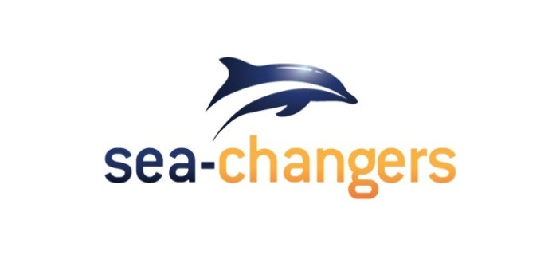

Sea-Changers Grant Application Form

Criteria: Before you complete this form please read through the Grant Giving Policy in full. Applications should be sent, via email to Helen@sea-changers.org.uk.

Your Contact Details

Name of organisation:
Are you part of a larger organisation? If so, which?
Organisational turnover
(Most recent financial year)
Address:
Postcode:
Contact Name:
Email:
Telephone number:
Website:

General Information

Is your organisation a registered charity? | Yes/No  (Delete as applicable)
If ‘yes’, what is your charity registration number?
If not, what kind of legal entity is your organisation?
Can you tell us how you heard about Sea-Changers grants?
Are you applying for funding specifically from the Sea-Changers Marine Litter Fund 2018-2019 | Yes/No  (Delete as applicable)

Details of the work of your organisation

A brief description of your organisation and its relevant track record in delivering marine conservation projects and activities.

Summary of project requiring funding, aims and outcomes

Project name:
Start and end dates:
Aim(s):
Project outline:
(Maximum 100 words.)

Outcome(s):

Indicators of success:
Amount applied for? | £

Project Outline
Please limit answers to 3 sides of A4 and do not reduce the form’s font size (11pt).

A description of the project and why it is important.
How does this project/work meet Sea-Changers’ Evaluation Criteria?
Measurable impact:

Community/grassroots base:

Value for money:

Sustainability/ongoing or wider benefit:

Innovation and creativity:

How will you evaluate the project’s success relative to its aims?
Project outcomes. How will outcomes be measured?
Will you be able to provide a range of high quality photographs of the project taking place (for use on the Sea-Changers website)?
Yes/No/Don’t know (Delete as applicable)
How will you publicise Sea-Changers’ funding of this project?
Sea-Changers are keen to understand and to promote collaborative working between projects, including sharing of research data. How does, or could your project link with similar projects or its findings be shared?
Is there anything further we should consider?
Budget

Overall budget needed for your project. Please provide detail of how the money you are requesting will be spent:
Are other funds being sought? If Yes, what and where from? What will you do if you are not successful in other funding applications and how this will impact on the project?
If your organisation is part of a larger parent organisation why is the parent organisation not (fully) funding the project?
If the funding request is part of a larger project, please state which particular element of the project we would be funding. Please state clearly the overall budget needed for your project; what other funds you are currently applying for/have secured and specifically and what our funding will be used for within your project.

Application Checklist
Before you submit your application please ensure the following:

- Have you read through the Sea-Changers funding Policy in full and ensured that your project meets our Eligibility Criteria?
- Have you ensured all your contact information is correct and up to date?
- Have you filled in all elements of the above form?

Thank you for taking the time to submit your application.

Please direct questions regarding applications and completed application forms to: Helen@sea-changers.org.uk

