Football Cheer & Dance Youth Clinic
The Basketball Cheerleading and Dance Team will be hosting a ONE day cheer and dance clinic!!! The little kids will do one dance and 2 cheers, and the older kids do one dance and 2 cheers. This will lessen the # of kids on the field at one time, as well as make it easier/challenging for the kids participating. The clinic will be on August 28th in Prophetstown for Prophetstown students from 3:15-5:30 and August 29th in Erie for Erie students from 3:15-5:30. Your child will only attend one of these dates depending on where their home school is. Your child will be provided with a t-shirt, along with both cheer and dance material which they will perform Friday night, August 30th, at the Boys varsity football game during Varsity halftime. The theme for that night is Carnival. The cost of the clinic is $15 for the first child and $5 for each additional family member. Please sign up by August 21st to guarantee that your child has a t-shirt and any other items purchased. There are additional items for sale if interested. We look forward to this experience with your child/children.
ALL FORMS ARE DUE BY Wednesday, August 21st in order to guarantee a t-shirt!!
****PERFORMANCE DAY IS August 30th Please be there by 7:00 PM****
All students in Preschool-8th grade are able to attend this clinic!
Please bring all forms to the
ANNEX, ELEMENTARY, MIDDLE SCHOOL OFFICE or contact Coach Bohms or Coach Schipper
If you have any questions, please contact
Kayla Bohms at: 309.738.7943 – kaytemp1229@gmail.com
Ann Schipper at: 309.738.2566 - annmschipper@hotmail.com

ALL FORMS ARE DUE BY August 21st in order to guarantee a t-shirt and accessories!

Name: _______________________________________ Grade: __________

Parent or Guardian: ___________________________ Phone: _________________

Allergies: __________________________ Medication: ____________________

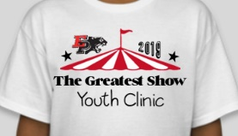T-Shirt Size: (Please circle one) T-shirt will be similar to the one pictured
YS YM YL AS AM AL
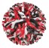Red, black and white POMS will be for sale, for $13.00
(Please circle one) Yes Poms No Poms
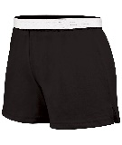Black shorts will be for sale, for $8.00
(Please circle one if you would like to purchase)
YS YM YL AS AM AL
Red and white hair bow will be for sale, for $9.00
(Please circle one) Yes hair bow No hair bow

**All checks can be made to: EHS CHEER/DANCE

