Comparing Distributions GREEN

1. There are two trays of plants in a greenhouse. The first tray of plants was given fertiliser. The second tray of plants was not given fertiliser. On Monday the heights of the plants were measured in centimetres. The boxes show some information about the heights of the plants.

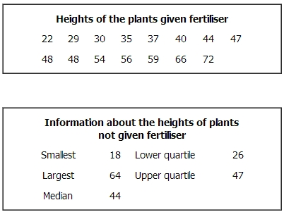

Compare the distribution of the heights of the plants given fertiliser to the distribution of the heights of the plants not given fertiliser.

2. Here are the ages, in years, of 15 women at West Ribble Tennis Club.
16, 18, 18, 20, 25, 25, 27, 28, 30, 35, 38, 42, 45, 46, 50
(a) On the grid, draw a box plot for this information.
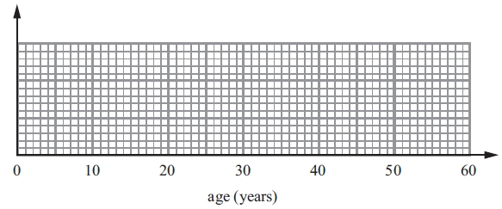
The box plot below shows the distribution of the ages of the men at West Ribble Tennis Club.
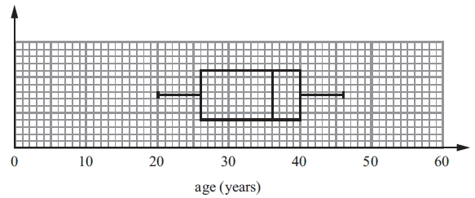
(b) Use the box plots to compare the distributions of the ages of these women and the distributions of the ages of these men.

3. There are 25 students in a class. 12 of the students are girls. Here are the heights, in cm, of the 12 girls.
160 | 173 | 148 | 154 | 152 | 164 | 179 | 164 | 162 | 174 | 168 | 170
a) Show this information in an ordered stem and leaf diagram.

There are 13 boys in the class. Here are the heights, in cm, of the 13 boys.
157 | 159 | 162 | 166 | 168 | 169 | 170 | 173 | 174 | 176 | 176 | 181 | 184
b) Compare the heights of the boys with the heights of the girls.

4. Kelly recorded the length of time 48 teachers took to travel to school on Monday. The table shows information about these travel times in minutes.

Least time | 5
Greatest time | 47
Median | 28
Lower quartile | 18
Upper quartile | 35

a) Work out the number of teachers with a travel time of 35 minutes or more.

b) On the grid, draw a box plot to show the information in the table.

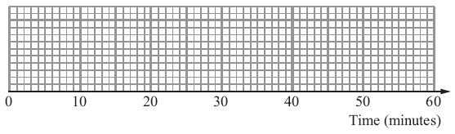

Kelly then recorded the times the same 48 teachers took to travel to school on Tuesday. The box plot shows some information about these times.

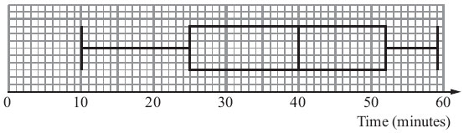
c) Compare the travel times on Monday and on Tuesday.

Comparing Distributions AMBER

1. There are two trays of plants in a greenhouse. The first tray of plants was given fertiliser. The second tray of plants was not given fertiliser. On Monday the heights of the plants were measured in centimetres. The boxes show some information about the heights of the plants.

Start by calculating the minimum, maximum, median, LQ, UQ and IQR for the first tray, then compare to the second tray.

Compare the distribution of the heights of the plants given fertiliser to the distribution of the heights of the plants not given fertiliser.

2. Here are the ages, in years, of 15 women at West Ribble Tennis Club.
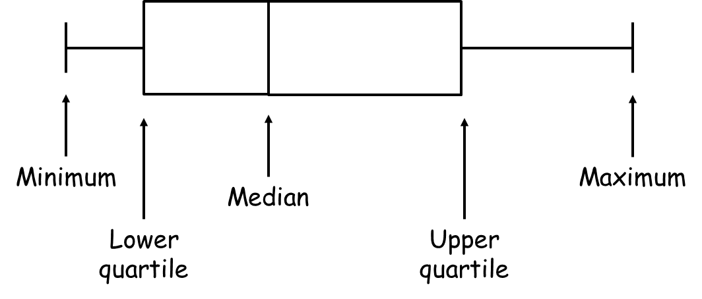
16, 18, 18, 20, 25, 25, 27, 28, 30, 35, 38, 42, 45, 46, 50
(a) On the grid, draw a box plot for this information.

The box plot below shows the distribution of the ages of the men at West Ribble Tennis Club.
(b) Use the box plots to compare the distributions of the ages of these women and the distributions of the ages of these men.

3. There are 25 students in a class. 12 of the students are girls. Here are the heights, in cm, of the 12 girls.
160 | 173 | 148 | 154 | 152 | 164 | 179 | 164 | 162 | 174 | 168 | 170
a) Show this information in an ordered stem and leaf diagram.

Key:

There are 13 boys in the class. Here are the heights, in cm, of the 13 boys.
157 | 159 | 162 | 166 | 168 | 169 | 170 | 173 | 174 | 176 | 176 | 181 | 184
b) Compare the heights of the boys with the heights of the girls.
Start by calculating the minimum, maximum, median, LQ, UQ and IQR for boys and girls, then compare.

4. Kelly recorded the length of time 48 teachers took to travel to school on Monday. The table shows information about these travel times in minutes.

Least time | 5
Greatest time | 47
Median | 28
Lower quartile | 18
Upper quartile | 35

a) Work out the number of teachers with a travel time of 35 minutes or more.
35 is the upper quartile. What does this tell you?

b) On the grid, draw a box plot to show the information in the table.

Kelly then recorded the times the same 48 teachers took to travel to school on Tuesday. The box plot shows some information about these times.

c) Compare the travel times on Monday and on Tuesday.

Comparing Distributions RED

1. There are two trays of plants in a greenhouse. The first tray of plants was given fertiliser. The second tray of plants was not given fertiliser. On Monday the heights of the plants were measured in centimetres. The boxes show some information about the heights of the plants.

Median
Start by calculating the minimum, maximum, median, LQ, UQ and IQR for the first tray, then compare to the second tray.

Compare the distribution of the heights of the plants given fertiliser to the distribution of the heights of the plants not given fertiliser.

On average…

2. Here are the ages, in years, of 15 women at West Ribble Tennis Club.

16, 18, 18, 20, 25, 25, 27, 28, 30, 35, 38, 42, 45, 46, 50

Median

(a) On the grid, draw a box plot for this information.

The box plot below shows the distribution of the ages of the men at West Ribble Tennis Club.
(b) Use the box plots to compare the distributions of the ages of these women and the distributions of the ages of these men.

On average…

3. There are 25 students in a class. 12 of the students are girls. Here are the heights, in cm, of the 12 girls.
160 | 173 | 148 | 154 | 152 | 164 | 179 | 164 | 162 | 174 | 168 | 170
a) Show this information in an ordered stem and leaf diagram.

Key:

There are 13 boys in the class. Here are the heights, in cm, of the 13 boys.
157 | 159 | 162 | 166 | 168 | 169 | 170 | 173 | 174 | 176 | 176 | 181 | 184
b) Compare the heights of the boys with the heights of the girls.
Start by calculating the minimum, maximum, median, LQ, UQ and IQR for boys and girls, then compare.
On average…

4. Kelly recorded the length of time 48 teachers took to travel to school on Monday. The table shows information about these travel times in minutes.

Least time | 5
Greatest time | 47
Median | 28
Lower quartile | 18
Upper quartile | 35

a) Work out the number of teachers with a travel time of 35 minutes or more.
35 is the upper quartile. What does this tell you?
¼ of 48 =

b) On the grid, draw a box plot to show the information in the table.

Kelly then recorded the times the same 48 teachers took to travel to school on Tuesday. The box plot shows some information about these times.

c) Compare the travel times on Monday and on Tuesday.

On average…

