**Surface Area of Cylinders GREEN**

Find the missing dimensions on the following cylinders:

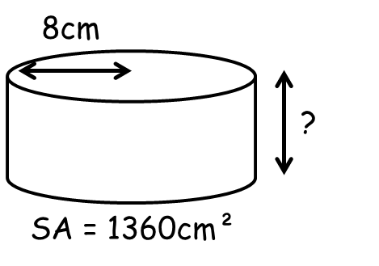 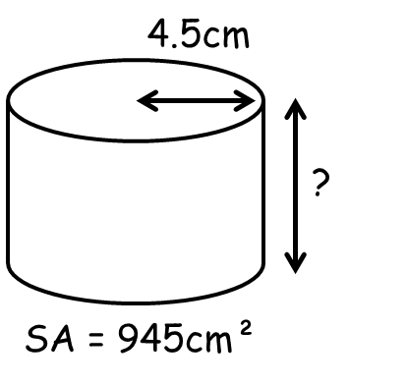

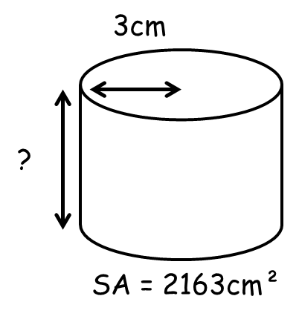 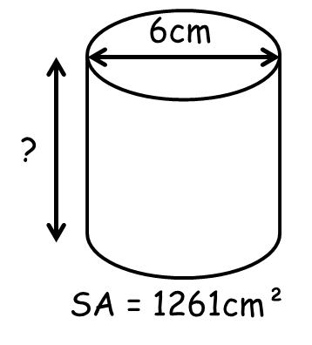

**Surface Area of Cylinders AMBER**

Add together the areas of all the faces to find the surface areas of these prisms.

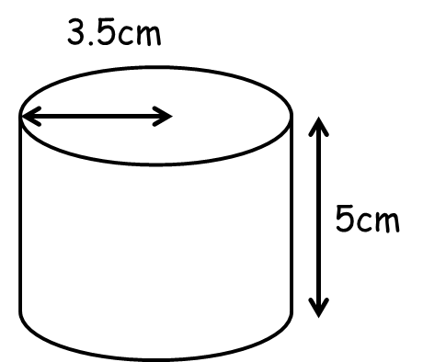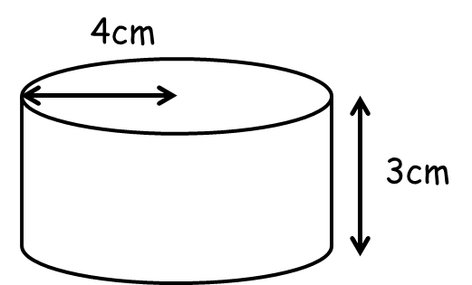

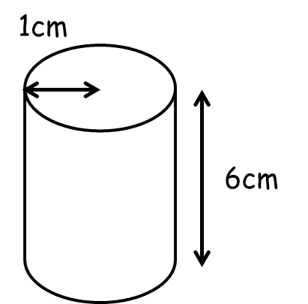

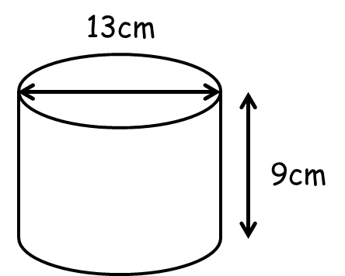

**Surface Area of Cylinders RED**

Add together the areas of all the faces to find the surface areas of these prisms.



Top =

Bottom =

Curved =

Surface Area =

Top =

Bottom =

Curved =

Surface Area =





Top =

Bottom =

Curved =

Surface Area =

Top =

Bottom =

Curved =

Surface Area =