Interpreting Histograms - GREEN

- This histogram shows information about the distances in metres that a number of people threw a ball. Draw a frequency table.

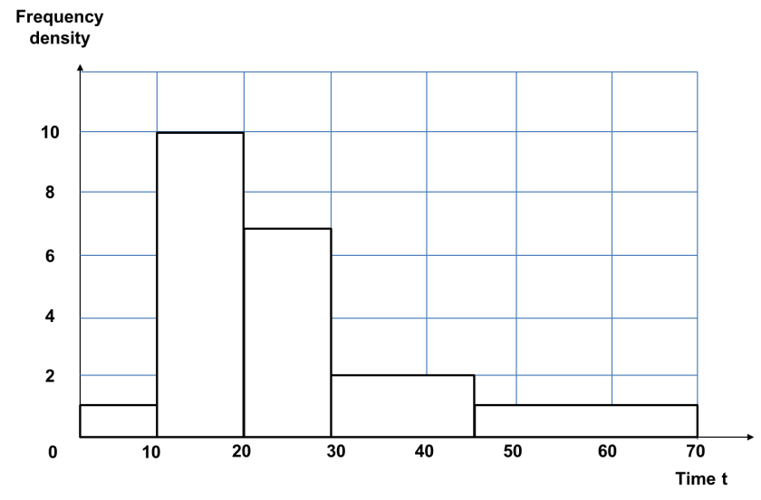

- This histogram shows information about the number of hours of television some students watched one evening. Draw a frequency table.

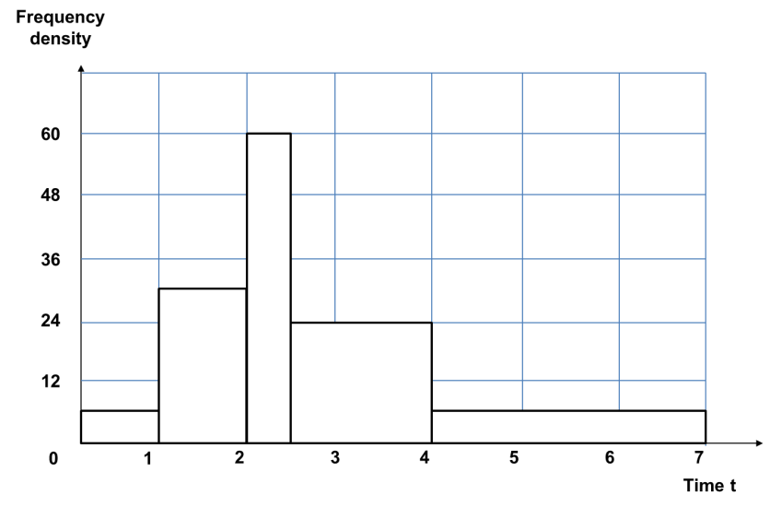

Interpreting Histograms - AMBER

- This histogram shows information about the distances in metres that a number of people threw a ball. Complete the frequency table.
Distance  (d metres) | Frequency
0 < d ≤ 10
10 < d ≤ 20
20 < d ≤ 30
30 < d ≤ 45
45 < d ≤ 70

- This histogram shows information about the number of hours of television some students watched one evening. Complete the frequency table.

Time (t hours) | Frequency
0 < t ≤ 1
1 < t ≤ 2
2 < t ≤ 2$\frac{1}{2}$
2$\frac{1}{2}$ < t ≤ 4
4 < t ≤ 7

Interpreting Histograms - RED

- This histogram shows information about the distances in metres that a number of people threw a ball. Complete the frequency table.

Distance  (d metres) | Class width | Frequency density | Frequency
0 < d ≤ 10 | 10 | 1 | 10 x 1 = 10
10 < d ≤ 20 | 10 | 10
20 < d ≤ 30
30 < d ≤ 45
45 < d ≤ 70

- This histogram shows information about the number of hours of television some students watched one evening. Complete the frequency table.

Time (t hours) | Class width | Frequency density | Frequency
0 < t ≤ 1 | 1 | 6
1 < t ≤ 2
2 < t ≤ 2$\frac{1}{2}$
2$\frac{1}{2}$ < t ≤ 4
4 < t ≤ 7

