Mean of a Subset GREEN

1. Alan works in a gym. One week he recorded the number of people who visited the gym each day.
For Monday to Friday, the mean number of people per day was 98.
For the whole week, the mean number of people per day was 114.
On Saturday, 162 people visited the gym.
Work out the number of people who visited the gym on Sunday.

2. 23 girls have a mean height of 153 cm.
17 boys have a mean height of 165 cm.
Work out the mean height of all 40 children.

3. The table gives information about the time it took each of 80 children to do a jigsaw puzzle.
 | Number of children | Mean time (mins)
Boys | 32 | 32.4
Girls | 48 | 28.4
Work out the mean time for all 80 children.

4. There are 18 packets of sweets and 12 boxes of sweets in a carton.
The mean number of sweets in all the 30 packets and boxes is 14
The mean number of sweets in the 18 packets is 10
Work out the mean number of sweets in the boxes.

5. 25 students in class A did a science exam.
30 students in class B did the same science exam.
The mean mark for the 25 students in class A is 67.8
The mean mark for all the 55 students is 72.0
Work out the mean mark for the students in class B.

6. Hertford Juniors is a basketball team.
At the end of 10 games, their mean score is 35 points per game.
At the end of 11 games, their mean score has gone down to 33 points per game.
How many points did the team score in the 11th game?

7. There are 10 boys and 20 girls in Mrs Brook's class.
Mrs Brook gave all the class a test.
The mean mark for all the class is 60
The mean mark for the girls is 56
Work out the mean mark for the boys.

8. Mr Brown gives his class a test.
The 10 girls in the class get a mean mark of 70%
The 15 boys in the class get a mean mark of 80%
Nick says that because the mean of 70 and 80 is 75 then the mean mark for the whole
class in the test is 75%
Nick is not correct.
Is the correct mean mark less than or greater than 75%?
You must justify your answer.
Mean of a Subset AMBER

1. Alan works in a gym. One week he recorded the number of people who visited the gym each day.
For Monday to Friday, the mean number of people per day was 98.
For the whole week, the mean number of people per day was 114.
On Saturday, 162 people visited the gym.
Work out the number of people who visited the gym on Sunday.
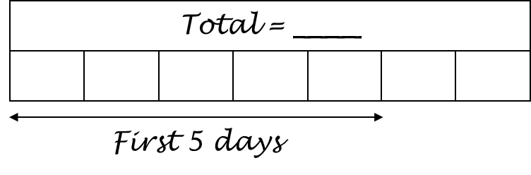

2. 23 girls have a mean height of 153 cm.
17 boys have a mean height of 165 cm.
Work out the mean height of all 40 children.
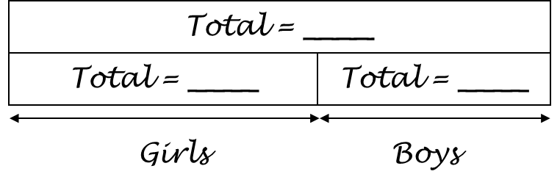

3. The table gives information about the time it took each of 80 children to do a jigsaw puzzle.
 | Number of children | Mean time (mins)
Boys | 32 | 32.4
Girls | 48 | 28.4
Work out the mean time for all 80 children.

4. There are 18 packets of sweets and 12 boxes of sweets in a carton.
The mean number of sweets in all the 30 packets and boxes is 14
The mean number of sweets in the 18 packets is 10
Work out the mean number of sweets in the boxes.

5. 25 students in class A did a science exam.
30 students in class B did the same science exam.
The mean mark for the 25 students in class A is 67.8
The mean mark for all the 55 students is 72.0
Work out the mean mark for the students in class B.

6. Hertford Juniors is a basketball team.
At the end of 10 games, their mean score is 35 points per game.
At the end of 11 games, their mean score has gone down to 33 points per game.
How many points did the team score in the 11th game?

7. There are 10 boys and 20 girls in Mrs Brook's class.
Mrs Brook gave all the class a test.
The mean mark for all the class is 60
The mean mark for the girls is 56
Work out the mean mark for the boys.

8. Mr Brown gives his class a test.
The 10 girls in the class get a mean mark of 70%
The 15 boys in the class get a mean mark of 80%
Nick says that because the mean of 70 and 80 is 75 then the mean mark for the whole
class in the test is 75%
Nick is not correct.
Is the correct mean mark less than or greater than 75%?
You must justify your answer.

Mean of a Subset RED

1. Alan works in a gym. One week he recorded the number of people who visited the gym each day.
For Monday to Friday, the mean number of people per day was 98.
For the whole week, the mean number of people per day was 114.
On Saturday, 162 people visited the gym.
Work out the number of people who visited the gym on Sunday.
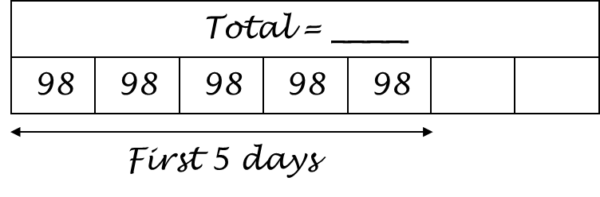
114 x 7 = 798

2. 23 girls have a mean height of 153 cm.
17 boys have a mean height of 165 cm.
Work out the mean height of all 40 children.
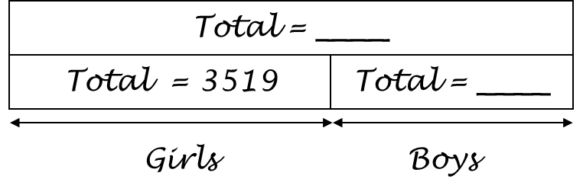
23 x 153 = 3519

3. The table gives information about the time it took each of 80 children to do a jigsaw puzzle.
 | Number of children | Mean time (mins)
Boys | 32 | 32.4
Girls | 48 | 28.4
Work out the mean time for all 80 children.

4. There are 18 packets of sweets and 12 boxes of sweets in a carton.
The mean number of sweets in all the 30 packets and boxes is 14
The mean number of sweets in the 18 packets is 10
Work out the mean number of sweets in the boxes.
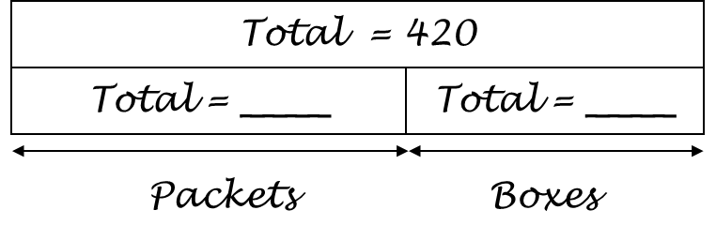
30 x 14 = 420

5. 25 students in class A did a science exam.
30 students in class B did the same science exam.
The mean mark for the 25 students in class A is 67.8
The mean mark for all the 55 students is 72.0
Work out the mean mark for the students in class B.

6. Hertford Juniors is a basketball team.
At the end of 10 games, their mean score is 35 points per game.
At the end of 11 games, their mean score has gone down to 33 points per game.
How many points did the team score in the 11th game?

7. There are 10 boys and 20 girls in Mrs Brook's class.
Mrs Brook gave all the class a test.
The mean mark for all the class is 60
The mean mark for the girls is 56
Work out the mean mark for the boys.

8. Mr Brown gives his class a test.
The 10 girls in the class get a mean mark of 70%
The 15 boys in the class get a mean mark of 80%
Nick says that because the mean of 70 and 80 is 75 then the mean mark for the whole
class in the test is 75%
Nick is not correct.
Is the correct mean mark less than or greater than 75%?
You must justify your answer.

