Parabolas, Roots and Turning Points GREEN
1. a) Complete the table of values for y = x² − 5x + 3
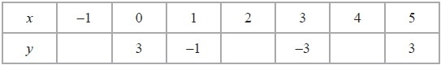

b) On the grid below, draw the graph of y = x² − 5x + 3 for values of x from x = −1 to x = 5
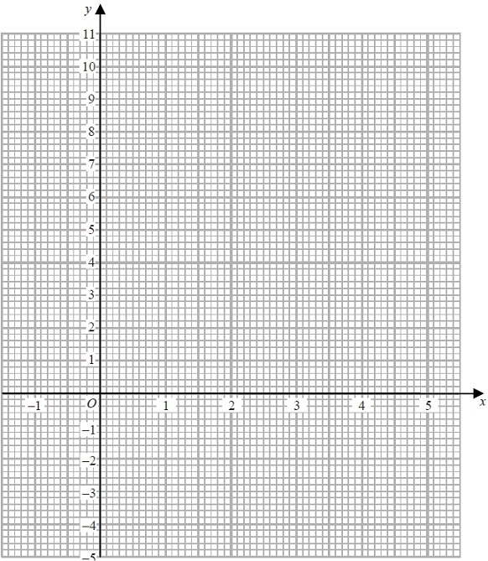
c) Find estimates of the solutions of the equation x² − 5x + 3 = 0

x = ………………… or …………………
d) Identify the turning point of y = x² − 5x + 3

(…………………, …………………)

2. a) Complete the table of values for y = x² − 2x − 1
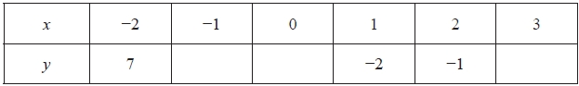

b) On the grid, draw the graph of y = x² − 2x − 1 for values of x from x = −2 = 3
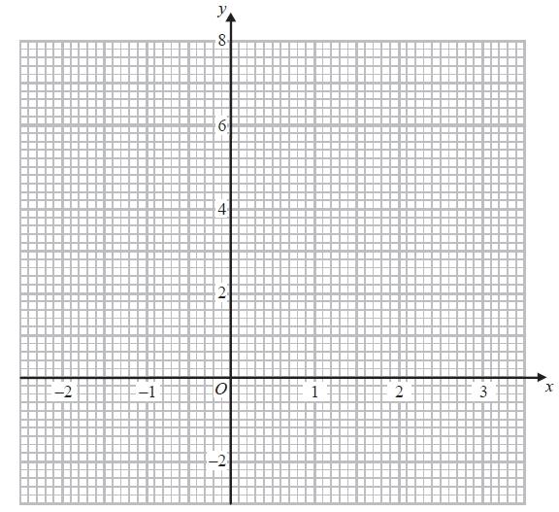

c) Find estimates for the solutions of the equation x² − 2x − 1 = x + 3
x = ………………… or …………………

d) Identify the turning point of y = x² − 2x − 1

(…………………, …………………)

3. a) Complete the table of values for y = x² – 3x + 2
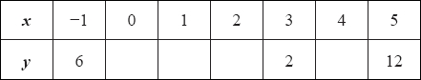

b) On the grid, draw the graph of y = x² – 3x + 2 for values of x from –1 to 5

c) Find estimates for the solutions of the equation x² – 3x + 2 = 4
x = ………………… or …………………

d) Identify the turning point of y = x² – 3x + 2

(…………………, …………………)

4. a) Complete the table of values for y = x² − 2x − 1
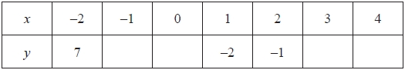

b) On the grid, draw the graph of y = x² − 2x − 1 for values of x from −2 to 4
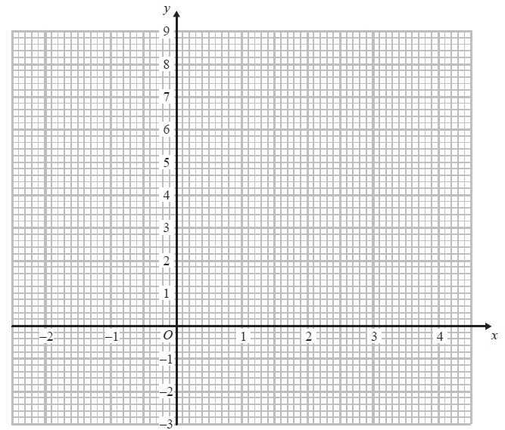

c) Solve x² − 2x − 1 = 2x

x = ………………… or …………………

d) Identify the turning point of y = x² – 3x + 2

(…………………, …………………)

Parabolas, Roots and Turning Points AMBER
1. a) Complete the table of values for y = x² − 5x + 3
Substitute the x values into the equation to get the y values

b) On the grid below, draw the graph of y = x² − 5x + 3 for values of x from x = −1 to x = 5
Remember to join the coordinates with a single smooth curve

The equation is equal to 0 so identify the roots of the equation
c) Find estimates of the solutions of the equation x² − 5x + 3 = 0

x = ………………… or …………………
d) Identify the turning point of y = x² − 5x + 3
At which coordinate does the graph change direction?
(…………………, …………………)
2. a) Complete the table of values for y = x² − 2x − 1

b) On the grid, draw the graph of y = x² − 2x − 1 for values of x from x = −2 = 3
Sketch the graph of y = x + 3 and identify the x values of the intersection points

c) Find estimates for the solutions of the equation x² − 2x − 1 = x + 3
x = ………………… or …………………

d) Identify the turning point of y = x² − 2x − 1

(…………………, …………………)

3. a) Complete the table of values for y = x² – 3x + 2

b) On the grid, draw the graph of y = x² – 3x + 2 for values of x from –1 to 5

c) Find estimates for the solutions of the equation x² – 3x + 2 = 4
x = ………………… or …………………

d) Identify the turning point of y = x² – 3x + 2

(…………………, …………………)

4. a) Complete the table of values for y = x² − 2x − 1

b) On the grid, draw the graph of y = x² − 2x − 1 for values of x from −2 to 4

c) Solve x² − 2x − 1 = 2x

x = ………………… or …………………

d) Identify the turning point of y = x² – 3x + 2

(…………………, …………………)

Parabolas, Roots and Turning Points RED
1. a) Complete the table of values for y = x² − 5x + 3
Substitute the x values into the equation to get the y values

b) On the grid below, draw the graph of y = x² − 5x + 3 for values of x from x = −1 to x = 5
Remember to join the coordinates with a single smooth curve

The equation is equal to 0 so identify the roots of the equation
c) Find estimates of the solutions of the equation x² − 5x + 3 = 0

x = ………………… or …………………
d) Identify the turning point of y = x² − 5x + 3
At which coordinate does the graph change direction?
(…………………, …………………)
2. a) Complete the table of values for y = x² − 2x − 1
Substitute the x values into the equation to get the y values

b) On the grid, draw the graph of y = x² − 2x − 1 for values of x from x = −2 = 3
Remember to join the coordinates with a single smooth curve

Sketch the graph of y = x + 3 and identify the x values of the intersection points

c) Find estimates for the solutions of the equation x² − 2x − 1 = x + 3
x = ………………… or …………………

d) Identify the turning point of y = x² − 2x − 1
At which coordinate does the graph change direction?
(…………………, …………………)

3. a) Complete the table of values for y = x² – 3x + 2
Substitute the x values into the equation to get the y values

b) On the grid, draw the graph of y = x² – 3x + 2 for values of x from –1 to 5
Remember to join the coordinates with a single smooth curve

Sketch the graph of y = 4 and identify the x values of the intersection points

c) Find estimates for the solutions of the equation x² – 3x + 2 = 4
x = ………………… or …………………

d) Identify the turning point of y = x² – 3x + 2
At which coordinate does the graph change direction?
(…………………, …………………)

4. a) Complete the table of values for y = x² − 2x − 1
Substitute the x values into the equation to get the y values
Remember to join the coordinates with a single smooth curve

b) On the grid, draw the graph of y = x² − 2x − 1 for values of x from −2 to 4

Sketch the graph of y = 2x and identify the x values of the intersection points
c) Solve x² − 2x − 1 = 2x

x = ………………… or …………………

d) Identify the turning point of y = x² – 3x + 2
At which coordinate does the graph change direction?
(…………………, …………………)

