Bearings

**1.**



The diagram shows the position of each of three buildings in a town.  
The bearing of the Hospital from the Art gallery is 072.  
The Cinema is due East of the Hospital.  
The distance from the Hospital to the Art gallery is equal to the distance from the Hospital to the Cinema.

Work out the bearing of the Cinema from the Art gallery.

……………………°

(Total 3 marks)

**2.** A lighthouse, *L,* is 3.2 km due West of a port, *P*.  
A ship, *S*, is 1.9 km due North of the lighthouse, *L*.

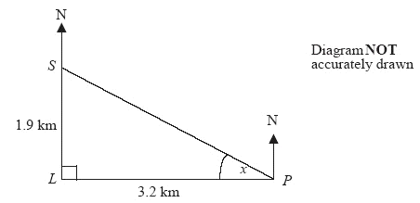

(a) Calculate the size of the angle marked *x*.  
Give your answer correct to 3 significant figures.

*x* = ……………….. °

(3)

(b) Find the bearing of the port, *P*, from the ship, *S*.  
Give your answer correct to 3 significant figures.

…………………... 

(1)

(Total 4 marks)

**3.** In the diagram, Point A marks the position of Prestwich.  
The position of Radcliffe is to be marked on the diagram as *Point B.*

(a) On the diagram, mark with a cross (×) the position of *B*, given that  
 B is on a bearing of 320° from A and  
 B is 6 cm from A.



(2)

The scale of the diagram is 1 : 50 000

(b) Work out the real distance 6 cm represents.  
Give your answer in kilometres.

..................... km

(3)

(Total 5 marks)

**4.** The diagram shows the position of a farm *F* and a bridge *B* on a map.



(a) Measure and write down the bearing of *B* from *F*.

....................................... º

(1)

A church *C* is on a bearing of 155º from the bridge *B*.  
On the map, the church is 5 cm from *B*.

(b) Mark the church with a cross () and label it *C.*

(2)

(Total 3 marks)