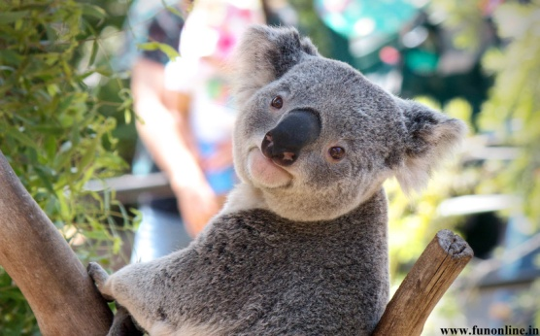[](http://www.google.co.uk/imgres?q=price+tag&safe=vss&hl=en&biw=1366&bih=651&tbm=isch&tbnid=aX3CKFiuZcaXPM:&imgrefurl=http://www.clker.com/clipart-price-tag.html&docid=lJe46nyB2pGLbM&imgurl=http://www.clker.com/cliparts/7/1/a/3/p/E/price-tag-md.png&w=298&h=252&ei=V8h3UfjMKIX30gWXkYG4AQ&zoom=1&ved=1t:3588,r:8,s:0,i:110&iact=rc&dur=400&page=1&tbnh=180&tbnw=213&start=0&ndsp=18&tx=93&ty=91)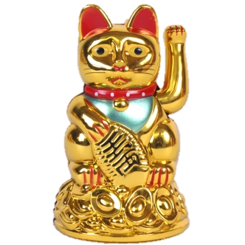[](http://www.google.co.uk/imgres?q=price+tag&safe=vss&hl=en&biw=1366&bih=651&tbm=isch&tbnid=aX3CKFiuZcaXPM:&imgrefurl=http://www.clker.com/clipart-price-tag.html&docid=lJe46nyB2pGLbM&imgurl=http://www.clker.com/cliparts/7/1/a/3/p/E/price-tag-md.png&w=298&h=252&ei=V8h3UfjMKIX30gWXkYG4AQ&zoom=1&ved=1t:3588,r:8,s:0,i:110&iact=rc&dur=400&page=1&tbnh=180&tbnw=213&start=0&ndsp=18&tx=93&ty=91)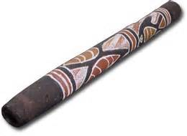[](http://www.google.co.uk/imgres?q=price+tag&safe=vss&hl=en&biw=1366&bih=651&tbm=isch&tbnid=aX3CKFiuZcaXPM:&imgrefurl=http://www.clker.com/clipart-price-tag.html&docid=lJe46nyB2pGLbM&imgurl=http://www.clker.com/cliparts/7/1/a/3/p/E/price-tag-md.png&w=298&h=252&ei=V8h3UfjMKIX30gWXkYG4AQ&zoom=1&ved=1t:3588,r:8,s:0,i:110&iact=rc&dur=400&page=1&tbnh=180&tbnw=213&start=0&ndsp=18&tx=93&ty=91)[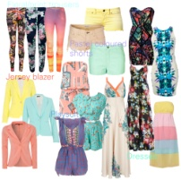](http://www.google.co.uk/url?sa=i&rct=j&q=holiday+clothes&source=images&cd=&cad=rja&docid=lOiUvaf30LJ2EM&tbnid=cOZ8kQqf0LTXXM:&ved=0CAUQjRw&url=http://www.newblackbook.co.uk/shopping/fashion/suitcase-essentials-when-on-a-budget.html&ei=Asx3UfvFLITQ0QXJjICwCA&psig=AFQjCNE4xiPPOTj2nxcUBxNfsKyrsHyGWw&ust=1366891886088500)[](http://www.google.co.uk/url?sa=i&rct=j&q=holiday+insurance&source=images&cd=&cad=rja&docid=oB4YnmrH2ZwK2M&tbnid=sk2jCTA_rXONCM:&ved=0CAUQjRw&url=http://www.totaltravelguide.co.uk/single-trip-vs-annual-travel-insurance/&ei=gct3Uc-eMMa90QWq_YGoCw&psig=AFQjCNEl9wBd3852Vc__waT1nsQPCOjuOg&ust=1366891759331575)[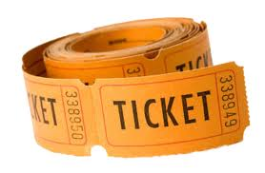](http://www.google.co.uk/url?sa=i&rct=j&q=price%20ticket&source=images&cd=&cad=rja&docid=WlRiihqx3C__QM&tbnid=lY6-WxSAx8j5nM:&ved=0CAUQjRw&url=http://www.silvermountainexperience.co.uk/tickets&ei=A8t3UeKjE6qG0AXcioCIBQ&psig=AFQjCNHSrjVu85Ks7qHkPjiNLmhc3mr3hQ&ust=1366891640651242)[](http://www.google.co.uk/imgres?q=price+tag&safe=vss&hl=en&biw=1366&bih=651&tbm=isch&tbnid=aX3CKFiuZcaXPM:&imgrefurl=http://www.clker.com/clipart-price-tag.html&docid=lJe46nyB2pGLbM&imgurl=http://www.clker.com/cliparts/7/1/a/3/p/E/price-tag-md.png&w=298&h=252&ei=V8h3UfjMKIX30gWXkYG4AQ&zoom=1&ved=1t:3588,r:8,s:0,i:110&iact=rc&dur=400&page=1&tbnh=180&tbnw=213&start=0&ndsp=18&tx=93&ty=91)[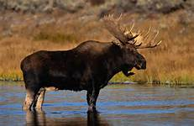](http://www.bing.com/images/search?q=moose&qs=n&form=QBIR&pq=moose&sc=0-0&sp=-1&sk=#view=detail&id=06EB2B4932D7D9FA2D71177E036625AD3289E07D&selectedIndex=4)[](http://www.google.co.uk/imgres?q=price+tag&safe=vss&hl=en&biw=1366&bih=651&tbm=isch&tbnid=aX3CKFiuZcaXPM:&imgrefurl=http://www.clker.com/clipart-price-tag.html&docid=lJe46nyB2pGLbM&imgurl=http://www.clker.com/cliparts/7/1/a/3/p/E/price-tag-md.png&w=298&h=252&ei=V8h3UfjMKIX30gWXkYG4AQ&zoom=1&ved=1t:3588,r:8,s:0,i:110&iact=rc&dur=400&page=1&tbnh=180&tbnw=213&start=0&ndsp=18&tx=93&ty=91)[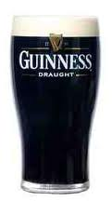](http://www.google.co.uk/url?sa=i&rct=j&q=pint+of+guinness#&source=images&cd=&cad=rja&docid=oQDRn1izvt2X8M&tbnid=nO0c6vjg9WmMjM:&ved=0CAUQjRw&url=http://www.funkyrhino.com/TrainingMaterials/_09.htm&ei=PMR3UfyZFMLU0QXzo4CgAQ&psig=AFQjCNEqvfzx4wNw5806ugkMArw9RoyckA&ust=1366889902647229)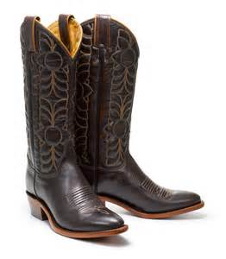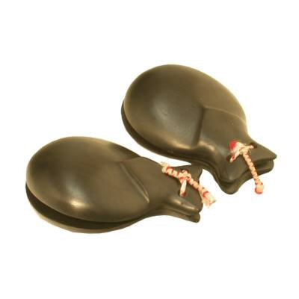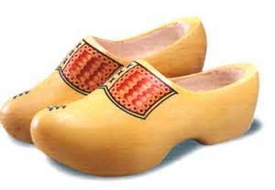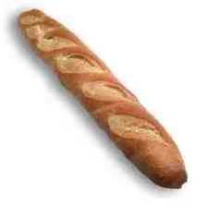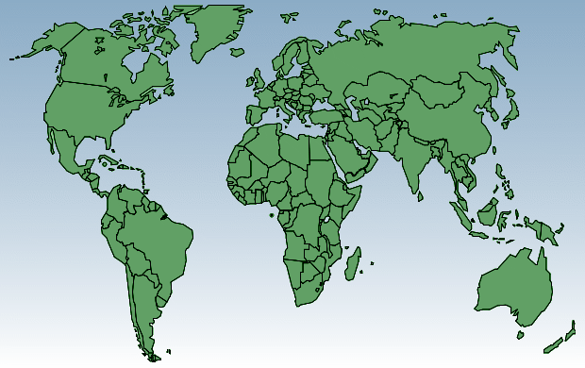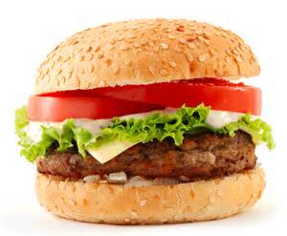

How much has my trip cost me in Pounds (£) altogether?

60 HKD

$75

400 JPY

Holiday clothes £190

Insurance £100

Round World Ticket £3500

$30

$450

€15

$5

€0.50

€20

€3.50

$750