Triangle Constructions GREEN

Construct the following triangles accurately using compasses, a protractor and a ruler.

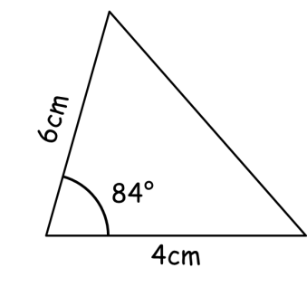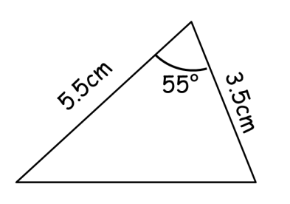

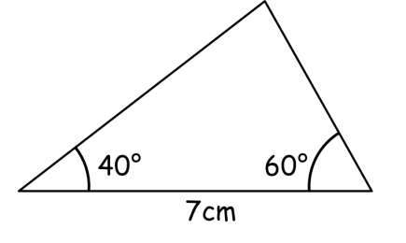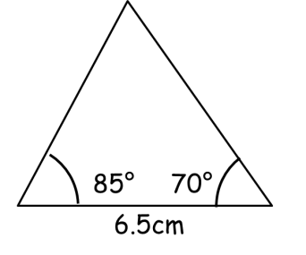

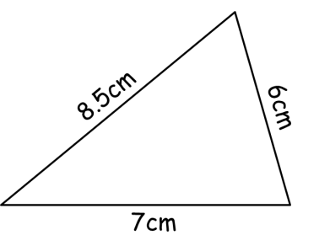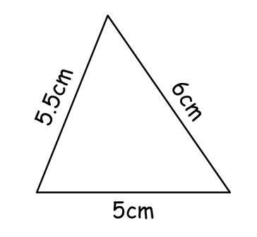

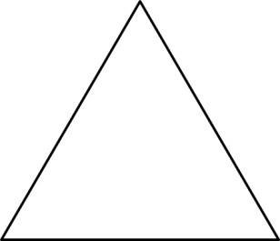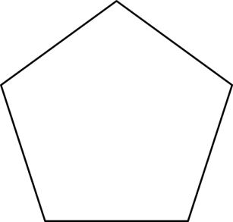
Equilateral triangle Regular pentagon
Side 7cm Side 5cm

Triangle Constructions AMBER

Construct the following triangles accurately using a protractor and a ruler.

Construct the following triangles accurately using a protractor and a ruler.

Construct the following triangles accurately using compasses and a ruler.

Construct the following polygons accurately using a protractor and a ruler.

Equilateral triangle Regular pentagon
Side 7cm Side 5cm
Angle = ____ Angle = ____

Triangle Constructions RED

Construct the following triangles accurately using a protractor and a ruler.
Draw a 4cm line.
Place the centre of the protractor at the left side of the line.
Measure an 84° angle an mark with a dot.
Draw a 5cm through the dot.
Join up the final side to complete the triangle.

Construct the following triangles accurately using a protractor and a ruler.
Draw a 7cm line.
Place the centre of the protractor on the left end of the line and measure a 40° angle. Draw a line through.
Place the centre of the protractor on the right end of the line and measure a 60° angle. Draw a line through.
Your triangle should be complete. Leave in construction lines.

Construct the following triangles accurately using compasses and a ruler.
Draw a 7cm line.
Set your compasses to 8.5cm and with the point on the left end of the base line draw an arc.
Set your compasses to 6cm and with the point on the right end of the base line draw an arc.
Draw in the other two sides of the triangle to the cross you have just created.

Construct the following polygons accurately using a protractor and a ruler.

Equilateral triangle Regular pentagon
Side 7cm Side 5cm
Angle = 60° Angle = 108°

