Area and Perimeter of Rectangles GREEN

Find the missing lengths, then answer the question.

Area = 20 cm²  Width = 4 cm  Find the perimeter | Perimeter = 12 cm  Width = 3 cm  Find the area | Area = 54 cm²  Width = 6 cm  Find the perimeter
Area = 30 m²  Width = 5 m  Find the perimeter | Perimeter = 18 mm  Width = 5 mm  Find the area | Perimeter = 28 mm  Width = 8 mm  Find the area
Area and Perimeter of Rectangles AMBER

Find the area and perimeter of the rectangles below. Make sure the sides have the same units before you calculate.

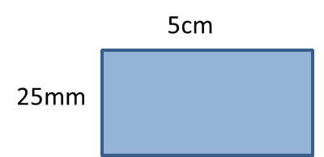 | 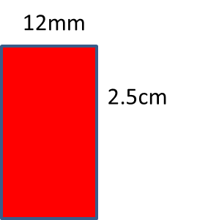 | 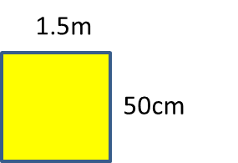
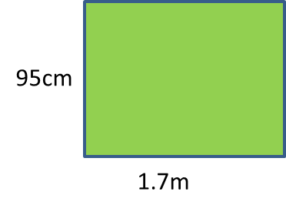 |  | 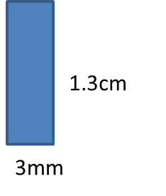
Area and Perimeter of Rectangles RED

Find the area and perimeter of the rectangles below.

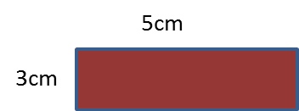 | 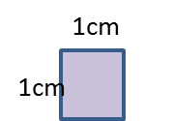 | 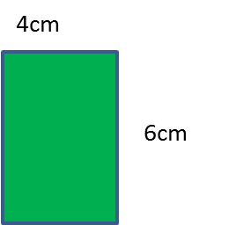
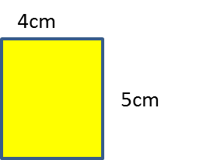 | 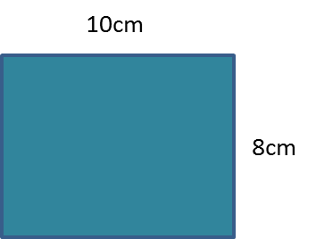 | 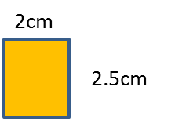
Area and Perimeter of Rectangles EXTENSION

- Write down the dimensions of a rectangle that could have an area of 24 cm². How many possible answers are there?

- Write down the dimensions of a rectangle that could have a perimeter of 18 cm. How many possible answers are there?

