Factorising quadratics with a coefficient of x² GREEN

Questions | Working | Answer
4x² – 19x + 12
2x² + x – 6.
4x² – 15x + 9.
4x² + 7x + 3
6x² + 19x + 10
2x² - x - 21
10x² - 11x + 3
2x² - 10x - 28

Factorising quadratics with a coefficient of x² AMBER

Questions | Working | Answer
4x² – 19x + 12 | 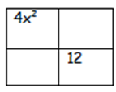
2x² + x – 6.
4x² – 15x + 9.
4x² + 7x + 3
6x² + 19x + 10
2x² - x - 21
10x² - 11x + 3
2x² - 10x - 28

Factorising quadratics with a coefficient of x² RED

Questions | Working | Answer
4x² – 19x + 12 | 4 x 12 = 48  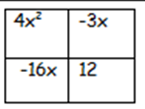  1 and 48, 2 and 24, 3 and 16, 4 and  12, 6 and 8  Must be -3 and -16
2x² + x – 6. | 2 x 6 = 12  1 and 12, 2 and 6, 3 and 4  One positive, one negative
4x² – 15x + 9. | 4 x 9 = 36
4x² + 7x + 3
6x² + 19x + 10
2x² - x - 21
10x² - 11x + 3
2x² - 10x - 28

