Surface Area of Triangular Prisms GREEN

Add together the areas of all the faces to find the surface areas of these prisms (all the edges are measured in cm)

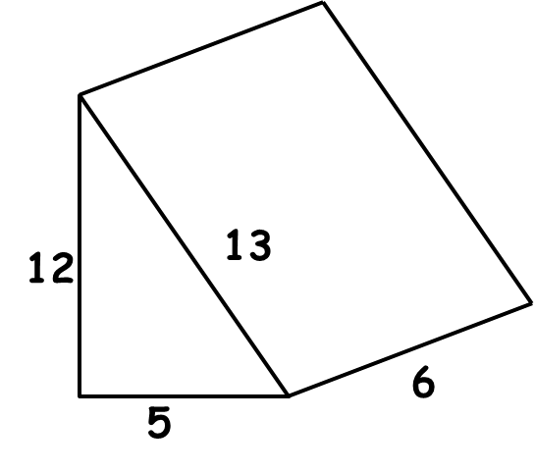
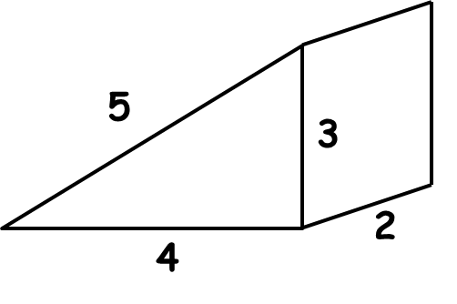

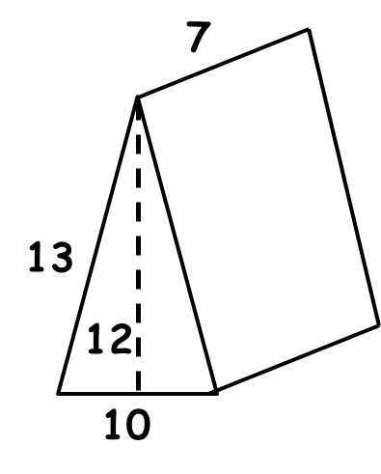

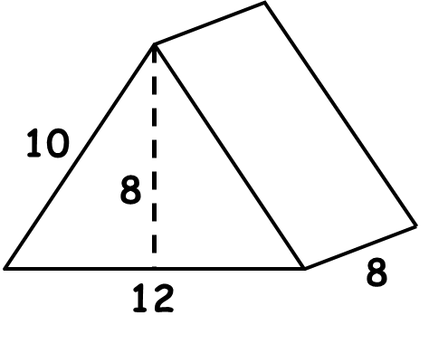

Surface Area of Triangular Prisms AMBER

Add together the areas of all the faces to find the surface areas of these prisms (all the edges are measured in cm)

Front =
Back =
Left =
Right =
Bottom =
Surface Area =
Front =
Back =
Left =
Right =
Bottom =
Surface Area =

Front =
Back =
Left =
Right =
Bottom =
Surface Area =
Front =
Back =
Left =
Right =
Bottom =
Surface Area =

Surface Area of Triangular Prisms RED

Add together the areas of all the faces to find the surface areas of these prisms (all the edges are measured in cm)

Front = 5 x 12 ÷ 2 =
Back =
Left = 12 x 6 =
Right = 13 x 6 =
Bottom = 6 x 5 =
Surface Area =
Front = 5 x 4 ÷ 2 =
Back = 5 x 4 ÷ 2 =
Left = 5 x 2 =
Right = 3 x 2 =
Bottom = 2 x 4 =
Surface Area =

Front =
Back =
Left =
Right =
Bottom =
Surface Area =
Front =
Back =
Left =
Right =
Bottom =
Surface Area =

