Real Life Graphs - GREEN

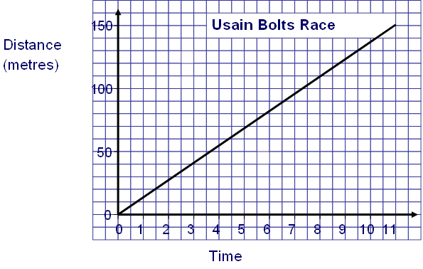
- How far has he run after 4.5 seconds?

- How long has it taken Usain to run 130 metres?

- How far has he run after 8 seconds?

- Why does the line go through the origin?
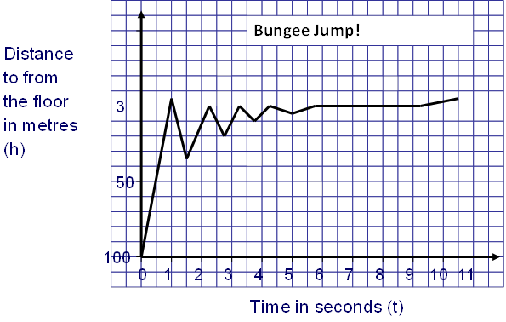
- How high is the bungee jump?

- Why does the graph zig zag?

- How long is the person falling for until they begin to bounce back up?

- Why does the person stop at 3 metres and not 0?

- How long is the person not bouncing but still upside down for?

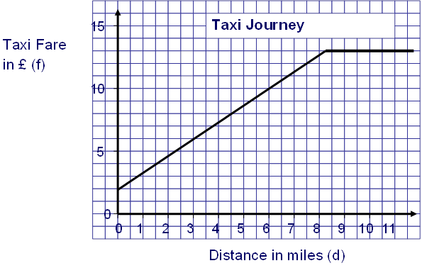

- Why does the taxi fare not go through the origin?

- How much does it cost to travel 6 miles?

- How far can I travel if I only have £10 in my pocket?

- What does the journey cost after 9 miles? And 11 miles?

- What does the flat part of the graph mean?

- What is the equation of the line from 0 to 8 minutes?

- What is the equation of the line from 8 minutes onwards?
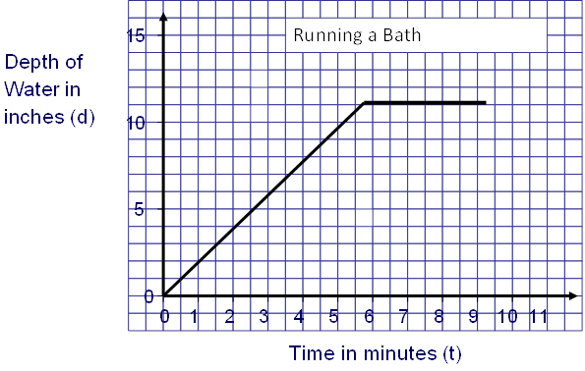
- How deep is the water after 3 minutes?

- What is the equation of the line from 0 to 5 minutes?

- What is happening from 5 minutes onwards?

- What is the equation of the line from 5 minutes onwards?

Real Life Graphs - AMBER

- How far has he run after 4.5 seconds?
Go to the line then across or down back to the other axis

- How long has it taken Usain to run 130 metres?

- How far has he run after 8 seconds?

- Why does the line go through the origin?
- How high is the bungee jump?

- Why does the graph zig zag?

- How long is the person falling for until they begin to bounce back up?

- Why does the person stop at 3 metres and not 0?

- How long is the person not bouncing but still upside down for?

- Why does the taxi fare not go through the origin?

- How much does it cost to travel 6 miles?

- How far can I travel if I only have £10 in my pocket?

- What does the journey cost after 9 miles? And 11 miles?

- What does the flat part of the graph mean?

- What is the equation of the line from 0 to 8 minutes?

- What is the equation of the line from 8 minutes onwards?
- How deep is the water after 3 minutes?

- What is the equation of the line from 0 to 5 minutes?

- What is happening from 5 minutes onwards?

- What is the equation of the line from 5 minutes onwards?

Real Life Graphs - RED

(d)
(c)
(b)
(a)
- How far has he run after 4.5 seconds?
Go to the line then across or down back to the other axis

- How long has it taken Usain to run 130 metres?

- How far has he run after 8 seconds?

- Why does the line go through the origin?
(e)
(d)
(c)
(b)
(a)
- How high is the bungee jump?

- Why does the graph zig zag?

- How long is the person falling for until they begin to bounce back up?

- Why does the person stop at 3 metres and not 0?

- How long is the person not bouncing but still upside down for?

(e), (g)
(f)
(c)
(b)
(a)
(d)
- Why does the taxi fare not go through the origin?

- How much does it cost to travel 6 miles?

- How far can I travel if I only have £10 in my pocket?

- What does the journey cost after 9 miles? And 11 miles?

- What does the flat part of the graph mean?

- What is the equation of the line from 0 to 8 minutes?

- What is the equation of the line from 8 minutes onwards?
(d)
(c)
(b)
(a)

- How deep is the water after 3 minutes?

- What is the equation of the line from 0 to 5 minutes?

- What is happening from 5 minutes onwards?

- What is the equation of the line from 5 minutes onwards?

