Similar Shapes GREEN

All the shapes below are mathematically similar. Use ratio to calculate the missing lengths for each pair of shapes.

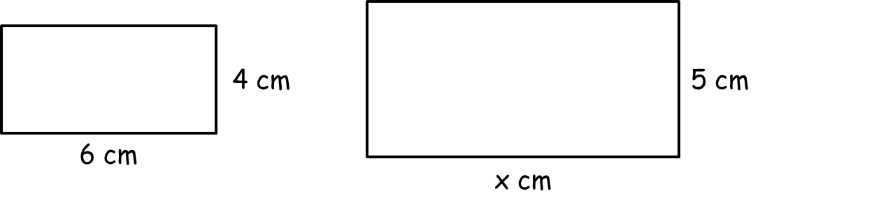
1)

x = _________

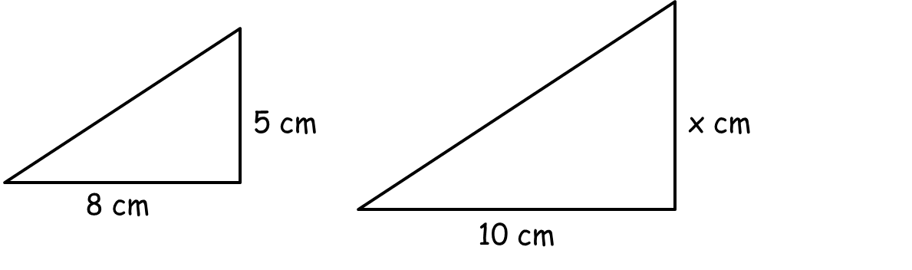
2)

x = _________

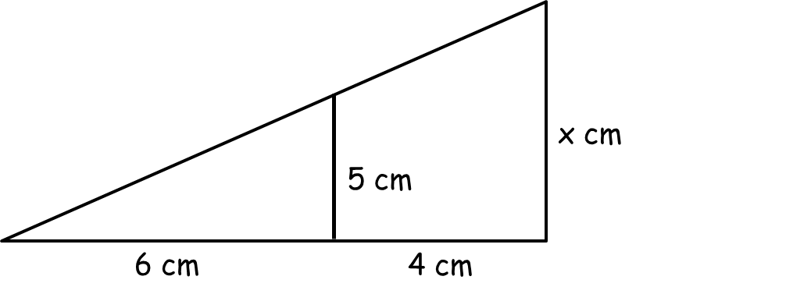
3)

x = _________

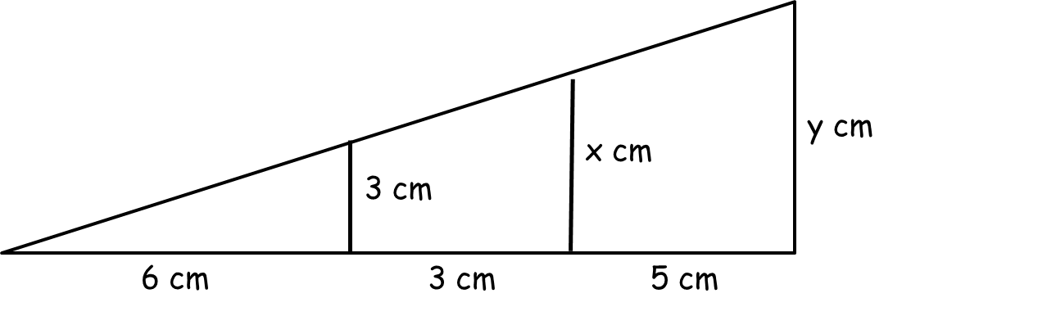
4)

x = _________

y = _________

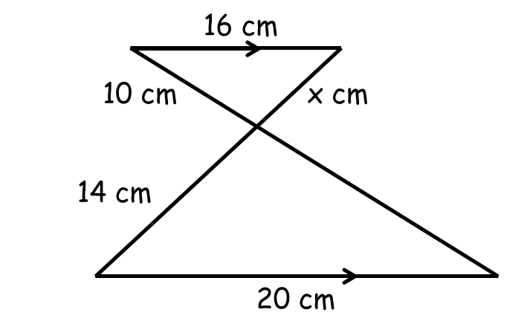
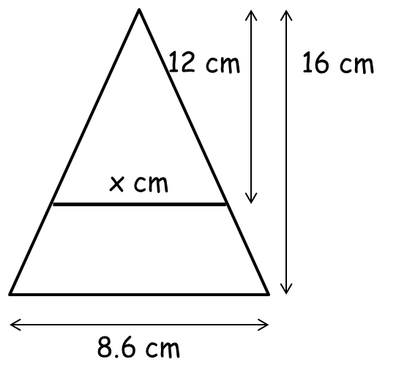
5) 6)

x = _________

y = _________ x = _________

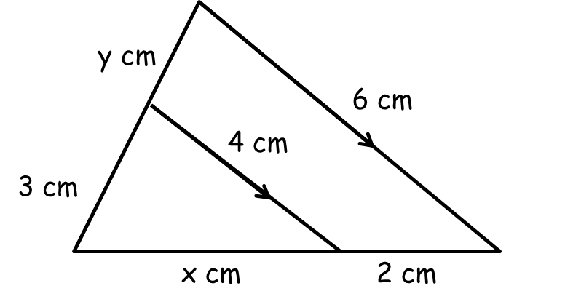
7) 8)

x = _________ x = _________

y = _________ y = _________

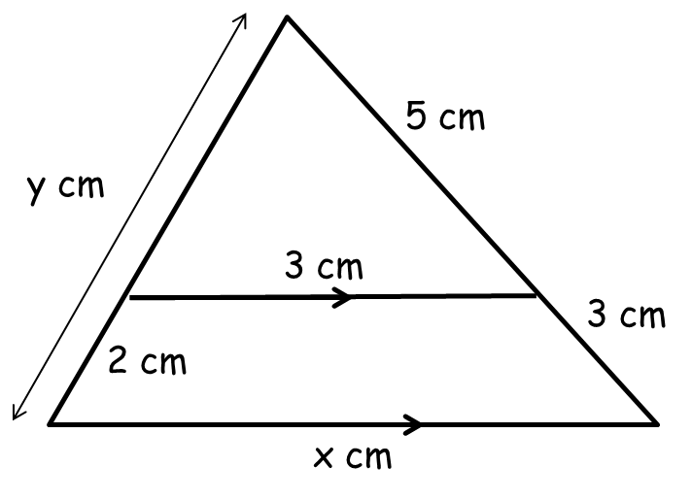
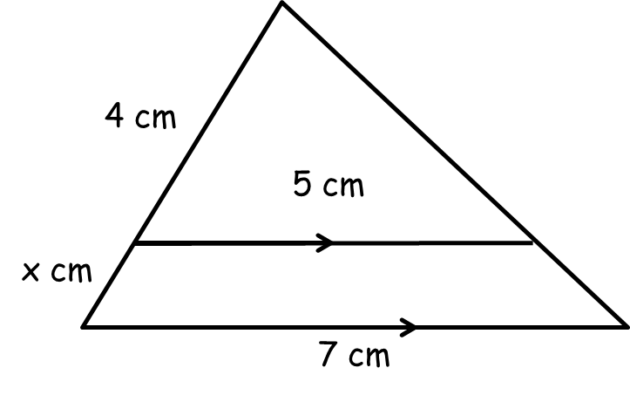
9) 10)

x = _________ x = _________

y = _________

Similar Shapes AMBER
The sides used to calculate the ratio are circled.

All the shapes below are mathematically similar. Use ratio to calculate the missing lengths for each pair of shapes.

1)

x = _________

2)

x = _________

3)

x = _________

4)

x = _________

y = _________

5) 6)

x = _________

y = _________ x = _________

7) 8)

x = _________ x = _________

y = _________ y = _________

9) 10)

x = _________ x = _________

y = _________

Similar Shapes RED
The sides used to calculate the ratio are circled.

All the shapes below are mathematically similar. Use ratio to calculate the missing lengths for each pair of shapes.
4 : 5 = 1 : _____
6 x _____ = _____

1)

x = _________

8 : 10 = 1 : _____
5 x _____ = _____
2)

x = _________

3)
6 : ____ = 1 : _____

x = _________

4)

x = _________

y = _________

5) 6)

x = _________

y = _________ x = _________

7) 8)

x = _________ x = _________

y = _________ y = _________

9) 10)

x = _________ x = _________

y = _________

