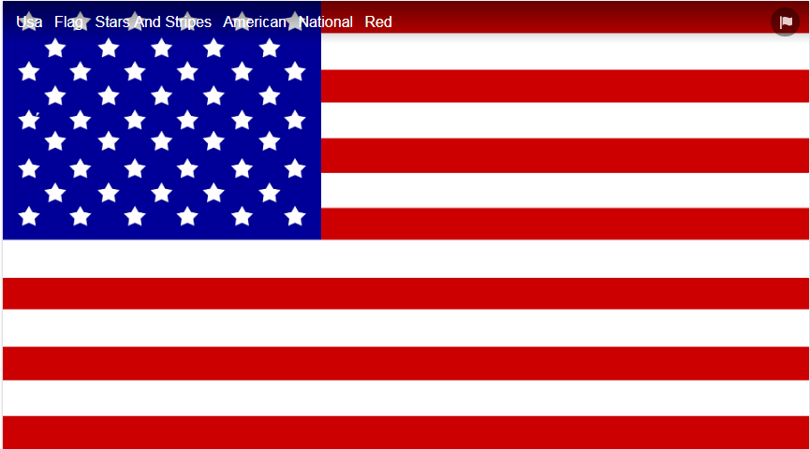 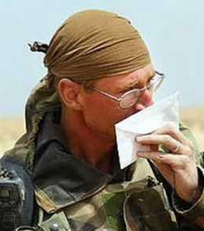 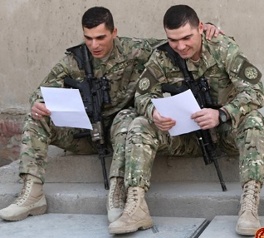 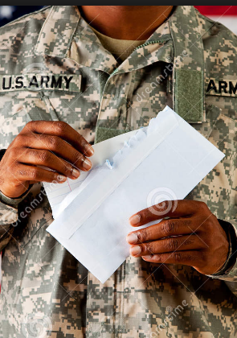 

Eagle Scout Service Project: “You are Not Forgotten”

Please support Lassiter High School Junior Jay D. of Boy Scout Troop 008 with his project to remember American servicemen & women stationed overseas. Project Mail Call sends care packages all over the world to these heroes with small everyday comforts of home, to boost morale and to express care and concern while they are far from home. Please consider donating some of the following items through 5/23 (non-aerosol only, large or individual sizes):

powdered/electrolyte drink mixes men/women’s deodorants tissue packs mints

healthy protein bars healthy snacks chewing gum lip balms eye drops

tuna/chicken kits & foil packets individual beef jerky packets and/or sticks oatmeal

granola bars pop-tarts toothbrushes toothpaste bandanas boot socks

tubes of shave gel (no aerosol) heavy-duty socks men’s black socks crew socks

*Also needed for the care packages are short, colorful, simple letters written by all ages. These notes are very cherished by the recipients, often carried in their front pockets when they go on mission. Please write/draw encouraging thoughts, and how much you appreciate their sacrifice and courage, and that “they are never forgotten”. Tell them a little about yourself too (first names only for children). Include an email address if you’d like a reply! *Project Mail Call has a current shortage of letters, so we need your help*!! 😊 ***Thank you for your support of these patriotic women and men!!***

Have questions? 470-202-5242 or [lynreither@gmail.com](mailto:lynreither@gmail.com)

Read their heartfelt words of gratitude at <https://www.facebook.com/ProjectMailCall/> 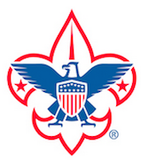

State-Recognized Project Mail Call, Marietta, Georgia—“Supporting Our Troops One Box At A Time”