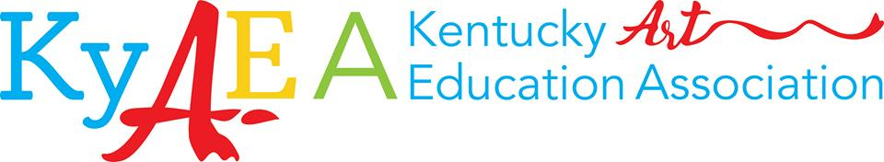

Vendor Form - Must be postmarked by September 9, 2019
Conference: Oct 11th and 12th @ Jessamine County Middle School
Vendor set up: 8:30-10:30 a.m. on Friday
Vending Times: 10:30-3:00 on Friday and 10:00-2:00 on Saturday

In appreciation for your support, KYAEA vendors receive:
Company logo printed in the 2019 conference booklet and published on KYAEA website conference page (please include copy of logo, or business card) and email it for better quality printing.
One (1) complimentary lunch ticket per day (Friday and Saturday), additional lunch tickets will be $10 each
Invitation to the KyAEA Awards Gala on Friday evening.
Access to visual art educators from across KY

Company Name:

Contact Name:

Address (including city, state and zip):

Email: |  |  |  | Phone: |  | Fax:
Company/Product Description:

Identify the way your donated door prize will be delivered:
Mailed or Dropped off by vendor?

Description of Donated Door Prize:

#’s of Tables Needed: | Electricity Hookup Needed: No Yes |  | # of additional lunch tickets needed ($10/each)  Friday: Saturday:
Would you like to hold a seminar class? No Yes – Cap size for class:
Seminar Title:

Seminar Description (50 word limit and to be printed in booklet):

Which day(s) will you present?  Friday Saturday |  | # of times you would like to present: 1 or 2 |  |  | Presentation done: at booth or classroom needed?
 |  | Cost
Vendor Registration Fee |  | $50.00 + Donated Door Prize Item
Want to upgrade your ad size? |  | ½ Page Ad  $60.00
Full Page Ad
$100.00
Sponsorship |  | $75.00  Company will be presented as a sponsor on our webpage and at event.
Total Amount Enclosed
Please mail completed form and payment by September 9th 2019 to:

Make CHECKS payable to: KyAEA
Mail packages to:
Marilyn Peters
2181 Hardesty Road
Springfield, Ky 40069
Phone: 859-481-1998
Questions? Email: presidentelectkyaea@gmail.com

Hotel info:
**Coming Soon**

