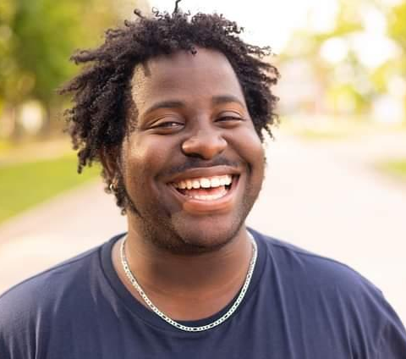

Antavius Draughn
Dancer, Singer
Dallas, Texas
(469) 309-0045
antaviusd@gmail.com

STAGE CREDITS
Professional Credits with Lyric Stage Theater of Dallas
Rocky Horror Picture Show Phantom/Transylvanian Dir. Brandon Mason
Aida Ensemble Dir. Sasha Maya Ada
Tarzan Snipes Dir. Brandon Mason
The Producers Ensemble Dir. Brandon. Mason

Professional Credits with Oklahoma Shakespearean Festival
Disney’s Newsies Oscar Delancey Dir. Riley Risso Coker
Disney’s Aladdin Guard#2/Prince#2 Dir. Riley Risso Coker
Company Cabaret Featured Vocalist Dir. Riley Risso Coker
Beauty and the Beast Ensemble Dir. Riley Risso Coker
Hamlet ESP Rosencrantz Dir. Riley Risso Coker
The Tempest Francisco/Mariner/Fury Dir. Riley Risso Coker
Much Ado About Nothing Conrad Dir. Riley Risso Coker

Arts Mission Oak Cliff
Cabaret Bobby Dir. Sasha Maya Ada

FILM/COMMERCIAL CREDITS
Prep (DFW Commercial) Main Dancer
American Underdog: The Kurt Warner Story Rams football player extra
Fifth Wheel (Short Film) Carl
Suffrage (Short Film) Activist
Betterman Movement (Promo) Young Adult
Topgolf (Nationwide Commercial) Extra
Dave and Busters (Commercial) Game Watcher
Tiff's Treats (Commercial) Employee
House of Spirits (A Cocktail Soiree) The Curator
7 Eleven Commercial. Actor

TRAINING
The Chorvettes - Southeastern Oklahoma State University Show Choir under the direction of Deborah Clements
Education:
Southeastern Oklahoma State University: B.A. in Musical Theatre with a minor in Dance.
Paris Junior College: Associate’s degree in science: Theatre

Special Skills:
Picks up choreography well. Loves working with children. Fully Vaccinated.

