NPID logo

# Electric Vehicle EVent

# 65 South Street - Morristown NJ

# 2016

**Saturday September 10th – 10am to 2pm – Free Admission**

# Learn all about Electric Vehicles (EVs) in one place from the owners. Hear from them first hand what it is like to own an EV

# Take one for a test drive

# Discover how old EVs really are by seeing a beautifully restored 1917 Detroit Electric Model 68

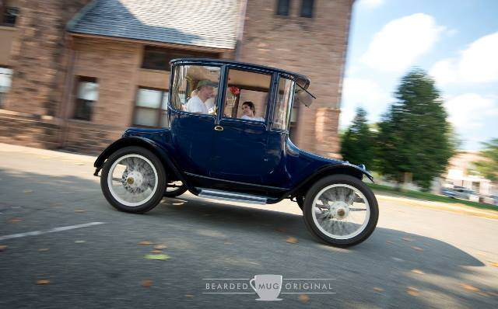

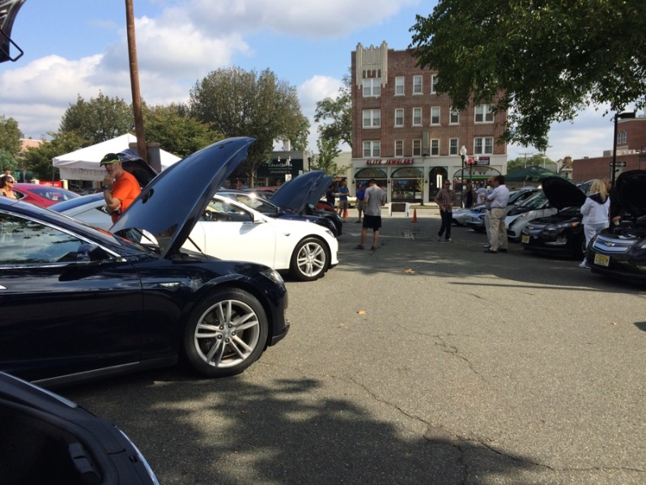

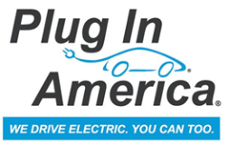http://i.imgur.com/Sq5X4rm.jpg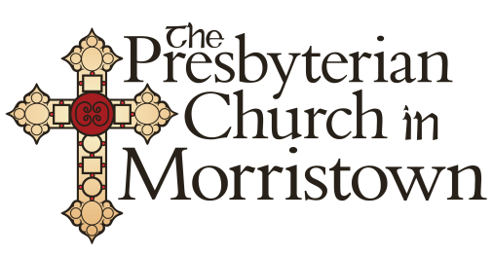

**For more info - tinyurl.com/EVMorristown2016**

[**Lauren@sustainablemorristown.org**](mailto:Lauren@sustainablemorristown.org)

**856-912-6586**