Exploring Christian Denominations
Class #1

Intro:

#1. We are exploring Christian denominations.

***We will be focusing on both the Christian Church and the Christian church.

The Church vs. The church?

One way to understand the two uses of the word church is that there is only one “Church”—one body of people called unto God. However, there are local manifestations of that body in different places, and these are called “churches.” We are familiar with this concept through the modern business franchise model. On one hand, there is only one McDonald’s Corporation. However, in a slightly different sense, there are many McDonald’s all over the world. There is one company with many different locations or local manifestations. When speaking of the church, people often speak of the universal church and the local church, or sometimes the invisible church and the visible church.

The “Big 3” Branches of Christianity (will talk more about this next week)

- _______________________ 2._____________________ 3.____________________

Figure #1

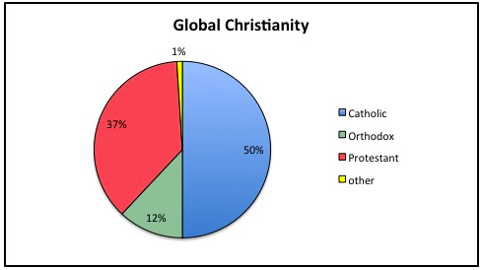

Figure #2
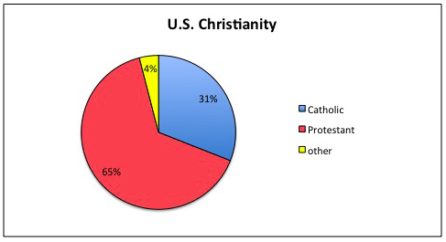

#2. We are exploring Christian denominations….specifically, Protestant denominations.

What are denominations?: Denominations are Christian faith communities that embrace certain doctrines, traditions, habits, histories, and priorities...they are particular ways of being Christian.

Figure #3

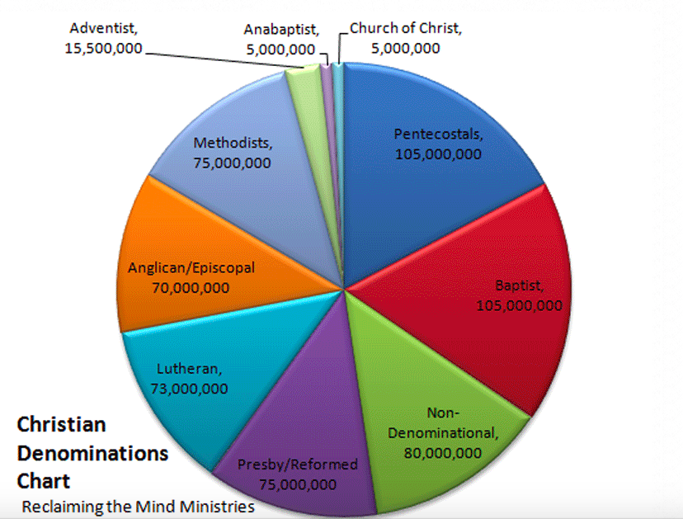

What does it mean to be Protestant?

One religious researcher suggests, “If the Christian church you’re sitting in isn’t Orthodox or Roman Catholic, then you are in a Protestant church of one variety or another. The thing to remember about Protestants is that they protest.” One cannot deny the element of protest in the history of Protestantism. Many scholars are quick to note, however, that the term protest etymologically carries the idea “to testify” or “to affirm.”

Thus, the actual word itself is charged with positive rather than negative connotations. “To protest,” then, in the true meaning of the word, is to make certain affirmations, to give testimony on behalf of certain things. The point is that Protestantism is not simply a reactionary, negative movement. To be sure, the early Reformers did take a stand against the teachings of the Roman Catholic Church. But Protestants predominantly testify to what they consider to be the truth!

﻿

Evangelical (Historic/Traditional) vs. Progressive (Liberal/Mainline) Protestantism

Primary Characteristics of Evangelical Protestantism:

- ______________________________: the belief that lives need to be transformed through a “born-again” experience and a life long process of following Jesus.

- ______________________________: the expression and demonstration of the gospel in missionary and social reform efforts.

- Trustworthiness and ____________________ of the Bible: a high regard for and obedience to the Bible as the ultimate authority.

- The ________________________ of the Cross and Resurrection: a stress on both the sacrifice of Jesus Christ on the cross, as well as his resurrection, making possible the redemption of humanity.

Primary Characteristics of Progressive Protestantism

Michael Kruger: “Progressive Christianity is a master class in half-truths that sound appealing on the surface until you dig down deeper and really explore their foundations and implications.”

1. Adopts a Belief That the Bible Is _____________________

“[The Bible is] a profoundly human book” (Rob Bell).

“Anything in the Bible that looks miraculous or contrary to the normal functions of the natural world is not factual, but rather is mythological” (James Burklo).

2. Has an ____________________Answer to the Problem of Evil

3. Affirms a Culture-Adapting ____________________

With the Bible evicted from its seat of authority, that authority will generally shift onto self. Personal conscience, opinion, and preference becomes the lens through which life and morality is evaluated and interpreted—and this will usually be informed by the current, accepted cultural norms.

4. Jesus Is a ____________________ for Living More Than an Object for Worship

5.Affirming People’s ___________________Is More Important Than Reminding Them of Their Brokenness

- Gracious Behavior Is More Important Than _____________________.

- Inviting Questions Is More Valuable Than Supplying ______________.

- We Should Care More about Love and Less about ______________.

- Life in This World Is _______________________ than the Afterlife

10.__________________________ terms (aka “Linguistic Theft”)

Figure #4

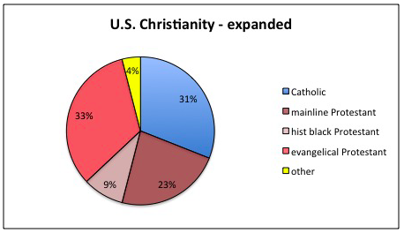

Why Denominations Matter
1. Theological ___________________

2. Missiological __________________

3. Ministerial ____________________

4. Pastoral ______________________

5. Encouragement and _____________________

https://www.gotquestions.org/one-church.html
Rhodes, Ron. The Complete Guide to Christian Denominations (p. 17).
See Michael Kruger’s The 10 Commandments of Progressive Christianity.
https://www.thegospelcoalition.org/article/3-beliefs-progressive-christians-atheists-share/
http://www.bpnews.net/53657/firstperson--why-denominations-and-networks-matter

