Neuro-rehabilitation camp 02.11.2015 to 10.11.2015
Soopramanien A, Jamwal S, Moeri-Brandalise J, Padaruth S, Paddison S, Pillay P
Soopramanien K. ¹

Introduction:
Over the past few decades, the island of Mauritius has seen significant improvements in the quality of medical care available in its hospitals. However, despite excellent progress in other areas, the services available for patients requiring post-acute and long-term rehabilitation are limited. The incidence of neurological conditions including stroke, acquired brain injury and spinal cord injury has been increasing in recent years, so there is a significant need for the provision of neuro-rehabilitation, with the aim of improving quality of life and facilitating a meaningful return to the community. Here, we describe the findings of our recent ‘neuro-rehabilitation camp’ into the provision of care and outcomes for patients with neurological conditions, and provide some recommendations on how services might be improved.

Background
The purpose of this ‘camp’ was to identify the problems faced by patients requiring rehabilitation for neurological conditions in Mauritius. A group of rehabilitation specialists¹ visited individuals in hospitals, homes and communities, performing a comprehensive assessment of the provision of neuro-rehabilitation services. Areas assessed also included equipment, clinical outcomes and experiences of patients.
This follows on from a research project conducted in 2011 to assess the needs of patients requiring neuro-rehabilitation in Mauritius, the conclusions of which were presented at a workshop organised by the Mauritius Research Council, and subsequently published ⁹. The current project was intended as a means of following up the recommendations set forward on the previous study, identifying areas of progress and those in need of further improvement.

The ‘camp’ concept was initially shared with Swami Pranava, Spiritual Head of Chinmaya Mission, Mauritius. He involved his team and all agreed that we needed the guidance and approval from the Ministry of Health and Quality of Life.

We therefore contacted Dr Pauvaday, Director General of Health and Dr Ramen, Deputy Director of Health who provided us with all the necessary help. Mr Sauntokhee, senior administrator from the Ministry of Health and Quality of Life organised all the professional clearances for our team to be able to work in Mauritius. In addition, he facilitated travel arrangements during our stay.

Methods
Activities:
The assessment was carried out over a period of 9 days from 2nd to 10th November 2015. We held dedicated clinics for patients at Victoria hospital in Quatre Bornes, during which we spoke to and examined patients and provided suggestions and advice to the patients, their carers and the staff. Therapists were well represented; a handful of nurses and doctors also attended. The twenty-five patients came with their relatives from all main hospitals.
We carried out home visits to eight patients on day one and saw three others during our stay.
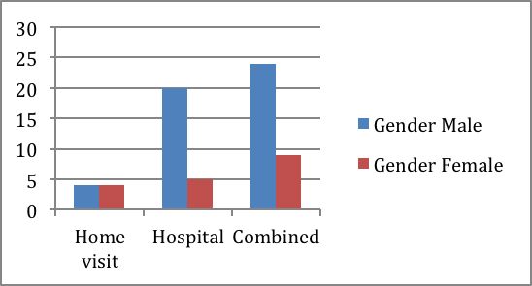
Chart 1: Gender distribution.

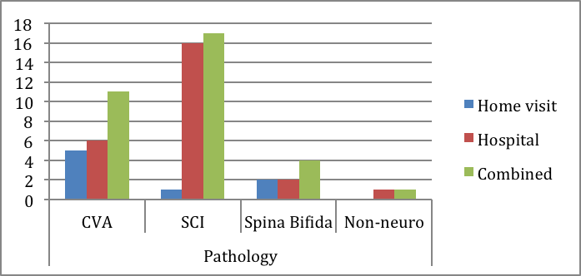
Chart 2: Pathology groups seen

We held lectures at the School of Nursing in Quatre Bornes. We visited the therapy department of Dr Jeetoo hospital in Port Louis and the orthopaedic department of Flacq hospital.

Practical arrangements in Mauritius:
- 02.11.15: public holiday in Mauritius. Chinmaya Mission organised visits to eight patients in their homes.
- 03.11.15 to 06.11.15 and 09.11.15- 10.11.15: outpatient clinics at Ward H3, Victoria (Candos) Hospital, Quatre Bornes.
- 05.11.15: meeting with Senior Officials at the Ministry of Health and Quality of Life
- 04.11.15, 06.11.15. 09.11.15 and 10.11.15: lectures at the School of Nursing, Quatre Bornes.
- 07.11.15: visit to the therapy department of Dr Jeetoo Hospital (Port Louis) and Orthopaedic departments Flacq Hospital.

Clinical findings:
Neurology:
At present, there are no doctors who specialise in neuro-rehabilitation, and consultants who practise rehabilitation in Mauritius told us that they were rheumatologists.

We did not witness the use of the neurological classification for Spinal Cord Injury and alerted doctors and teams to its existence ².

There was no awareness on the issue of autonomic dysreflexia. It is a potentially dangerous clinical syndrome that develops in individuals with spinal cord injury, resulting in acute, uncontrolled hypertension. All patients, carers, doctors, and therapists must be aware of this syndrome, recognise the symptoms, and understand the principles of treatment. In the UK, all high level spinal cord injury patients above T6 carry an alert card with them at all times.

We were surprised that only two doctors turned up to our clinics/ teaching programmes. Surgeons and doctors need to understand that a great ‘surgical fixation’ will lead nowhere if there is no post-acute care in a paralysed patient. Leaving a patient and their relatives to deal with the aftermaths of the paralysis is unkind and an inefficient use of resources. Neuro-rehabilitation cannot be improvised and its skills have to be mastered. The lack of appropriate rehabilitation results in patients not reaching their potential and worse still, developing secondary complications. These complications will eventually require further medical involvement and unnecessary costs incurred.

We presented a film that deals with the comprehensive management of spinal cord injury ‘from injury to return into the community’ ³. Physicians and surgeons would benefit from watching this film. They would understand the principles of multidisciplinary working in spinal cord injury.

Pressure ulcers:
Pressure ulcers are a common and challenging problem for patients with neurological conditions. Reduced sensation in pressure areas can be a significant contributing factor, since the patient may not be able to sense when damage is occurring, and reduced mobility may mean the patient stays in the same position for prolonged periods of time. Prevention of pressure ulcers is an important part of neuro-rehabilitation, since they can cause significant pain and potentially life-threatening complications. Of the patients referred to us and seen in our outpatient clinics, 44% had pressure ulcers (see example fig. 1), the majority of which were severe (grade IV)
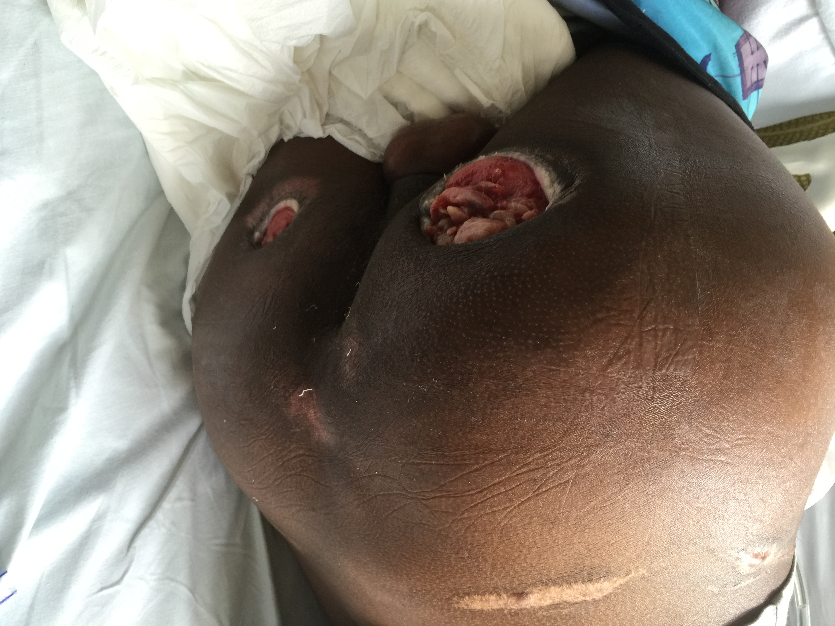
Figure 1. A case of severe
pressure ulcers seen in a patient
at Victoria hospital.
(Used with kind permission of the
patient and their relatives)

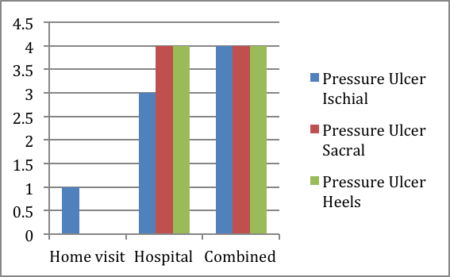
Chart 3: Types and number of pressure ulcers.

Female patients could not be turned on the wards, as female nurses felt that they lacked the physical strength to reposition patients and male nurses were not allowed in female wards.

The patient above (figure 1) was living at home and had not been given appropriate advice and dressings to manage her ulcers. Such pressure ulcers would require hospital management and are likely to be managed by plastic surgery. Complete bed rest is essential until complete healing has been achieved.

In 2012 AS co-authored a chapter ‘pressure ulcers in neurologically compromised patients’ in a book ‘Measurements in wound healing’ ⁴. It sets out the principles in wound management in the neurological disability.

Continence:
Changes in bowel and bladder function can have an enormous impact on quality of life for patients, and inadequate management can not only hinder integration into the community but also lead to further complications, contributing to morbidity and mortality.
Regarding bladder management, the majority of patients surveyed had indwelling urethral catheters; none had suprapubic catheters. Only one patient had been educated in intermittent self-catheterisation. Video-urodynamics testing was not available in any of the hospitals we visited, so it was not possible to properly assess the safest method of bladder drainage for each patient. We understand that viodeourodynamics are available in the private sector.

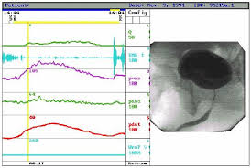
Figure 2. Video-urodynamics
On the right of the picture is the video
showing the contours of bladder and urethra,
and on the left are graphs showing the pressures
generated in the bladder, urethra and abdomen.
This investigation is useful to determine the
safest and most appropriate method of bladder
emptying for patients with urinary incontinence.

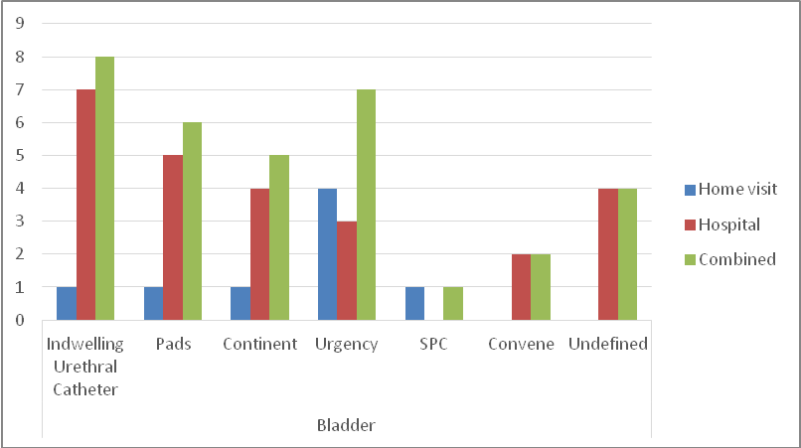
Chart 4: Bladder issues

Bowels:
Most patients had incontinence pads and nurses were not familiar with the techniques of bowel training for the paralysed bowels.
Bowel training is a specialised field and a good resource can be the ‘Guidelines for Management of Neurogenic Bowels’ ⁵.

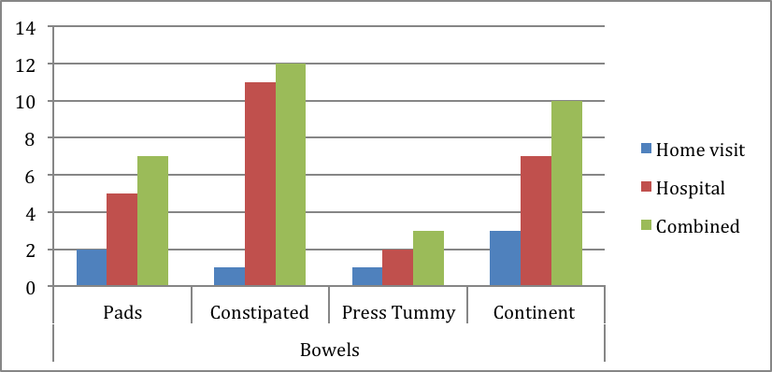
Chart 5: Bowel management

Pain:
For some of the patients interviewed we found that pain was not adequately treated. Management of musculoskeletal and neuropathic pain in patients with neurological conditions can be complex and challenging. It requires a multifaceted approach combining several different types of analgesia alongside physical therapy.

Spasticity:
Spasticity was noted in a few patients. Staff did not routinely evaluate spasticity, and they were not familiar with the use of rating systems such as the Modified Ashworth and Tardieu scales ⁶.
Botulinum Toxin injection was not widely available, and Baclofen is not yet in the hospital formulary for the oral treatment of spasticity.

Contractures
We noted a high level of contractures, as a result of lack of proper rehabilitation and/or management of spasticity. Contractures mostly occur in the skin, the tissues underneath, muscles, tendons, ligaments, and joint areas. It then becomes hard to stretch the joint, thus preventing normal movement.

Communication with patients:
Patients and relatives complained to us that they did not always know which treatment had been provided in hospital. They said that no medical report or discharge summary was given to them. Rarely was diagnosis or prognosis discussed with patients or relatives.

Therapy:
General remark:
Overall, the provision of rehabilitation was piecemeal and uncoordinated. There was only one example of multi disciplinary teamwork for a patient rehabilitated in South Africa.

Physiotherapists and occupational therapists:
Staff at the centres are hard working and eager to learn about new techniques. However, there was a lack of training in neuro-rehabilitation, and it was reported to us that there has not been any in-house training since 1990.
We found that there were not enough trained physiotherapists and occupational therapists to provide adequate therapy sessions to meet patients’ requirements.

Physiotherapists were assigned to the whole hospital rather than specific wards, meaning they often had to delegate care to assistants. They do not routinely provide chest physiotherapy outside of the intensive care setting. Neurologically impaired patients frequently present with severe respiratory compromise. We witnessed a patient who had suffered a CVA and was clearly struggling to clear secretions from his chest whilst he lay in a hospital ward. The consultant told us that they would see a physiotherapist on the ward for a few moments and only for postoperative patients.

Occupational Therapists told us that they are not involved in acute care.

There was lack of knowledge on manual handling of patients both in the hospitals and the community.

We were given copies of the curriculum used to train physiotherapists and occupational therapists and consider that we can make suggestions for the inclusion of a few further learning topics.

There was no documentation of the provision of occupational therapy and physiotherapy in the patients' notes; instead, therapists kept their own records separately, a situation that made them less accessible to other caregivers.

Many expressed a desire to set up a designated regulatory body for occupational and physiotherapy, equivalent to the Health and Care Professional Council (HCPC) in the UK, which would help to provide training and maintain standards within the profession.
Community Rehabilitation Assistants:
There was no evidence of regular input from Community Rehabilitation Assistants. The Community Rehabilitation Assistants’ initiative is good as they are dedicated individuals who were doing their best with limited means. They mainly act as social workers, counsellors but would need further and continuous training. They told us that they had to pay their own transport and use public transport; they therefore could only see a limited number of individuals. Those who retire are not replaced. Their role is expected to encompass that of every member of a multidisciplinary team. They are expected to problem solve for complex and unique situations. They are not trained to the competence level required to be able to manage these situations and nor should they be expected to.

Speech and language therapy:
Patients rarely had access to these professionals, to deal with aphasia or swallowing difficulties. We are unaware of a pathway of care regarding swallowing difficulties. We saw patients on a ward being fed through a thick-bore nasogastric tube and were told that percutaneous endoscopic gastrostomies (PEGs) were not routinely used.

Our input and Continuous Professional Development (CPD):
Initially, we felt that there was some reticence among the therapists to welcome us. Most must have been wondering what we could offer them.

However, as we started seeing patients together and organised lectures, we gained their trust, as they understood the intentions of our team. They became very receptive and keen to ask questions. There is a concern that some staff believe that they know enough and that they have not identified their learning needs to develop their clinical practice. They seem content with the status quo.

The ‘camp’ provided an opportunity for the staff to meet and improve their knowledge, share information about patients and network among themselves. It would be useful to encourage such meetings. They identified this as a very positive and beneficial opportunity.

The ‘camp’ was a most rewarding experience for the ‘expatriate’ staff as we met some lovely people: patients, relatives and staff all united in the desire to improve care for the people with physical disabilities.

Equipment
Wheelchairs
Wheelchairs had fixed armrests, making transfers difficult for people with paralysed lower limbs. Cushions were not provided, so patients sat directly on the canvas of wheelchairs, thus compromising their skin. This factor in itself greatly disabled the individuals from gaining any independence. They have become more reliant on others purely because they cannot get out of bed into the wheelchair. We provided staff with advice on types of wheelchairs available and their use, and showed a film entitled ‘Choosing a wheelchair’ ⁷.
We have offered to prepare national guidelines for the issue of mobility equipment, wheelchairs and cushions.

Transfers
As mentioned above, the fixed armrests on wheelchairs made transfers more difficult. Transfer boards and sliding sheets were not previously available, but we took with us some transfer boards and sliding sheets, generously donated by Inspire Mobility ⁸. Hoists were not available. Most patients we saw did not know how to transfer safely, so we taught staff and patients a few simple techniques to make the process easier and safer.
It would be fair to mention that therapists were not familiar with the concept of patients ‘transferring independently’.

Rehabilitation equipment
Flacq Hospital and Dr Jeetoo hospital demonstrated the use of innovative low-cost technology in the field of rehabilitation. We saw ripple mattresses being used in Flacq Hospital for the prevention of pressure ulcers, and Dr Jeetoo Hospital had reasonably good facilities and provided a good environment for rehabilitation. Dr Jeetoo Hospital was equipped with a hydrotherapy pool, although it did not have any hoist or changing facilities for people with disabilities. We did not see any disabled toilets anywhere within the treatment areas.
The hospital gym had minimal facilities. The lack of equipment meant that the range of activities available to patients was very restricted. At the same time equipment available, e.g. in Dr Jeetoo Hospital was not being used appropriately to maximise benefits. This highlights the question of ongoing training.

From a manual handling perspective it must be highlighted that with a growing elderly and heavier population the need for hoists cannot be ignored. The alternative is to employ lifting teams to assist with moving patients safely. The staff will otherwise risk their own backs or decline to move the patients. Both of these scenarios are unacceptable.

Transportation
Government authorities provided the necessary food and transportation to allow patients to attend our and other clinics. However, many patients had to travel long distances, with one patient changing ambulances twice to reach the clinic. The complex logistics involved mean that patients are not always able to travel to their appointments, and may also have difficulties getting home. None of the patients have access to adapted vehicles, so are completely dependent on ambulances to bring them to clinics. There are limited numbers of ambulances, and a few patients are transported in the lying position, reducing the carrying capacity of the vehicle. A few patients miss their appointments as a result.

Accessibility
During home visits, we found that most houses had steps at the entrance and were therefore not wheelchair-friendly. The interiors were rarely adapted for wheelchair use; floors could be slippery, and corridors were often too narrow for the width of the wheelchairs provided. Kitchens were adapted for patients’ requirements. There were no wet rooms in patients’ homes, and the wet room in Dr Jeetoo hospital did not allow easy access for wheelchairs due to the presence of a step at the entrance of the shower (fig. 3). The purpose of that wet room is to show patients how to build such facilities, so it should not have had any obstacles itself.

Figure 3: The wet room shower at Dr Jeetoo Hospital, showing the step at the entrance of the shower.
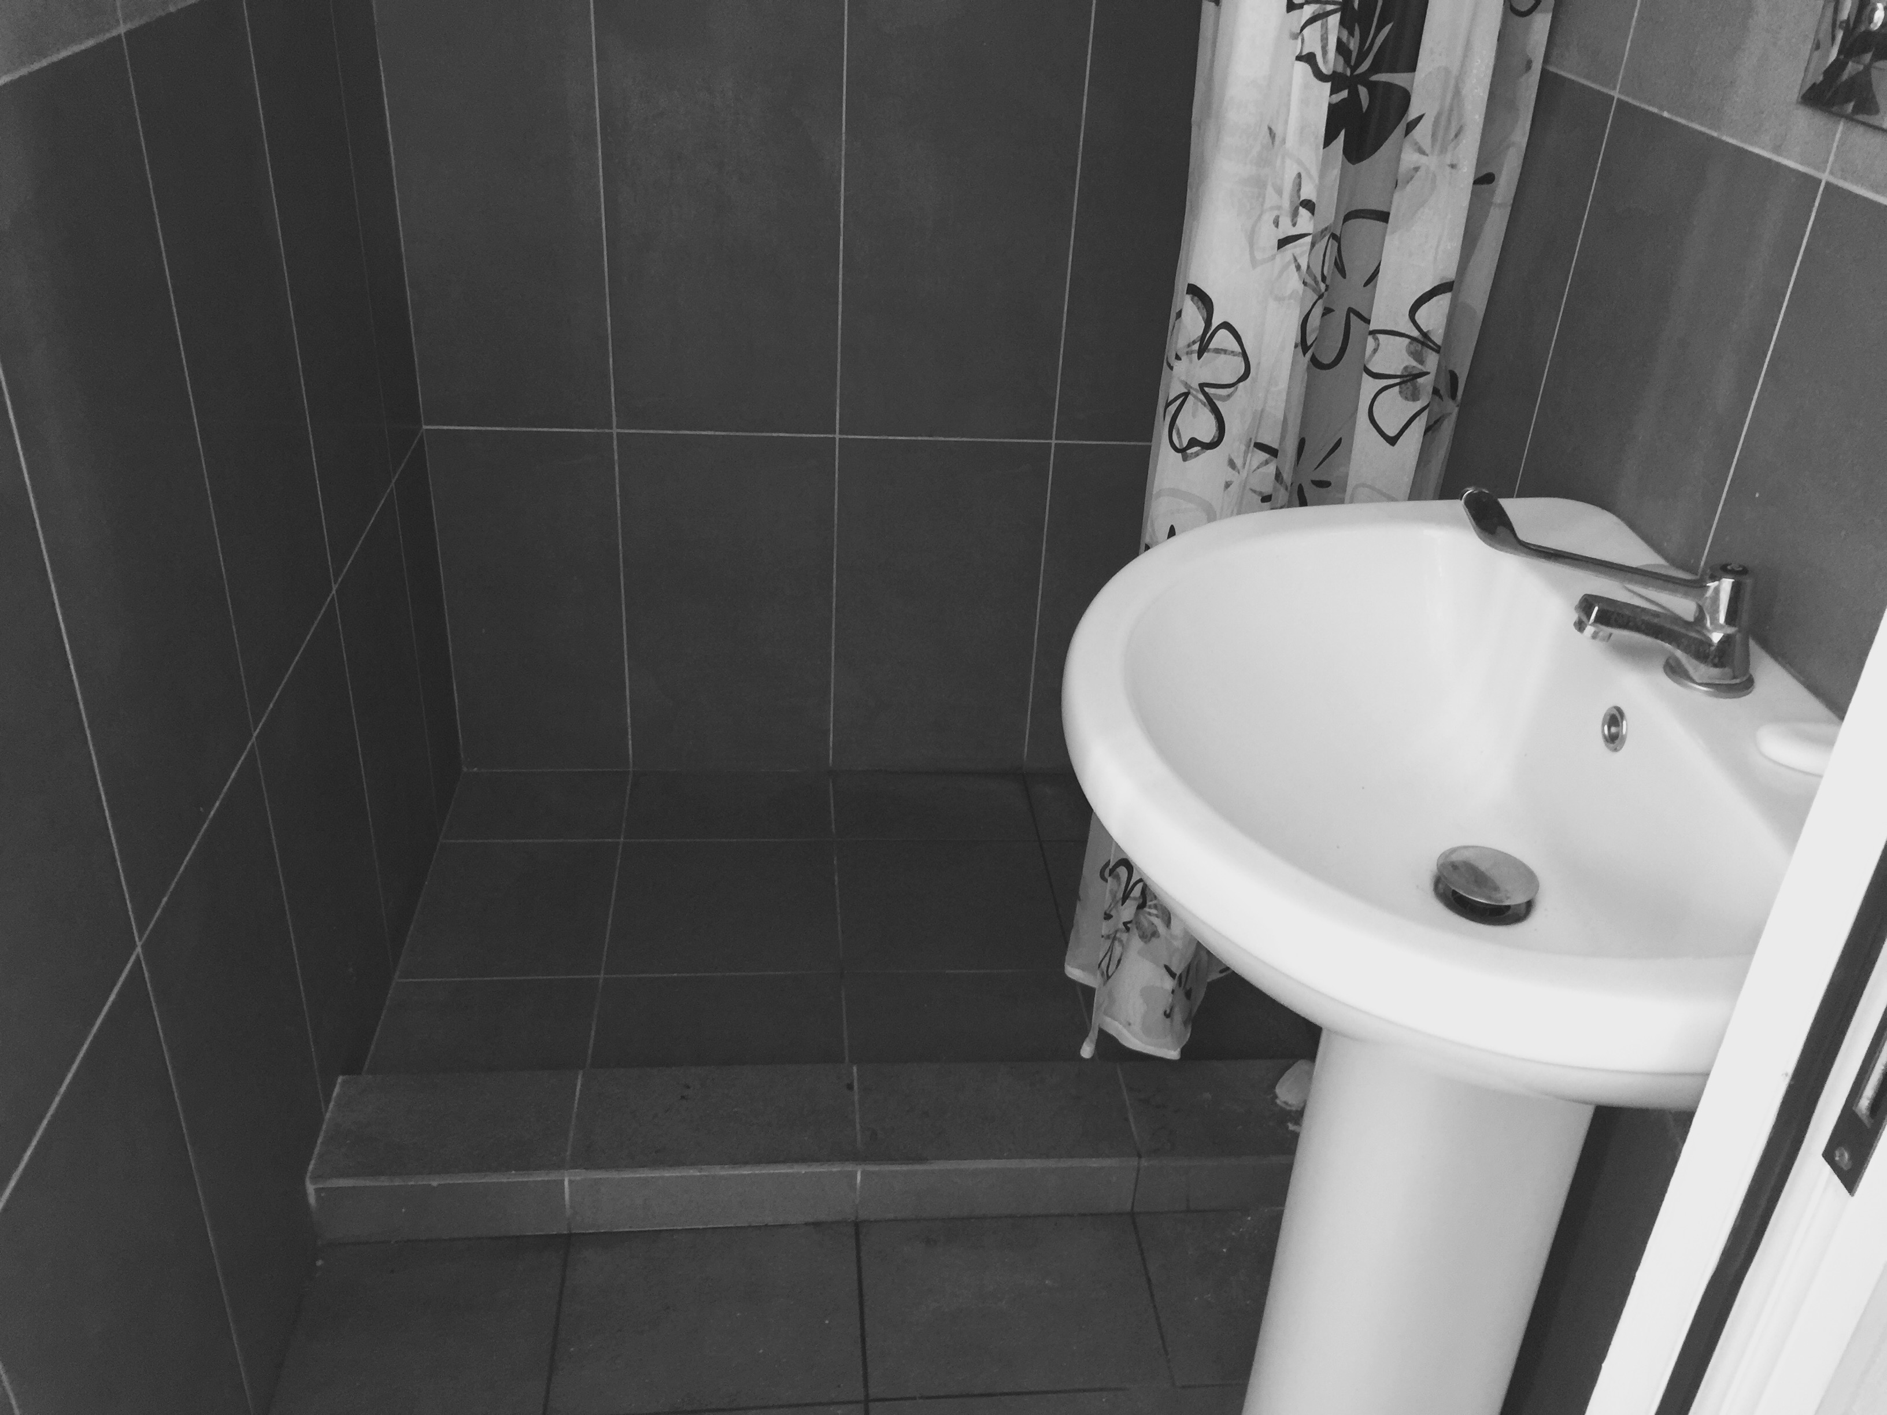

Attitudes towards disability and case studies:

Attitudes towards disability
Patients: they have a poor quality of life, with little scope for re-integration into the community, as there are few job opportunities for them. The environment is hostile to people in wheelchairs: roads and pavements have been designed to accommodate motor vehicles and not wheelchairs. Further, we have not seen a single adapted vehicle that would accommodate a wheelchair.

We found that most public buildings were not wheelchair-friendly.

Patients and relatives were generally grateful for the interest we showed in their struggles and eager to learn to deal/manage the situation. All family members were very co-operative.

Family and friends of patients were very eager to help patients and did all they could for them, but for many patients this ultimately led to a feeling of disempowerment. Most had limited interactions with the community. In view of this, we applaud the young lady who went back to work after her spinal cord injury. However, she did not want to be seen in a wheelchair, and although her level of injury should have allowed her to transfer independently with proper training, ultimately her father had to help her by lifting her into the car or into the chair in her office.
We met a 20 year-old girl with spina bifida who did not want to be seen wearing a catheter bag. She therefore folded it and kept it inside her underpant, which resulted in the urine bypassing the catheter and causing further problems. The majority of patients received good support from their families, although some reported significant tension in the home, probably as a result of the many difficulties they are faced with.

Case Studies:
Case study 1
A 14-year-old boy with Spina Bifida lived on the 3rd floor of his parents’ house. There was no lift, and his family found it difficult to take him downstairs on a daily basis; he was unable to attend school as it was too difficult to carry him there.
We did not have time to visit schools, but were told that there was no facility in mainstreaming physically challenged children to regular schools, due to lack of physical infrastructure.
This young man had significant rehabilitation needs that had not been addressed; we identified kyphoscoliosis and windswept hip deformities, which would have benefited from intervention. His parents were managing his constipation by exerting pressure on his abdomen each day in an attempt to empty his bowels. Lack of expert advice to the parents was sadly missing.

Case study 2
An ex-headmistress of a private secondary school had a stroke in 2010. She had no provision of speech and language therapy from government services, and had no access to communication aids, clinical psychologists, cognitive assessment or gait training. She did not have any splints for her foot drop, putting her at increased risk of falling. We advised her on the use of functional electrical stimulation and dynamic splints for the paralysed muscles, which would improve her mobility.

Actions:
We refer to the policy recommendation in AS’ previous article ⁹ (Box 1).
Based on the findings of the present investigation, we have identified some additional areas for urgent action, as follows:
- Bring more awareness on the concept on interdisciplinary working in rehabilitation.
- Appoint a medical doctor specialist in rehabilitation medicine to inspire change in the country’s healthcare system.
- Initiate a plan to deal with (i) pressure ulcers, (ii) bladder and bowel care and (iii) manual handling and transfers.
- Review the curriculum of training for physiotherapists and occupational therapists.
- Set up an a group across all relevant ministries to raise awareness among healthcare professionals and in the community on the issues of disability, adaptations, accessibility, and the integration of people with disabilities.
- Provide advice on the selection and use of appropriate wheelchairs, cushions, rehabilitation equipment and mobility aids, as well as the importance of studying seating and posture.
- Train patients, carers and staff using the e-Learning platform for remote and face-to-face teaching.
- Improve collaboration between hospital staff and establish multi-disciplinary teams for the management of patients with complex needs.

Box 1: Policy Recommendations (taken from an earlier paper by the author ⁹)
1. In hospitals:
- Allocate more staff to meet patient needs in neurological rehabilitation.
- Develop expertise in neurological rehabilitation for medical doctors and allied health professionals.
- Offer specialist training, refresher courses, and workshops to staff on how to provide quality care to patients and cope with changing needs.
- Set up multidisciplinary teams to include physiotherapists, occupational therapists, speech and language therapists, psychologists, social workers, dieticians, orthopedic workshop staff, and nongovernmental organizations.
- Develop specialist skills that include sensory rehabilitation and swallowing assessment.
- Set up a hospital devoted partly or entirely to neurorehabilitation. All services would be located on the same site. A neurorehabilitation hospital would include treatment facilities (medical and/or surgical, therapy such as gymnasium and hydrotherapy pool, sensory room), diagnostic facilities (electromyography, radiology, swallowing clinic), outpatient and outreach services, and preventative medicine.
- Provide a rehabilitation programme in the community for less severe cases or as a follow-up after acute admissions.
- Develop a good and reliable transport infrastructure for people with disabilities, which should also be appropriately adapted to patient condition. Some ambulances should solely be used for rehabilitation services to make access easier and faster.
- Given the geographical isolation of the island, far removed from all the continents and centres of excellence abroad, encourage communication (live or virtual conferences, visits, distance training) and exchange programmes with institutions providing neurological rehabilitation services abroad.
- Enhance the communication infrastructure to include administrative equipment such as computers, telephones, and fax machines.

2. In patients’ homes:
- Increase the frequency of follow-up home visits by doctors, therapists, and community nurses.
- Customise programmes and leisure activities to highlight personal independence and skills.
- Educate patients and families about their rights and the services and benefits to which they are entitled.
- Subsidise in-cash or in-kind home adaptations for disabled individuals.
- Supply equipment such as specialist beds, backrests, splints, neck collars, chairs with special head support, and walking frames. These should be easily available and not subject to waiting lists; the use of local technology should be encouraged.

3. Within society:
- Encourage hospitals to work in close collaboration with relevant nongovernmental organizations that provide legal and/or social assistance to people with disabilities, thereby facilitating a smoother transition back into society, and with those that focus on the prevention of accidents and diseases as well as the promotion of health.
- Raise awareness and educate the general public about the social and economic impact on people suffering from neurological accidents.
- Comply with United Nations standards such as provision of disabled access features to all new public buildings and public spaces and free and reserved parking.

4. Encourage monitoring, evaluation, and research in this particular area:
- Encourage institutions to share data for more effective monitoring and planning for neurological conditions in view of setting up a central database for stroke, SCI, and TBI.
- Provide controlled access to such information to researchers and university students with an interest in neurological rehabilitation.
- Evaluate programmes systematically to ensure the effectiveness of the measures taken.

Conclusion:
This mission has confirmed that there are huge unmet needs in the field of neurological rehabilitation in Mauritius. The project provided an opportunity for the staff to meet and improve their knowledge, share information about patients and network among themselves. It would be useful to encourage such meetings.
Neurological rehabilitation is founded on the concept that disaster, when it strikes, should not signal a slow end to one’s life. Appropriate medical, rehabilitation and pastoral care can transform an unfortunate event into a different but equally meaningful life. We should aim to provide the infrastructure for that challenge.
A Memorandum of Understanding will define the roles of the different partners in an attempt to improve the delivery of care in neuro-rehabilitation in Mauritius.
Together we can make a change in the lives of those affected by neurological disabilities.

Conflict of interest:
There was none. Affinity Care Management UK (Mr Chris Bialan, Chairman) www.affinitycm.co.uk, and Premavani Medical Ltd www.anbasoopramanien.com
sponsored the trip. Chinmaya Mission Mauritius http://www.chinmayamission.com liaised with the Ministry of Health and Quality of Life.

Appendix 1:
1. The team consisted of:
- Mrs Shiva Jamwal (SJ), Lead Occupational Therapist, Royal Buckinghamshire Hospital, UK
- Mrs Jeanine Moeri Brandalise (JMB), Senior Occupational Therapist, Geneva, Switzerland.
- Miss Sunanda Padaruth (SunP), Senior Sister Imperial College, London, UK
- Mrs Sue Paddison (SueP) , Lead Physiotherapist, London Spinal Cord Injury Centre, Royal National Orthopaedic Hospital, London, UK
- Mrs Pakyam (Devi) Pillay (PP), Senior Nurse Manager, Imperial College London, UK
- Professor Anba Soopramanien (AS), Consultant in Spinal Injuries and Rehabilitation Medicine, Royal Buckinghamshire Hospital, Aylesbury, UK
- Mrs Kamachee (Veda) Soopramanien (KS), Administrative Co-ordinator, UK
- The CVs of the team are presented in Annex 1.
- http://www.iscos.org.uk/sitefiles/International%20Standards%20Worksheet.pdf
- The Outreach film can be downloaded from:
www.spinalinjurycentre.org.uk
- Soopramanien A Singh S (2012): ‘Pressure ulcers in Neurologically compromised patients’ in Measurements in Wound Healing- Science and Practice. Eds Raj Mani, Marco Romanelli, Vijay Shukla 397p. Springer Verlag 2012 ISBN 978:1- 4471-2986-8
- Bowel management:
www.rcn.org.uk/__data/assets/pdf_file/0019/253036/CV453N_full_doc
http://www.mascip.co.uk/wp-content/iplaods/2015/CV653N-
Neurogenic=Guidelines-Sept-2012.pdf
- Spasticity scales
www.rehabmeasures.org/.../ModifiedAshworthScaleInstruct…
or the Tardieu www.rehabmeasures.org/Lists/RehabMeasures/DispForm.aspx?ID=1038
- About wheelchairs
www.choosingawheelchair.com
- www.inspiremobility.co.uk/
- Soopramanien A. (2012) ‘Mauritius calling: medical care and neurorehabilitation needs in an oceanic idyll’ in Arch Phys Med Rehabil 2012;93:2377-81

Appendix 2:
CVs

Mrs Shiva Jamwal
(Occupational Therapist/ Case manager)

EDUCATION
- Bachelors of Occupational therapy (4 ½ year programme)
Manipal academy of higher education, India 1998-2003
- Six months internship 2002-2003
Kasturba Medical College, India
Indian Spinal injuries centre, India
- Oxford Brookes University 2012-2013
Post graduate certification, posture management in complex disabilities
- MSc Health management , Leadership and Strategic development -ongoing
City University London

PROFESSIONAL MEMBERSHIP:

Health and care professional council, UK & Ireland
Associate member, Asian Spinal Cord society

WORK EXPERIENCE
11 years of work experience in private and statutory sectors.

Clinical Lead August 2013 till present
Royal Buckinghamshire Hospital, Buckinghamshire UK

I work as Lead Occupational therapist where my role is to provide management and leadership to the occupational therapy department and the associated members of the rehabilitation team. As a clinical lead to the inpatient / outpatient spinal injury and neurological rehabilitation team, I co-ordinate the functions of the team, taking lead role in developing and implementing strategic and operational improvements to the rehabilitation services.

Case Manager January 2013 till present
Spinal injury unit, Royal National orthopaedic hospital, NHS UK

Providing Case management services to individuals following catastrophic injury. My work includes accurate assessment of patient needs and liaising with relevant professionals, equipment companies, and housing and care agencies to ensuring smooth discharge into the community, often within tight time constraints.

Freelance Occupational Therapist 2012 till present
Partner SpinalNetwork

I run SpinalNetwork Company which provides private, domiciliary therapy services primarily to individuals with complex neurological conditions .My work includes hand therapy, posture and seating assessment, assessment of activities of daily living, advice on environmental adaptations and recommendations for specialist equipments.

PAST WORK EXPERIENCE

Senior Occupational Therapist 2012-2013
Bucks neuro-rehabilitation services, Amersham, Buckinghamshire UK

Working on the stroke and neuro rehabilitation unit, I provided occupational therapy rehabilitation to individuals, using specialist neurological and Bobath approaches .My job involved preparing patients for discharge and community re integration liaising with family members and relevant teams in the community and social services.

Clinical Specialist 2007- 2012
Royal Buckinghamshire hospital, Aylesbury, Bucks, UK

The job was to provide highly specialist Occupational Therapy assessment and intervention including wheelchair and seating assessments. functional electrical stimulation, hand therapy including splinting, functional rehabilitation and prescription of equipment. I set up and successfully ran posture and seating clinic which involved business planning, budgeting, setting up clinical guidelines, writing policies and training staff to deliver the services. My job involved recruitment and induction of staff; departmental audits and developmental plans; preparing business plans for the department, making standards and policies for OT department and seating clinic.
Senior I occupational therapist 2006 - 2007
Musgrave park hospital, NHS Belfast, North Ireland

The job involved caseload of adult and paediatric orthopaedic patients. My role involved discharge planning, home assessments and liaising with community OT, other professional voluntary and statutory groups as required .I worked with carers and family to provide support and advice related to equipment needs, home adaptations and practical management of the patients home. I participated in setting Standards of Practice, monitor and evaluate treatment methods; audit research and evidence based practice. I was responsible for the maintenance of equipment and assessing the need of new items for the department.
Occupational Therapy Consultant (Volunteer) 2005- 2006
Sharjah City of humanitarian services, United Arab Emirates

The job was to provide specialist Occupational therapy advice to ‘Early Intervention Centre’ dealing with multiple physical disabilities in children and adolescents. I was involved in health promotion, organizing and conducting care giver education programs and awareness programmes to the local communities on disability and its management. My job responsibilities included-providing specialized skills for functional independence; advice on assistive aids; advice on home programs and to provide recommendations on home adaptations.
Occupational therapist 2003 – 2005
Indian Spinal Injuries centre, India

This was an opportunity to work in areas of acute neurology, neurosurgery including neuro ITU, spinal injuries, orthopaedics, and paediatrics. I was instrumental in patient education initiatives and community awareness programmes .I was involved in carer education and training as a part of community re integration initiatives by the Centre.

Mrs Jeanine Moeri Brandalise
I studied Occupational Therapy (OT) in Switzerland and spent the last 15 years as an OT in a multidisciplinary team working in the community setting ( Association Vaudoise d'Aide et de Soins à Domicile).
The clients are mainly adults with physical, cognitive and mental disabilities. Our role is to make them as independent as possible in activities of daily living and improve the quality of their lives. Apart from my professional and paid work, I dedicate some of my time volunteering for an Association for Multiple Sclerosis (MS) by participating in camps, meetings and assisting them in activities of daily living.
Previous attachments as an OT were in Switzerland (Pediatrics and General Hospital), Egypt (in a rehabilitation home for children suffering from sequelae of Poliomyelitis and other physical traumas) and Pakistan (Rehabilitation Centre for patients with Spinal Cord Injuries). I also lived for several years in Zimbabwe, South Africa and Kenya and travelled for months in Asia and Croatia.
Living and working away from my home country has made me understand and appreciate cultural diversity. My training as an OT, a "sense of fairness" and a need to assist vulnerable people made me look for work in different cultural and social environments. I bring the experience gathered over the years to the Neuro-Rehab Camp in Mauritius.
I believe in the importance of community rehabilitation and enjoy working in a team that puts the interest of patients first and offers support to their caregivers and relatives.

Miss Sunanada PADARUTH, RGN, Dip. Critical Care
I am a nursing sister with over twenty five years’ experience. I trained and worked as a nurse in Mauritius from 1987 and moved to the UK 13 years ago. I have a post graduate qualification in critical care and renal nursing.
I am currently working as a renal high dependency sister at the Imperial College Healthcare Trust (London, UK), formerly Hammersmith Hospital NHS Trust.
As one of the nurses in charge of a high dependency unit my role is to make sure that all the patients receive adequate medical and nursing care during their stay. Patients’ safety is paramount and nurses act as their advocates. We make sure that we prepare them for a safe discharge home, and provide support to families and friends.
My experience in neurological rehabilitation centres on stroke patients with end stage renal failure. I am part of a multi-disciplinary team comprising of physiotherapists, occupational therapists to provide optimal care to these patients.
London, being a multi-ethnic society, provides me with the opportunity of dealing with the diverse cultural needs of patients under our care.
I take part in the formal and informal training of nurses and other healthcare professionals in my field of expertise.

Mrs SUE PADDISON M.C.S.P

Lead Clinical Specialist Physiotherapist in Spinal Cord Injuries, London

I am employed as Lead Clinical Specialist Physiotherapist in the London Spinal Cord Injuries Centre at the Royal National Orthopaedic Hospital Trust, Stanmore, having commenced this role in 1993. I now work in this NHS role part time.

The London Spinal Cord Injury Centre is one of the national specialist Spinal Cord Injury Centres, offering comprehensive experience working with adults and children with spinal cord injury, from the acute stage immediately post injury through the early rehabilitation and onto reintegration back into the community. The Royal National Orthopaedic Hospital NHS Trust (RNOH) is the largest orthopaedic hospitals in the UK, and is regarded as a leader in the field of orthopaedics both in the UK and world-wide. It provides a comprehensive range of neuro-musculoskeletal health care, with a broad range of services that is unique within the NHS.
As a national centre of excellence, the specialist units provide wider experience working with peripheral nerve injury and brachial plexus management.
Our patients benefit from access to ASPIRE leisure centre which is located on site and hosts first-class facilities for able-bodied and disabled people.

Teaching and clinical effectiveness are enhanced by the work in research and development and academic links with University College, London. Research departments at Stanmore include the Institute of Orthopaedics, the Centre for Disability Research and Innovation, the Institute of Human Performance and the Centre for Biomedical Engineering.
I am involved in cutting edge developmental practice and research in order to support the evidence-based service. I work in an interdisciplinary culture based on a patient focused goal planning approach.
I have regular commitments to teaching at undergraduate and postgraduate level. I have lectured nationally and internationally to diverse professional groups, as well as presenting papers at conferences and meetings relevant to my specialist field. I have published chapters in several Neurological Physiotherapy textbooks. My main area of research and specialist interest is in Functional Electrical Stimulation in neurological rehabilitation. I am currently involved in a research project involving this technology and recently won an award for a scientific poster related to this work.

I worked with a colleague over the last year, to develop a training package on behalf of Handicap International and UK Aid. We have created a practical skills training day as well as presentations and patient information leaflets. The teaching package contributes to a comprehensive programme of training for UK professionals who will work in humanitarian settings following conflict and disaster.

I work as a consultant physiotherapist with the Rugby Football Union Injured Players Foundation charity to support spinal cord injured players in their on-going care in the community.

I am a member of a highly specialist multidisciplinary team, Complex Neurological Consulting, providing holistic assessment of spinal cord injured individuals, following discharge from inpatient rehabilitation.

I believe that it is important to provide opportunities to explore new technologies and developments that will be of benefit to our patients, in their life long physical management.

I act as an expert witness in the medico-legal context, providing reports in the physiotherapy management of spinal cord injuries and peripheral nerve injuries.

I am member of several clinical interest groups to support my specialist role including the Association of Chartered Physiotherapists in Neurology (ACPIN), Multi-Disciplinary Association of Spinal Cord Injury Professionals (MASCIP), Association of Orthopaedic Chartered Physiotherapists (AOCP) and The International Spinal Cord Injury Physiotherapists Network (ISCIPT Network). I am Chair of the UK & Eire Spinal Cord Injury Therapy Leads (SCITLs)

Mrs Pakyam (Devi) Pillay, RGN Diploma in Adv. Phys. Ass.
I am a Clinical Nurse Specialist. I trained and worked in Mauritius from 1987 to 2001, when I moved to the UK.
My first job was at Ramsay Healthcare New Hall Hospital, Salisbury and I became the Lead Nurse in the Surgical Pre-assessment Department. I was involved at a national level in formulating care pathway policies and guidelines, for the Ramsay group.
I am currently working as a Cardiothoracic Pre-assessment Sister at Imperial College Trust (London, UK), formerly Hammersmith Hospital.
Specialist nurses take a leading role in making sure that patients receive the best care in the hospital. To achieve this we need to understand patients’ needs, design and implement care pathways, and offer fairness and compassion.
I worked in Neuro rehabilitation in Acquired Brain injury at Glenside Neuro Rehabilitation Hospital in Salisbury. I learnt about transfer techniques, positioning in bed, bladder and bowel management. I look after the skin: prevention and management of pressure ulcers. I would be delighted to share my experience with colleagues in Mauritius.

Professor Anba Soopramanien MD, PhD, FRCP
Honorary Consultant in Spinal Injuries and Rehabilitation Medicine Salisbury, Visiting Professor University of Bournemouth
Specialty: Spinal Cord Injuries. Acquired Brain Injuries and Neurological Rehabilitation

Special interest:
- Neurogenic Bladder
- Community-based rehabilitation with the use of technology

I trained and worked in France (Bordeaux, Amiens and Paris), and the UK (Stoke Mandeville, Stanmore, Lincoln and Salisbury).
I worked for five years in rehabilitation and spinal injuries, with the International Red Cross Movement (Pakistan and Romania).
I was a substantive Consultant with the NHS in Lincoln and Salisbury (UK).
In 2009, I retired from working as an NHS Consultant at the Salisbury Spinal Centre.
I then worked as a Consultant (mainly brain injuries and spinal cord injuries) in a private Neuro-Rehabilitation hospital from 2009-2013. I became Director of Rehabilitation in an outpatient setting (2013-2015).
In January 2015, I joined The Royal Buckinghamshire Hospital’s Consultant team.
My research activities centre on Telemedicine in Neuro-rehabilitation, and the provision of neuro-rehabilitation in the third world.

(Mrs) Kamachee (Veda) SOOPRAMANIEN,
‘Higher Diploma’ de INALCO (Institut NAtional des Langues et Civilisations Orientales), ‘Women in management’ Salisbury College (UK).
I left Mauritius at the age of 17 and did my ‘baccalaureat’ in Lycee Sophie Germain in Paris.
My interest in social anthropology and Tamil Culture led me to read for the 4-year-course, Higher Diploma at INALCO (Universite de Dauphine, Paris).
In Peshawar (Pakistan), where my husband Anba was working for the International Committee of Red Cross (ICRC) during the Afghan war, I was co-founder of a European School. I taught expatriate and Afghan children aged 5 to 12 and the syllabus used was based on the European School curriculum.
Anba’s next posting was Romania with the International Federation of Red Cross, and I worked as a volunteer social worker in ‘Georg Marinescu Hospital’ and coauthored a paper in our experience ¹.
After returning to the UK following our postings abroad, I became a full-time wife and mum, although I did take time off to learn the skills of being a manager. I then became co-director of a private limited company that my husband and I set up: Premavani Medical Limited. I am its co-Director and Administrative Coordinator.
I am delighted to help with the logistics for the Neuro-rehabilitation Camp.
1. “A Soopramanien¹ and K Soopramanien² (1995) ‘A medico-social survey of Romanians with spinal cord injury’ in Paraplegia (1995) 33, 49–54; doi:10.1038/sc.1995.12
- ¹ Formerly Team Leader, Spinal Injury Project Bucharest, Romania.
²Volunteer Social Worker, Spinal Injury Project, Romania from 1991 to 1993.”

