YOUR 4 DENIM STAPLES

THE DENIM JACKET  If you’re looking for anything versatile in your wardrobe, then the denim jacket is the way to go!  You can wear it over any outfit, any season and any time of the day no matter the occasion.  This goes for stylists  · White T-shirt mixed with a checked shirt is a basic way of rocking the “jeanious” item when taking a walk in the park.  · Guys can wear it to work with dark jeans, a nice structured shirt and even a tie. Ladies! A dress with bold colours is good for a good work day.  · Earthy colours are awesome for accessories… gold jewellery, brown, rust or nude bag and brown or black shoes. | 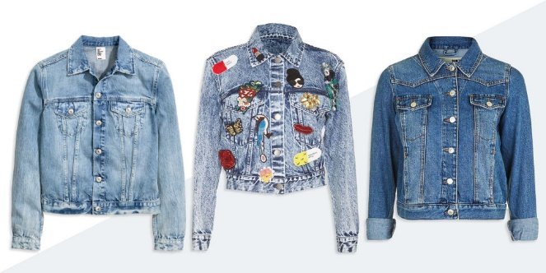
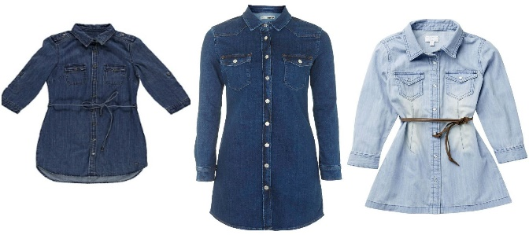 | THE DENIM DRESS  · No styling is needed on this one; just add accessories and we’re ready to go.  · I’m loving brown shoes and bags this season… not forgetting to top it all up with a cute black hat.  · Gold is perfect for the night, glamming up the denim dress.  ·Or you can go for bold colours if you’re happy and you really wanna show it off!
THE DENIM DUNGAREE  · A lot of people make this trend look very tricky, but really the key here is just a great fit (no oversized, no too tight) and light layering.  · For both ladies and gents, black and white horizontal stripes are basic.  ·The checked shirt gives it a really cool Country feel… From there? Well the rest is up to you. | 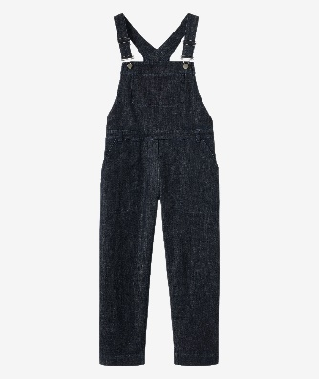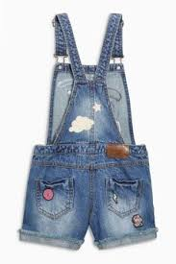
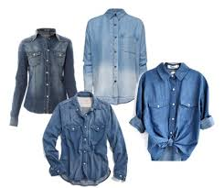 | THE DENIM SHIRT  · Day time, night time…. Dressed up, dressed down, the denim shirt is ready to go!  · Two toned, dark or blue, there is just nothing a welcoming denim shirt can’t do in the world.  · It can even turn into a nice light jacket if you want it to be!

