Assignment: Mysterious Political Decoy Cases
Client: SWAMP Media
January 13th, 2017
Published Here: https://theswamp.media/mysterious-political-decoy-cases

German Folklore Amid the Most Mysterious Political Decoy Cases in History
We have all seen that person on the street that strikes an eerie resemblance to either ourselves, or someone we may know. Wondrous appearance similarities have dazzled many minds throughout time, and the phenomenon has even coined its own phrase, Doppelganger; a German phrase that translates to “double goer.”
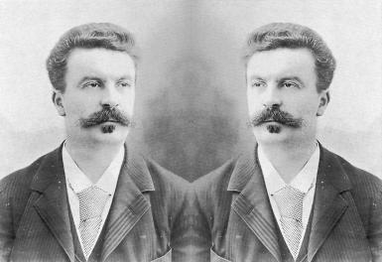
The Doppelganger first arose in German Folklore in the late 18th Century, and was described to illuminate a double being. It can be noted that the Doppelganger was not a ghost, but a second self, one that existed on another plain of existence, or another dimension. Although based from German Folklore, the Doppelganger has entertained our minds, and curiosity, for centuries. Most people find it humorous, and entertaining, to see someone who strikes an almost twin-like resemblance to themselves, or a friend. Nonetheless, the Doppelganger has found its way into various nations’ governments, as many scholars and historians have suspected that it to be used as a political strategy.
In some cases, the Doppelganger has allegedly been used to protect a nation’s leader, or to confuse the enemy in war fare. However, the creature of German Folklore has also found its way into elaborate cover-ups, and riddles itself through many conspiracy cases; putting into creation some of the most mysterious political decoy cases in history.

The Top 5 Most Mysterious Political Decoy Cases in American History
It is hard to turn one’s head when observing numerous mysterious political decoy cases in U.S. history. Although the various cases are “alleged” for “security reasons,” the stories strongly hint at a truth, hiding behind a mask carved from the classic ideal: too strange for fiction. We will explore some of these cases, starting from the most recent, to the oldest cases of what might be known as one of the oldest tricks in the book: The Political Decoy.

Number 1: Barack Obama
Barack Hussein Obama II served as our 44th president. With his presidency, Obama claimed the title of first African-American president, and as of recently, has been confirmed to be the first president of the United States that was born outside of the country. Although Barack represented a “new America,” many of his political strategies corresponded to some of the oldest political tactics, one being the political decoy.
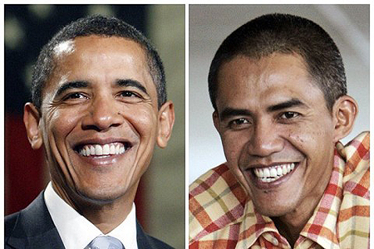
One can observe the information leek of this political scandal in, Making a Living as a President Barack Obama Body Double. In this interesting article, The Guardian gets together with Ilham Anas. Anas not only appeared on television to share the story of his estranged job, but he brought cameras into the actual process which took place when he would “go to work.” Even though the evidence is overpowering, and has become a reality for many, the Obama Administration stands strongly by their vow of silence and denies such activity. Thus, this account remains one of the most mysterious political decoy cases to this day; even though the solid evidence is staggering.

Number 2: George W. Bush
Former to Obama, George Walker Bush served as our 43rd president for two terms. His family roots are deeply rooted in the American political system, as G.W. Bush was the oldest son of former president, George Bush Senior.
G.W. Bush upset many nations while he was in presidency, with his eagerness to enter war, and with his direct reluctance to the requests from the United Nations. Anger rose amongst the American Citizens when legal documents such as The Patriot Act were being implemented into effect during his time spent in office. In short, George W. Bush was not that of a very adored man.
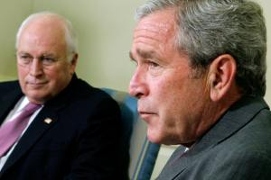
It has been questioned and assumed with minimum doubt that former president, George W. Bush used many Doppelgangers to his protective advantage. Bush’s administration had a knack for keeping information sealed tight within their confinement, so many have certainly assumed that this mysterious political decoy case is indeed fiction.

Number 3: Henry Kissinger
The ruthless genius held by Henry Alfred Kissinger was perceived as national treasure in the early 70’s, and his role as a top National Security Advisor, without question, put a price on this man’s life. To kill Kissinger, to rival nations, was to snip a dire piece off the mechanical brain power of America.
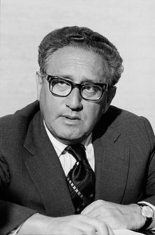
In 1971, Kissinger had “attended” a meeting in China, one that was so top secret, that the nature of this meeting was to be sheathed from the public. However, as it does, word quickly got out, and before long, it was known to the masses that Kissinger attended this meeting. Or did he?
It has been documented that no one could approach Kissinger during his stay in China, as security would not let anyone within his diameter. It has also been rumored that one of Kissinger’s top aides claimed that Kissinger used a double for the visit to China, presumably explaining why no one could get near the national treasure. This behavior, viewed as suspicious to many, has kept this case alive as one of the most mysterious political decoy cases in American History.

Number 4: John F. Kennedy
John Fitzgerald Kennedy gave the nation hope when he was elected in 1960 as the 35th president of this proud nation. John Kennedy brought truth to American Politics, and by doing this, the citizens of America adored the new face of hope. However, behind closed doors in Washington, Kennedy had disrupted the patience of many powerful organizations; the military being one. The disaster in Cuba, during the Bay of Pigs infiltration, amongst rumors of Kennedy wanting to pull out of Vietnam essentially put this man’s life in danger. This danger became internationally prevalent in 1963, as our nation watched in horror, their face of hope being publicly murdered in Dallas, Texas.
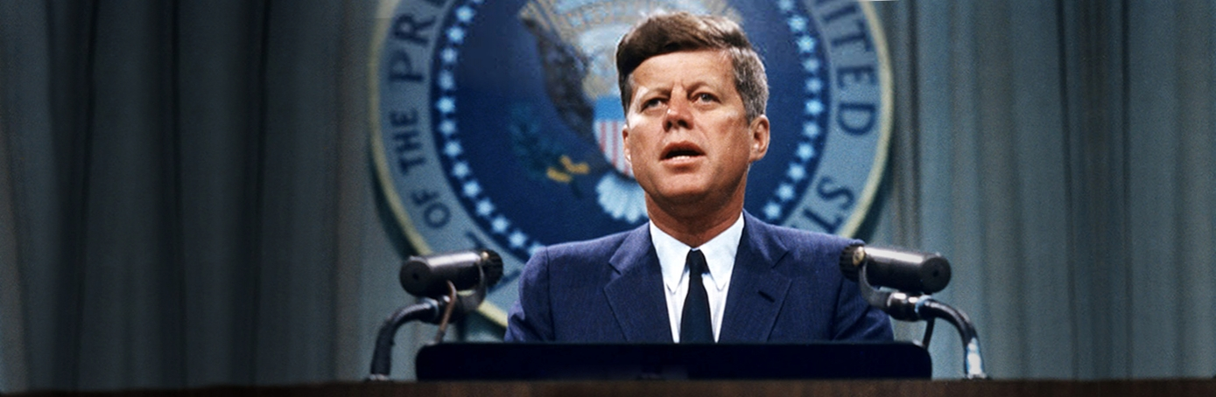
An interesting interview with Howard Brennan, a witness to the murder of former president Kennedy, said something very strange to news reporters. Brennan explained that “The man standing there was the exact double of the late president,” as he recalled an encounter that he had with an agent who “allegedly” acted as Kennedy’s double. Facts have not yet solidified this mysterious political decoy case, as over time, the account has drifted from report to legend.

Number 5: Lee Harvey Oswald
To further the Kennedy assassination discussion, Lee Harvey Oswald’s role in the tragedy remains a prominent question to this very day, and some have deeply queried if Oswald was the one who pulled the trigger.
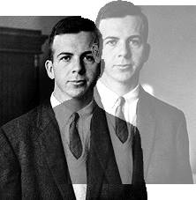
Many stories have circulated the Kennedy Assassination. Conspiracies and “alleged accounts” riddle themselves throughout this historical tragedy for our nation. One story is that Oswald was unsuspecting to what belay in his future. Oswald claimed that he was just watching a movie, and when he came out of the theatre, police swarmed him. It is very possible that Oswald had been set up as a patsy, and that the true killer was an agent of some kind. The debate still cannot place the source of the agent, as some have muttered that the Mafia was responsible, while others say it was the Russians. Tales have been told that the Military was the culprit, or that the CIA played out the assassination for political interests. Stories aside, Lee Harvey Oswald, is by far one of the most controversial and mysterious political decoy cases known to America History.

The Top 5 International Most Mysterious Political Decoy Cases
Mysterious political decoy cases are not just limited to U.S. borders, as they have sprung up internationally within the fibers of time. In the following, we will briefly observe and explore some of these famous cases; cases that today are still, you guessed it, “alleged.”

Number 1: Adolf Hitler
Adolf Hitler rose to power in Germany during the year of 1933. Hitler led the Nazi party, which overcame Germany’s government shortly after World War I. The country had been devastated with destruction during World War I, and Hitler used this national depression to his advantage. By preaching power to the Germans, few citizens truly new of what the Nazi Party represented to the rest of the world. The coming of Adolf Hitler brought the coming of World War II, when the world joined forces to stop the immensely growing force known as The Nazi Party; a force that was spreading through Europe like a wild fire.
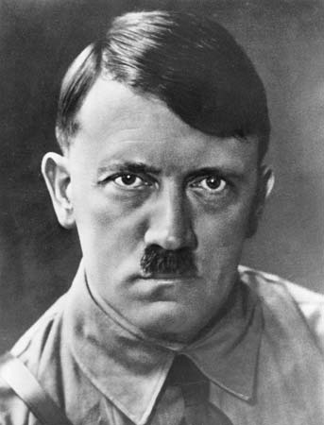
One thing is very certain: Hitler was very paranoid. It has been rumored that he had up to six doubles, but fear governed the people’s inquiry of such a fact. However, the assassination of Gustav Weler brought this political myth alive. When military ally forces found the body of Weler, they were certain that it belonged to Hitler himself. The uncertainty of this feeble documentation continues to make Hitler’s Doppelganger one of the most mysterious political decoy cases even in the realm of today.

Number 2: Joseph Stalin
Joseph Stalin arose to the leader of the Soviet Union. The security that encompassed this man exceeded most any other politician in the world, and as Stalin was a political target by many countries, incognito was game that Stalin played all too well. History has suggested that this political leader had two political decoys.
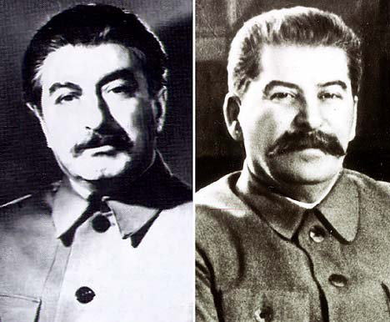
In 1953, following Stalin’s death, one of these Doppelgangers came out into the public’s view, as the man, who was only addressed as “Rashid,” had been spotted and identified by KGB officials as being a decoy. Once again, the term “alleged” surrounds this case.
However, Felix Dadaev, was given the green light to share his tale by the Putin government, and, in 2008, wrote a most peculiar book. His work illuminated his time spent as a political decoy for Stalin in the 20’s, and corresponded with the agreeance that Stalin used a double; possibly two. This book has stifled one of the most mysterious political decoy cases in the world. Or did it?

Number 3: Saddam Hussein
The fifth president of Iraq, Saddam Hussein Abd al-Majid al-Tikriti, was known to be very keen and careful with his daily operations. Hussein evaded U.S. forces for nearly five years, but then was captured and executed in 2006. To the dismay of the U.S. Military, during past conflict with Iran, American CIA had trained Saddam to fight as an ally. This facet of Saddam Hussein made the man nearly impossible to terminate.
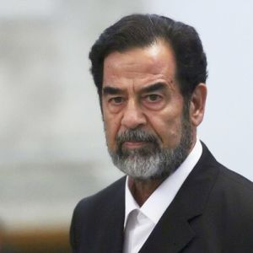
With many tricks up his sleeve, Hussein was called out internationally by a German television network, ZDF Broadcast, for one of the oldest political tricks known. They claimed that many of his television debuts were not of him, but of various Doppelgangers acting as doubles. Curious minds continued to further investigate these allegations, and many of them became convinced that the assumed allegations were true. Nonetheless, the accusations remain “alleged,” thus, remaining another one of many mysterious political decoy cases.

Number 4: Fidel Castro
Fidel Castro rose to power in 1956, formerly being a Communist revolutionary. He maintained his role as Cuba’s Prime Minister until 1976, where he switched roles to becoming the nation’s president. America and Cuba have always been in quarrel, up until recently, as the Cuban government was always backed by America’s enemy, the Communist Soviets. It is no secret that many attempts were meant to “terminate” Fidel Castro during the Cold War period; a grueling window in history that had the entire world on the edge of their seats, or under their table.
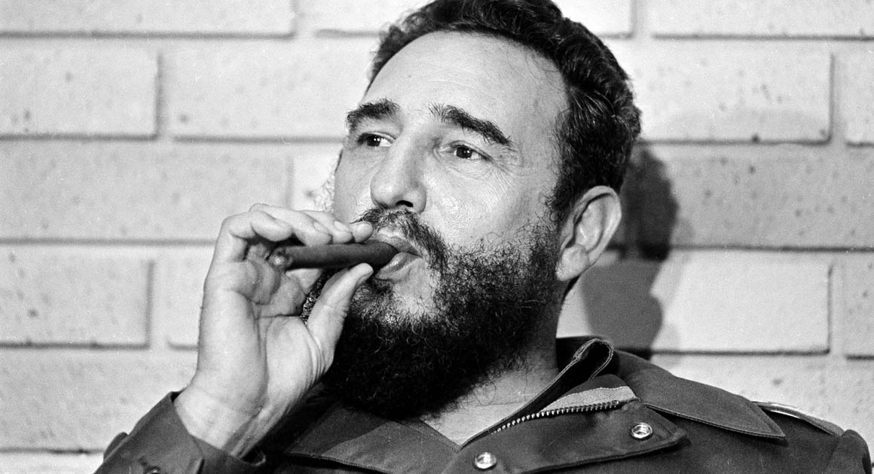
Juan Reinaldo Sanchez, Castro’s personal bodyguard of 17 years, came out to the public and revealed many dark secrets behind Castro’s regime. One secret was that Castro did, indeed, use decoys to avoid assassination. Today, although widely accepted as truth, the story still maintains its label as “alleged,” adding yet another tale to the vast list of mysterious political decoy cases.

Number 5: Osama Bin Laden
By far one of the most wanted men in America, or he was, Osama Bin Laden was assumed to be the leader of the terrorist group Al-Qaeda. He was accused and convicted for terrorism shortly after thousands of Americans died when the Twin Towers crumbled in 2001. Other conspiracies correlate to this tragic event, but overall, Bin Laden was held responsible; making him America’s most wanted for nearly a decade. It would not be surprising if Bin Laden used doubles.
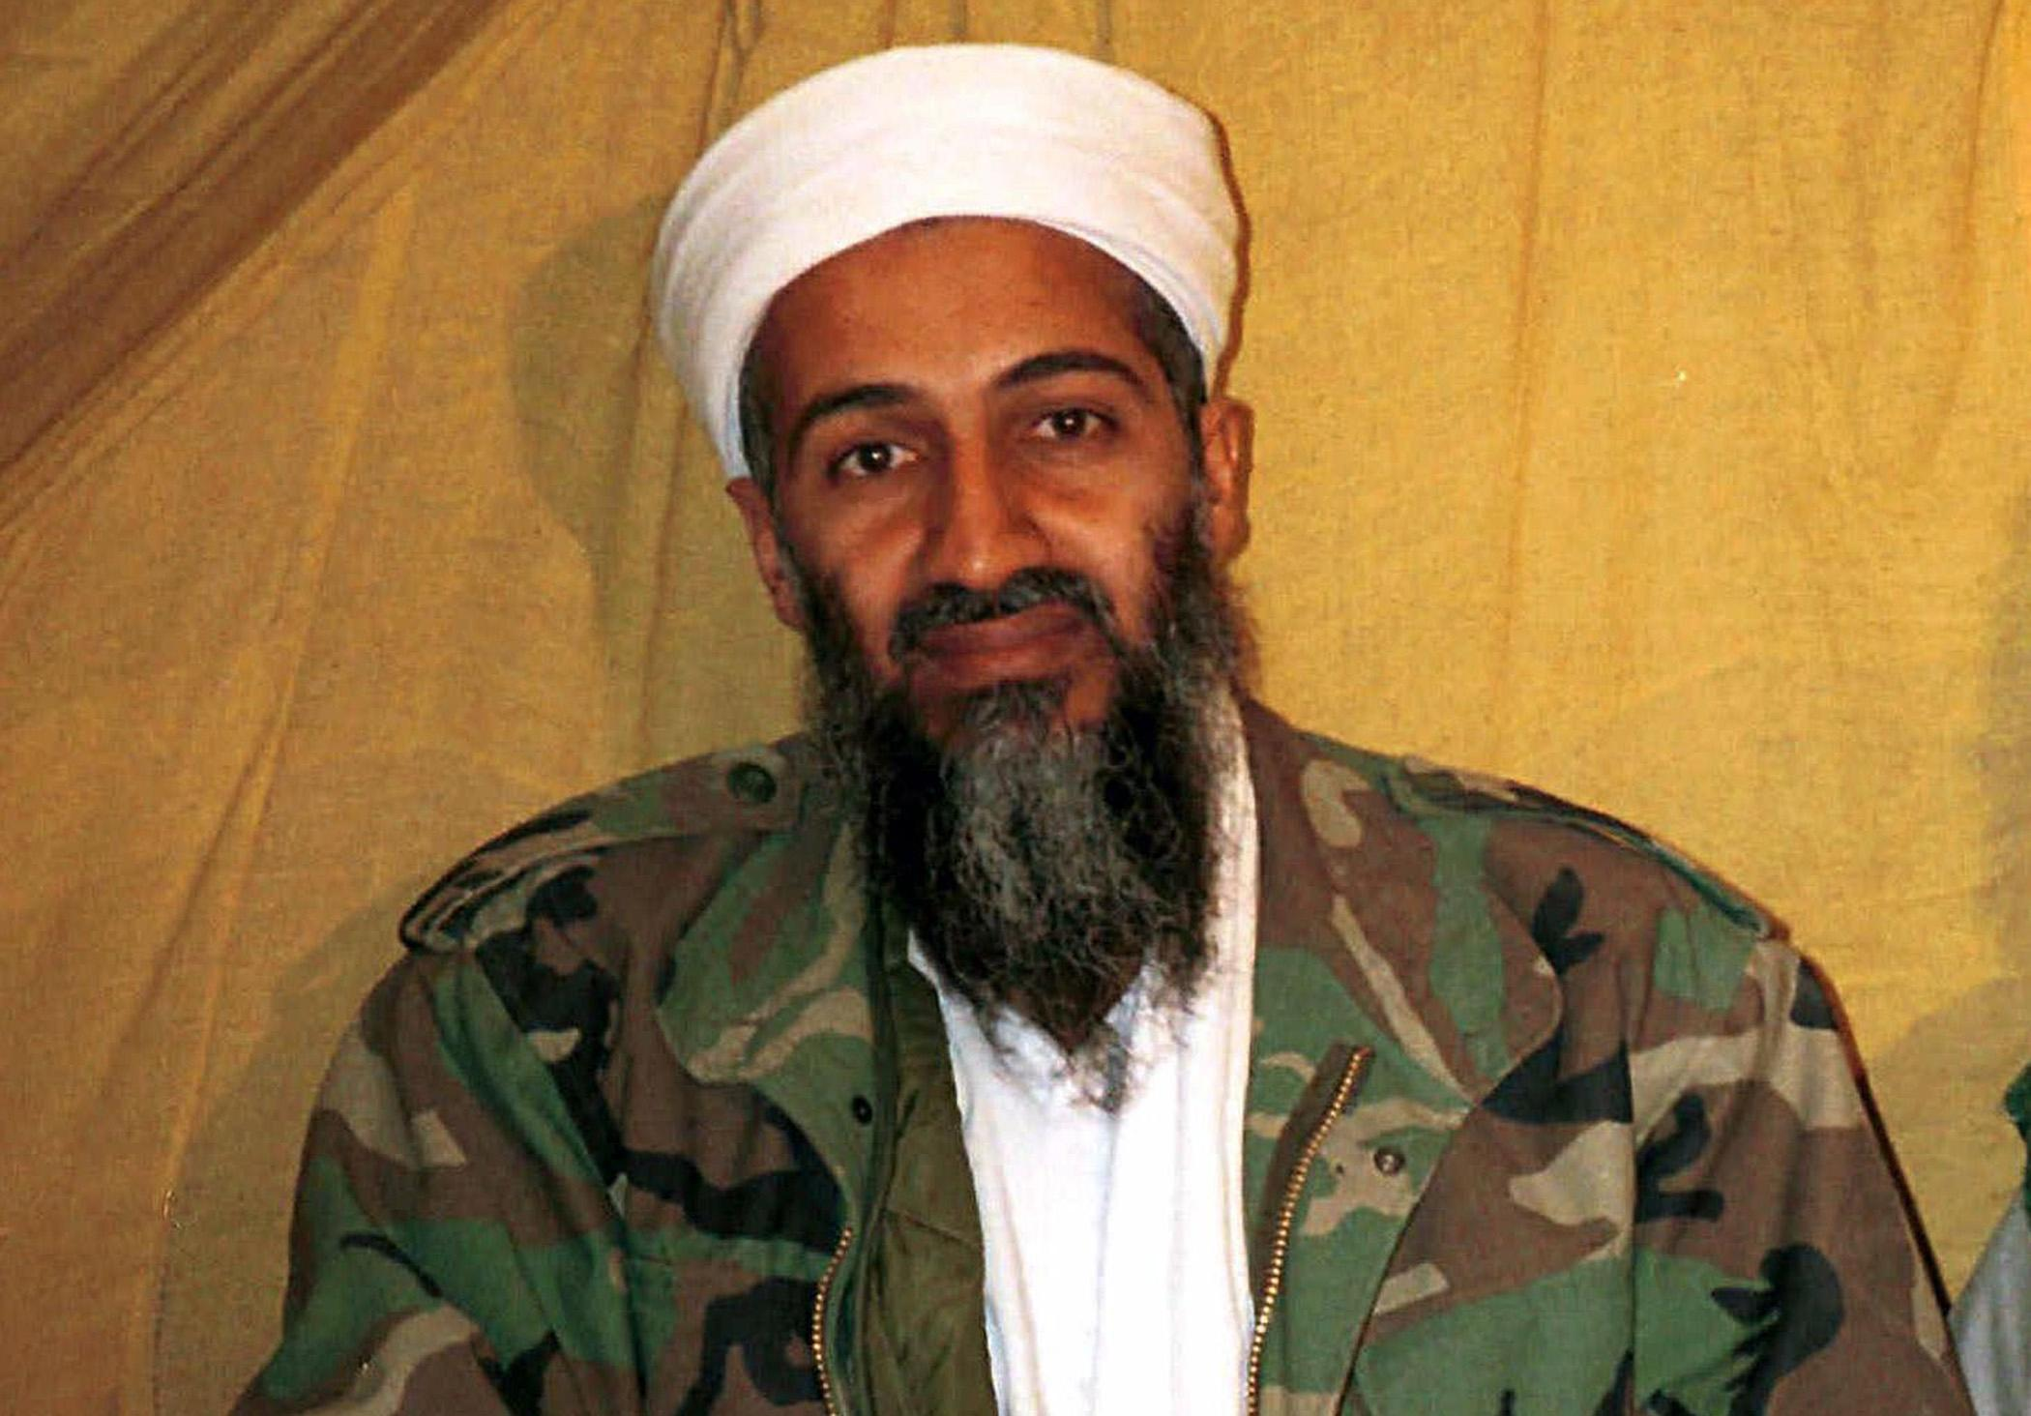
It has been said that the military lawyer, Joe R. Reeder, came out publicly and said that Bin Laden was in fact using decoys. However, the truth behind this remains “alleged.” Throughout the first decade of the 21st Century, American newsrooms were filled with Osama Bin Laden Doppelganger stories, and, to this very day, some doubt that his execution even took place. The stories and conspiracies go deep, and this case, one of the most mysterious political decoy cases, currently remains in dispute.

Hiding Behind “Alleged”
As we have encountered countlessly, throughout these cases the term “alleged” has repeatedly been used to describe the nature of these cases. Even in some cases, when the evidence is overwhelming, the truth is swept under a political rug, where it remains hiding behind its esteemed “alleged”; only to live on as the most mysterious political decoy cases in history.

