Law Society Council Report
26 September 2018

The Law Society is the representative body for solicitors in England and Wales. The Society negotiates on behalf of the profession, lobbies regulators, Government and others and has a public interest role in working for reform of the law

Council met in Chancery Lane on 26 September for the first meeting of the 2018-19 season, under the presidency, for the first time, of Christina Blacklaws. Council welcomed several new members attending their first Council meeting following elections earlier in the year. It also congratulated Sara Chandler following her election as chair of the Equality, Diversity and Inclusion Committee.
Christina tweeted a picture of Council from the chamber with the message “Delighted and a little nervous to chair my first council meeting. Your council members give up huge amounts of time to devote themselves to the governance and the policy development of our profession. We don’t see enough of them so here they are! #solicitors #publicinterest”

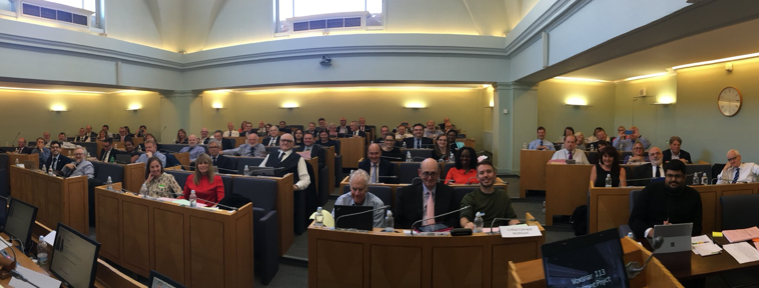

The new president is taking the opportunity to make some changes to how Council conducts its business, with the aim of giving Council more opportunity to scan the horizon on behalf of the profession and debate major issues of policy. She is also keen to encourage networking among Council members and between Council members and the staff of the Society as part of the Society’s work to act as one team for the benefit of the members it serves.

Influencing for impact – policy debate and legal interventions
Council spent some time ‘in committee’ – with the formal rules of business relaxed to permit a more interactive debate – discussing the Law Society’s policy priorities. Inevitably, Brexit continued to loom large, with a clear view from Council of the dangers of a non-negotiated Brexit and the importance of continuing to press for a negotiated settlement that would ensure the protection of the Law Society’s priorities in the interests of the profession and the public. Council also heard about the Society’s continuing work in terms of events, round tables, briefings and case studies.

A number of successful legal interventions were reported to Council. Firstly, the Law Society’s successful judicial review in relation to changes in the Litigation Graduated Fees Scheme (LGFS) – which would have substantially reduced the ‘cap’ on pages of prosecution evidence the reading of which can be charged for – which received widespread coverage. Secondly the Law Society had provided litigation support to the Law Centres Network (LCN) claim for judicial review of the proposed changes to the Housing Possession Court Duty Scheme which would have introduced larger scheme areas and price-competitive tendering. This challenge was also successful, and the matter has been remitted to the Lord Chancellor for re-consideration. In a third legal success, the Law Society had intervened in the case of ENRC v SFO as part of our ongoing campaign to protect legal professional privilege, and the Court of Appeal’s judgment delivered earlier in September had been favourable.

On the wider policy agenda, Council discussed the Law Society’s role in dealing with regulatory issues including the SRA’s handbook reforms, transparency proposals, the solicitors’ qualifying examination, and the forthcoming changes to the internal governance rules; civil justice including clinical negligence and civil liabilities; access to justice, including legal aid support, the condition of court premises, and the pro bono charter; technology and innovation in the law, including the role of artificial intelligence in the law, the work of the public policy commission of criminal justice and humans rights, and GDPR and cyber security; and the Law Society’s continuing work on the role of the profession, for example in the context of the UN General Principles, and legal professional privilege. A planned series of policy discussions will follow.

Practice excellence and career companion – supporting the profession
Council also had a highly engaged discussion of options for enhancing the Law Society’s offer to the profession in terms of education and learning, including mentoring, career coaching, and personal development. With warm support from Council for the business case for this, the details are now under active development and this is part of the business plan for 2018-19.

Council were also updated on a review of the Society’s Diversity and Inclusion Charter which is currently under way. The Society’s Divisions and a range of stakeholders are already engaged in the review. Piloting a new approach to the Charter, designed to help firms of all sizes meet their obligations and tackle diversity within all levels of the profession will begin in 2019.

Promoting the profession
The Society’s campaign to promote the profession as honest and honourable, approachable and accessible, experts in their field, client focused, delivering value for clients and adding value to society was also highlighted following an advertising campaign on busses, trains and social media. The campaign features our members. Council were shown some of our latest advertising during their lunch break. You can see more by clicking the “for the public” button on our Law Society homepage.

Ongoing programmes of work include continuing the solicitor brand campaign to promote the benefits to clients of using solicitors; the global legal centre campaign to protect the position of the Law of England and Wales internationally post-Brexit, the Women in Leadership in Law campaign, personally sponsored by the president, which aims to increase gender equality in the profession; and the Society’s work on technology and the law.

It was also noted that the Society has received overwhelmingly positive coverage in the press and broadcast media. Broadcast media coverage has been a priority and has doubled this year. Keeping the Society and our views in the spotlight supports our lobbying and influencing as well as promoting the profession.

Keeping members informed
Council heard about the new publication ‘Your professional body – the value of membership’, which sets out the key components of the work we do to promote the profession, influence for impact, keep members up to date, support practice excellence and support members at every stage of their career. This is available on line and is now sent in hard copy to every new member along with a welcome note from the president. Copies are available from corporatecommunications@lawsociety.org.uk.

Efficient and effective – planning for the future
Council spent time at this meeting considering future plans and budgets for the Law Society, including formal approval of the final budgets for the Law Society and the SRA for 2018-19 following detailed scrutiny by the relevant boards.

The business plan agreed by Council for the Law Society draws on input from the successful Council strategy weekend earlier in the year, setting a number of priorities focused on the efficient and effective delivery of services to our members. This includes planned improvements to the way the Law Society manages and uses data about its members, the creation of an enhanced online experience for our members, streamlining the management of the accreditation process and enhancements to Law Society telephony to make it more flexible and user-friendly. Council also agreed to progress plans to refurbish 113 Chancery Lane and to market 114 Chancery Lane for rental. Refurbishment work will enable more efficient use of the central London premises and create revenue from the vacated building. This will not impact on our member areas such as the Library, Reading Room and newly refurbished 113 Restaurant.

The next meeting of Council is scheduled for 5 December.

