Shafter Elementary PTO General Meeting Minutes
15 JANUARY 2019 / 6:00 PM / CAFETERIA

Attendees
Jared Campbell, Tatiana Masuda, Jenna Hall, J. Castellano, Ronnell Nipp, Austyn Brouillette, Judith Santiago, Officer Cochrane, Officer Norman, Lincoln Tyler, Christina Savala, Paul Watkins, Giusy Montoorsry, Valerie Kim, Andrea Alcala, Alexis Schwietz, Kerry Campbell, Jennifer Rodriguez, Ann Miller, Martha Powers, Lori Watkins

Agenda

Welcome - Jennifer opened the meeting by welcoming everyone and reminding them to sign in and to consider signing up on the Volunteer sheet for events to be discussed in the meeting.

Follow-up
Holiday Shop - Kerry reminded everyone that this was our first year doing the Holiday Shop and the feedback from the kids has been that they really enjoyed it. A huge thanks to Kerry and all the volunteers for setting up the shop and making it a success! The board is working on putting together a list of things that worked and didn’t work to improve for next year if we decide to do it again. Mrs. Nipp said that the teachers do have some comments and Kerry will send out a survey to gather their suggestions. We may be able to get a discount on next year’s shop if we sign up early enough. More info to follow.
Box Tops - Caity Clarke is doing a great job with her system of collection and our check for this first semester was $847! Thank you so much to all the teachers for passing out and collecting the sheets Caity provides and thanks to the parents for filling them up. Don’t forget to ask your friends and neighbors for their Box Tops and we can do even better this half of the year!
Treasurer’s Report - Martha went over all the items listed on her report (see last page of minutes). Our current balance is $8,714.12. Martha also discussed that even though we have been soliciting staff and teachers for fund requests and they have been making requests, we have not been able to start dispersing the money because of a tax issue that was recently brought to our attention. We found out that when we switched from a PTA to a PTO in April of 2016, we became subject to a general excise tax on our fundraisers. Martha and Kerry have been reviewing the tax laws and consulting professionals to determine what we owe for this year (first 3 lines on the report) and to set up a plan to pay what we owe for previous years as well. Now that we have more clarity, we can vote on fund requests to support. Thank you so much, Martha and Kerry for slogging through tax law!
Also, we will be applying again for the two grants from Boutiki at Pearl Harbor and the Shafter Hui that normally covers the cost of next year’s gold folders and planners. Those applications are due in March.
Principal’s Report - Mrs. Ronnell Nipp is our acting-principal after Mrs. Higa’s retirement in December. She addressed the meeting with the school’s Academic Plan which can also be found on the Hawaii DOE website http://www.hawaiipublicschools.org/Reports/228_2017-20_AcademicPlan.pdf The plan has 3 points of focus - student success, staff success and system success. To help students succeed, goals for performance are aligned with State standards. Instruction is done through differentiation which attempts to meet the needs of all students with the curriculum. Students also have articulation twice a month where they meet in data teams and teaching is modified for individual needs. The curriculum uses Wonders for it’s reading program, Singapore Math and focuses on STEAM. To help staff succeed in supporting students academic, social and emotional needs, the school promotes TRIBES behavior and Positive Behavior Intervention Support. For system success the school promotes transparency across campus with an Academic Review Team that monitors and provides feedback to ensure academic plan is being met.
Mrs. Nipp also reiterated that this year’s student enrollment did not meet the original projection by almost 100 kids and the school had to return $200,000 of funding back to the State. This means that the budget for this half of the year is severely limited and that is why the staff has made fund requests for items like toner and lawn mowers which would normally come out of school funds.
Lastly, the School Quality Survey comes out this week and Mrs. Nipp wanted to remind everyone to fill them out and mail them in by March.
Staff Donation Requests - Staff liaison Lincoln Tyler presented a report on how much toner the school typically orders for the second half of the year and the minimum they need to get through this year (see attached). Requests were then listed in order of importance and all were voted on by members present.
- Toner cartridges - 18 classroom, 1 library, 1 SSC and 1 color - $1690.00 - Unanimously approved
- $2 per student towards field trips - $800 - Approved with quorum
- Lawn mower: requested Honda 21” Model# HRRZ16VYA SKU# 407235 self propelled lawn mower from Home Depot for $499.00 - Unanimously approved for purchase after bread sales
- Four tetherballs with string $48.00 - Unanimously approved for purchase after bread sales

**Update - budget was reviewed after the meeting and all approved purchases are able to be made immediately.

New Business
Newsletter - Kerry asked for input on making the newsletter digital to save paper, toner, etc. Those present agreed that newsletter should be digital, however, it was recommended to make one last print newsletter to notify everyone of the change to digital and request email addresses. February was decided to have the last print newsletter.

Events/Fundraisers:
Feb 1-20: Regal Bread Sales - Kerry and Brandi Richardson are co-chairs; Kerry will be creating an email to send teachers that goes over all instructions for sales and can be emailed directly to parents. A direct donation option will also be included.
Feb 8: Kids Heart Challenge - PTO is responsible for providing snacks (granola bars, tangerines) and manning the water station. We are looking for volunteers! Please contact any board member if you are interested. Also, Lincoln is verifying with Paul Wasada whether or not they need PTO to solicit volunteers for the other stations. Kerry asked the Bike Patrol officers present if they would be interested in helping and they said yes. Kerry will help coordinate.
Mar 5: Bread Pick-up - same procedure as cookies.
Mar 8: Spring Fling - this is our annual family event that can be a dance or just a fun get together to promote school spirit. The board is looking for volunteers to be on a planning committee that will meet in 2 weeks to propose theme ideas and get the ball rolling. Please contact any board member if you are interested. Help us make this awesome!
Mar 11-15: Book Fair - we will probably be looking for volunteers again. Keep an eye out!
Apr 1-4: Month of the Military Child - this is normally when we do our field day event, however due to testing, the staff has requested that we do Field Day in May and keep activities in April more passive. If you have any ideas on ways we can honor all our great Military kids, please let a board member know. We are working on some of our own but welcome your input!!
Apr 2-4: Reading for Education - this is a simple fundraiser that requires you to fill out 10 addresses on 10 postcards and BOOM! You’re done and you earned the school $5. Kerry is verifying that this one is available this year.
Apr TBD: Volunteer Appreciation - we want to say thank you to all the volunteers who donated their time to all our wonderful events and fundraisers this year. So hurry and volunteer for one of our spring events and you will be included!!
Apr-Jun: Keiki Kits - we would like to advertise this fundraiser better and increase the length of sale. Jenna Hall was cited as our contact so we will meet with her to discuss options.
May 6-10: Teacher/Staff Appreciation - Ann Miller is looking for a parent co-chair. Please let her know if you are interested!
May 29: 6th Grade Promotion - Last year Jennifer was able to get leis donated for the 6th graders and she would like to do that again this year so if you have any kukui nut leis you would like to donate, please let her know! Also she was able to get Wendy’s to donate a free Frosty tag which she attached to each lei. If you have another idea for something similar, please share it! Jennifer also reported that the 6th graders were given 5 days to help with ice pop sales and keep the proceeds to offset costs of their year-end activities. They raised $193 but only came to 4 of the sales. They requested a make-up sale for the one they missed and the members present voted to give them one more sale date of January 30th.

Bike Patrol: Officers Cochrane and Norman addressed the meeting to remind everyone that they are here in the mornings and afternoons to assist with student safety at drop-off and pick-up and that if any of our parents or staff notice misconduct by officers, they should immediately report it to 1LT Robinson 517-749-0091. In cases of emergency, the police station on post can be reached at 808-438-7114. Thank you, Officers Cochrane and Norman!

Questions/Concerns: One parent asked how our yard sales had gone. Jennifer responded that they were successful and we raised a total of $1351.95 for both sales. After our first sale in August we were able to purchase large hand sanitizers for each classroom/office. While the yard sales are a great way to make money, they require a lot of manpower and we really need more parent volunteer involvement to keep them going. We’re willing if you are!
Also concern was raised about the quality of school lunches. Mrs. Nipp stated that we do not make the lunches on campus but receive them from Makalapa. The lunches follow the health and wellness guidelines of the Hawaii DOE. It was also brought up that food flavors/seasonings are more geared to the tastes of the local population which some newer students may not be familiar with. As always, there is a monthly schedule of daily lunches and breakfasts listed on the Shafter Elementary website and you have the option to provide your child with home or school lunch as you see fit. Thanks for your input!

Thank you so much to everyone for coming and thank you to IPC for supplying Subway sandwiches!

Next General Meeting: Tuesday April 2nd @6pm in the cafeteria

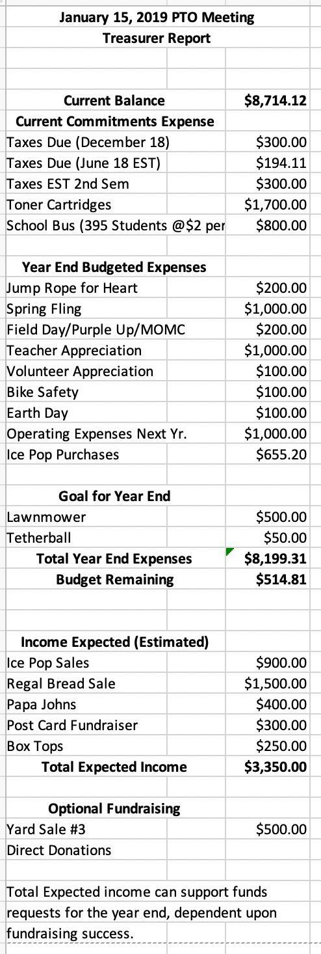
Staff Request for Toner

**Toner** This is what we normally order for the 2nd half of the school year.

Classroom Type 1 $62.00 X 15 = $930.00
Classroom Type 2 $47.00 X 15 = $705.00
Library $130.00 X 1 =$130.00
SSC $80.00 X 2 =$160.00
***Subtotal*** =$1925.00

Colored $500.00 X 5 = $2500.00

***Total*** =$4,425.00

Minimum Toner to get us through the School Year

18 Classrooms that use either $62.00 or $47.00 cartridges = $980.00
1 Library = $130.00
1 SSC = $80.00
1 Colored =$500.00

***TOTAL*** = $1690.00

Staff is requesting that PTO purchase the minimum amount of toner for $1690.00

