“Around the Horn”
Baseball News for the Pacific Northwest
May 20, 2019
In this issue: | Page: |  | Page:
Quote of the Week | 1 | Northwest League Update | 5-6
Birthdays | 1 | Pacific Coast League Update | 7
American League Standings and  Leaders | 2 | West Coast League Update | 7-8
National League Standings and  Leaders | 3 | Golden State Collegiate League Update | 8-9
MLB Players with Oregon Ties Weekly Update | 4 | Pac 12 Conference Update | 9
Old Timers Baseball Association of Portland Golf Tournament | 5 | Ballparks – Vince Genna Stadium, Bend, Oregon | 10-12

Quote of the Week:
“Slumps are like a soft bed – they are easy to get into and hard to get out of.”
Johnny Bench, Hall of Fame catcher

MLB Players Born in Oregon with Birthdays in May:
Player | Birthplace | Date | Year
Del Baker | Sherwood | 3 | 1892
Paul Gehrman | Marquam | 3 | 1912
John Leovich | Portland | 5 | 1918
Larry Anderson | Portland | 6 | 1953
Jim McDonald | Grants Pass | 7 | 1927
Dick Smith | Lebanon | 17 | 1939
Drew Carpenter | Grants Pass | 18 | 1985
Sam Gaviglio | Ashland | 22 | 1990
John Jaha | Portland | 27 | 1966
Bobby Gene Smith | Hood River | 28 | 1934
American League Standings (as of May 20, 2019)
East
Team | W | L | Pct | GB | Last 10 | Streak
NY Yankees | 28 | 17 | .622 | - | 7-3 | W1
Tampa Bay | 27 | 17 | .614 | 0.5 | 5.5 | L1
Boston | 24 | 22 | .522 | 4.5 | 7-3 | W1
Toronto | 19 | 27 | .413 | 9.5 | 4-6 | W1
Baltimore | 15 | 31 | .326 | 13.5 | 2-8 | L2

Central
Team | W | L | Pct | GB | Last 10 | Streak
Minnesota | 30 | 16 | .652 | - | 6-4 | L1
Cleveland | 25 | 20 | .556 | 4.5 | 6-4 | W2
Chicago WS | 21 | 24 | .467 | 8.5 | 5-5 | L1
Detroit | 18 | 26 | .409 | 11.0 | 2-8 | L6
Kansas City | 16 | 31 | .340 | 14.5 | 3-7 | W1

West
Team | W | L | Pct | GB | Last 10 | Streak
Houston | 31 | 16 | .660 | - | 9-1 | L1
LA Angels | 22 | 24 | .478 | 8.5 | 6-4 | L1
Texas | 21 | 23 | .477 | 8.5 | 4-6 | W1
Seattle | 23 | 26 | .469 | 9.0 | 3-7 | W1
Oakland | 22 | 25 | .468 | 9.0 | 6-4 | W3

American League Leaders:
Batting Average: | Home Runs: | Runs Batted In:
Jorge Polanco (Min) .343 | George Springer (Hou) 17 | George Springer (Hou) 42
Tim Anderson (CWS) .335 | Alex Bregman (Hou) 14 | Domingo Santana (Sea) 38
Josh Reddick (Hou) .333 | 4 tied with 13 | Jose Abreu (CWS) 38
Elvis Andrus (Tex) .325 |  | Adalberto Mondesi (KC) 37
Wins: | Earned Run Average: | Strikeouts:
Domingo German (NYY) 8 | Tyler Glasnow (TB) 1.86 | Gerrit Cole (Hou) 93
Justin Verlander (Hou) 7 | Justin Verlander (Hou) 2.38 | Chris Sale (Bos) 83
5 tied with 6 | Spenser Turnbull (Det) 2.40 | Justin Verlander (Hou) 77
 | Domingo German (NYY) 2.50 | Trevor Bauer (Cle) 75
 | Mike Minor (Tex) 2.61 | Matthew Boyd (DET) 73

National League Standings (as of May 20, 2019)
East
Team | W | L | Pct | GB | Last 10 | Streak
Philadelphia | 27 | 19 | .587 | - | 6-4 | W3
Atlanta | 25 | 22 | .532 | 2.5 | 7-3 | L1
NY Mets | 20 | 25 | .444 | 6.5 | 4-6 | L5
Washington | 19 | 27 | .413 | 8.0 | 5-5 | L1
Miami | 13 | 31 | .295 | 13.0 | 3-7 | W3

Central
Team | W | L | Pct | GB | Last 10 | Streak
Chi Cubs | 27 | 17 | .614 | - | 6-4 | W1
Milwaukee | 28 | 21 | .571 | 1.5 | 5-5 | W1
Pittsburgh | 24 | 20 | .545 | 3.0 | 7-3 | W3
St. Louis | 24 | 23 | .511 | 4.5 | 3-7 | L1
Cincinnati | 21 | 26 | .447 | 7.5 | 6-4 | L1

West
Team | W | L | Pct | GB | Last 10 | Streak
LA Dodgers | 31 | 17 | .646 | - | 7-3 | W1
Arizona | 25 | 22 | .532 | 5.5 | 4-6 | L2
San Diego | 23 | 24 | .489 | 7.5 | 3-7 | L3
SF Giants | 20 | 25 | .444 | 9.5 | 5-5 | W2
Colorado | 20 | 25 | .444 | 9.5 | 4-6 | L4

National League Leaders:
Batting Average: | Home Runs: | Runs Batted In:
Cody Bellinger (LAD) .405 | Christian Yelich (MIL) 19 | Josh Bell (Pit) 44
Jeff McNeil (NYM) .342 | Cody Bellinger (LAD) 17 | Cody Bellinger (LAD) 44
Melky Cabrera (Pit) .341 | 4 tied with 14 | Christian Yelich (MIL) 41
Josh Bell (Pit) .333 |  | Marcell Ozuna (StL) 40
Wins: | Earned Run Average: | Strikeouts:
Zack Greinke (AZ) 6 | Hyun –Jin Ryu (LAD) 1.52 | Max Scherzer (WSH) 87
Max Fried (ATL) 6 | Zach Davies (MIL) 1.54 | Stephen Strasburg (WSH) 82
Brandon Woodruff (MIL) 6 | Luis Castillo (CIN) 1.90 | Luis Castillo (CIN) 76
Hyun –Jin Ryu (LAD) 6 | Jordan Lyles (PIT) 1.97 | Patrick Corbin (WSH) 69
4 tied with 5 | Caleb Smith (Mia) 2.25 | Robbie Ray (AZ) 67

MLB Players with Oregon Ties Weekly Update

Injuries and Transactions for the week:

Cole Irvin – After his contract was selected by the Philadelphia Phillies from Lehigh Valley (AAA) on May 12, the left-handed pitcher made his major league debut and won both games that he started. Drafted out of the University of Oregon in the 2016 draft, Irvine was 2-0 with a 2.25 ERA in six starts for the IronPigs. He is the 19,497th player in MLB history.

Jimmy Nelson – Nelson (shoulder) threw 5.2 scoreless innings in his rehab start Friday for Triple-A San Antonio. He gave up three hits and one walk while striking out eight.

Michael Conforto - Conforto (concussion) will be placed on the 7-day injured list Friday.

Kyle Garlick – Called up by the LA Dodgers from Oklahoma City on May 17th and made his Major League debut on May 19th, the 19,510th player in MLB history.

Jed Lowrie – Lowrie started the season on the 10-Day Injured list with a capsule strain in his left knee. On April 28 he reported to St. Lucie Mets (High A) and on May 4 to the Syracuse Mets (AAA) on rehab assignments. As of May 14th, dealing with a hamstring strain. Now expected back in early June.

DJ Johnson - Optioned to Albuquerque May 17

Jimmie Sherfy – Recalled from Reno (AAA) May 13

Zac Rosscup – Designated for Assignment May 17

Click on the following link to open the complete Weekly Update
https://docs.google.com/spreadsheets/d/10e3n5XUzYHouwd1LMMxFuS4gB4jQHSbl_McvQEG_oaQ/edit?usp=sharing

Old Timers Baseball Association of Portland
Diamond Classic Golf Tournament

The Old Timers Baseball Association of Portland’s annual golf tournament will be held Monday, August 5, 2019 at The Reserve Vineyards and Golf Club in Aloha.
The Old-Timers Baseball Association of Portland is an inclusive, non-profit organization raising funds with the goal of tutoring, mentoring and giving back to the amateur/professional baseball community.
On the first Monday of August each year we hold a golf tournament to help raise money for our organization to give to youth baseball organizations.
Ticket information can be found on the Old Timers website or by clicking here.
Photos from last year’s golf outing can be found here.

Northwest League

The Northwest League (Short-Season Single-A) kicks off their 76-game 2019 season on Friday, June 14.

The Northwest League has been in existence since 1955. Prior to then, they were the Western International League, among others. There are eight teams in the league, and all are affiliates of Major League Baseball teams.

The league’s website can be found by clicking here.

The Opening Weekend schedule includes:
Spokane @ Vancouver
Everett @ Tri-City
Hillsboro @ Eugene
Boise @ Salem-Keizer

The Northwest League/ Pioneer League All-Star Game will be held in Boise on Tuesday, August 6. For more information on the festivities, click here.

Team Websites (click on the team name to be directed to their website):

Boise Hawks

Eugene Emeralds

Everett AquaSox

Hillsboro Hops

Salem-Keizer Volcanoes

Spokane Indians

Tri-City Dust Devils

Vancouver Canadians
Pacific Coast League

The Tacoma Rainiers are in second place in the Pacific Coast League Pacific Northern Division, two games behind the Fresno Grizzlies, the Washington Nationals Triple-A affiliate. The Rainiers are third in the league in team batting at .289 and have four players who have played in at least half of the team’s games batting over .300. The Rainiers pitching staff is second in the PCL in strikeouts with 401 on the season.

The Tacoma Rainiers are the only Pacific Northwest based Pacific Coast League team, but there are plenty of opportunities to see the Triple-A players from your favorite MLB teams when they play in Tacoma.

Home series for the months of May and June:
May 21 – 24 Fresno (Washington Nationals)
June 4 - 6 Memphis (St. Louis Cardinals)
June 7 – 10 Nashville (Texas Rangers)
June 20 – 24 El Paso (San Diego Padres)
June 29 – July 3 Salt Lake (LA Angels)

There are a few mid-week day games for those of you who like to attend a game in Tacoma and return home the same day.

Wednesday May 22 11:35 AM vs Fresno
Monday June 10 11:35 AM vs Nashville

For the Rainiers schedule and more team information, click here.

West Coast League

The 2019 West Coast League season gets under way on June 4.

For schedules and more information on the West Coast League, click here.

About the West Coast League:
The West Coast League (WCL) is the premier summer collegiate baseball league west of the Mississippi. Situated in the beautiful Pacific Northwest, the 15-year-old, 12-team, professionally operated wood-bat league showcases pro prospects from major conferences around the nation. Every summer, the league features unparalleled fan and player experiences, with the best summer weather in North America. Seventy-two players with WCL experience were selected in the MLB 2018 June draft. Also in 2018, 294 WCL alums appeared or were active in affiliated professional baseball, including 39 in the major leagues, such as all-star outfielder Mitch Haniger (Seattle Mariners); ace hurler James Paxton (New York Yankees): slugger Rhys Hoskins (Philadelphia Phillies); and rising star pitchers Marco Gonzales (Seattle Mariners) and Matt Boyd (Detroit Tigers). Overall member attendance was 496,278 this past summer, a tremendous increase of 20 percent over the previous season.

Golden State Collegiate League
For baseball fans in the southern part of Oregon, Reno, and Northern California to feed their baseball addictions, the Golden State Collegiate League will provide you with some wooden bat, collegiate league action.
The Medford Rogues have joined the Golden State Collegiate League for the 2019 season. The Rogues were a member of the West Coast League from 2012 to 2015 and the now-defunct Great West League from 2016 to 2018.
The Medford Rogues, who averaged 1017 fans per game in 2018, will join the California Bees, Reno Rams, Sacramento Heat, San Francisco Seagulls, South Bay Storm, Top Speed Baseball, and the Yuba-Sutter Gold Sox in the 2019 season that begins on May 30th and runs through July 23rd. Playoffs follow from July 25th through the 28th.
Thirty-two alumni from the Golden State Collegiate League have signed professional contracts since the league’s inception in 2012.
To access the Golden State Collegiate League website, click here.

PAC-12

In a very important three-game series over the weekend at Stanford University’s Sunken Diamond, the Stanford Cardinal won one, the Oregon State Beavers won one, and Mother Nature won one. Stanford took Friday’s game 8-5, Saturday’s game was rained out and not rescheduled, and Oregon State won Sunday by a score of 5-2.
Earlier in the week, the Beavers beat the University of Portland 4-3 in Corvallis.
In another important PAC-12 series, Number one ranked UCLA swept the University of Washington in a three-game series in LA.
UCLA holds on to first place in the PAC-12 with a 22-5-0 conference record (45-8 overall), with Stanford and Oregon State tied for second at 20-6-0. Stanford, ranked Number 3 by Baseball America, beat Cal Poly last Tuesday and is now 39-10 overall. Oregon State remains at Number 11 and is 35-16 overall.
The regular season ends Saturday, May 25. UCLA travels to Eugene to take on the University of Oregon at PK Park, Stanford heads south to take on Arizona State at Phoenix Municipal Stadium, and Oregon State stays home to take on USC at Goss Stadium at Coleman Field.
The regular season ends on Saturday, May 25, followed by the NCAA Regionals from May 31 (Fri) to June 3 (Mon), the Super Regionals from June 7 (Fri) to June 10 (Mon), and the NCAA College World Series from June 15 (Sat) to June 26 (Wed).
The Ballparks
Vince Genna Stadium, Bend, Oregon

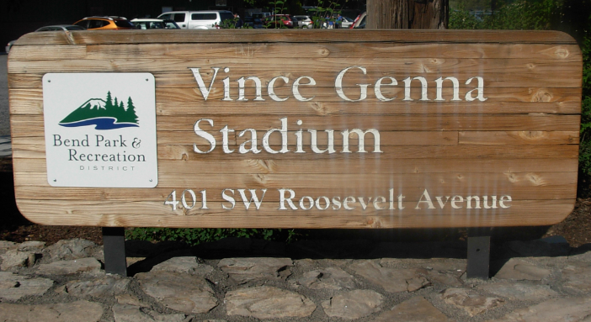

Bend’s Municipal Ball Park, now known as Vince Genna Stadium, was built in 1964. For its first six years, Vince Genna Stadium was used for high school, American Legion, and semi-pro baseball. Vince Genna was the director of Bend’s Park and Recreation District from 1964 - 1990 and the ballpark was named for him in 1972.
In 1970, the Bend Rainbows, a Short-Season Single-A affiliate of the California Angels, became the first professional team to use the ballpark. They played in Bend for two seasons before relocating to Walla Walla to become the Islanders.
Professional baseball returned to Vince Genna Stadium in 1978 when the Bend Timber Hawks, an affiliate of the Oakland Athletics, played a season in Bend before moving to Medford. In 1979, the Philadelphia Phillies began an eight-year run with a Northwest League affiliate to play their home games at Vince Genna Stadium. The team was called the Central Oregon Phillies for two seasons before renaming the team the Bend Phillies until they left the league after the 1987 season. The California Angels had Bend as an affiliate for two seasons (1988, 1989) before two seasons of Co-op in 1990 and 1991.
Jack and Mary Cain bought the franchise in 1981 and in 1991 were contacted by Bob Gebhard of the new Major League expansion Colorado Rockies. The Bend Rockies played in 1992 as the first team in the Rockies organization. When the Portland Beavers left Portland after the 1993 season, the Cain’s found the opportunity very appealing and moved the franchise from Bend to Portland for the 1995 season, ending the city’s affiliation with the Northwest League.
After the Rockies moved to Portland, the Bend Bandits of the independent Western Baseball League called Vince Genna Stadium home from 1995 – 1998.
Since 2000, the Bend Elks of the West Coast League, a wooden-bat, collegiate league, have been playing in Vince Genna Stadium.
Notable players who have called Vince Genna Stadium home include: Kurt Russell, Tom Trebelhorn, Julio Franco, Juan Samuel, Andy Ashby, Mike Maddux, Jason Grimsley, Rick Schu, Damion Easley, Craig Counsell, Quinton McCracken, Neifi Perez, Tim Salmon, and Jim Edmonds.
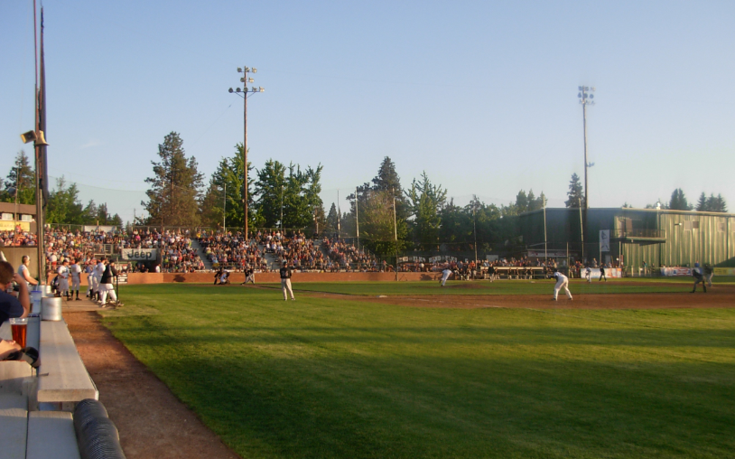
Action from Vince Genna Stadium in 2015

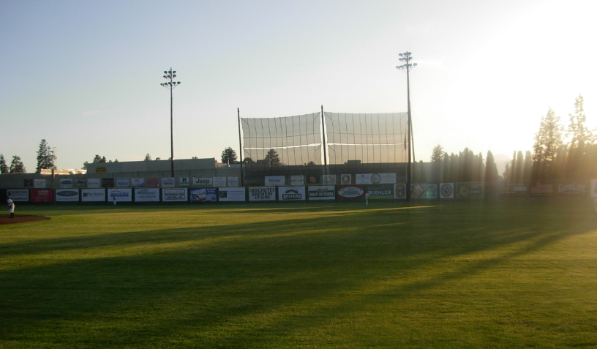
Because the setting sun is directly in the batter’s, catcher’s, and umpire’s eyes, a
screen was erected to help block the sun beyond left-center field wall.

