

**Annual General Meeting**

**Tuesday, June 26 2018 – 7:00 pm**

**Sage Room - FLC**



Annual General Meeting

of

South East Athletic Club (SEAC)

held at 7:00 pm on June 26, 2018

at the Sage Room, Family Leisure Centre

**AGENDA**

1. Opening Remarks

2. Adoption of Agenda

3. President’s Report

4. Audited Financial Statements

5. Closing remarks

President’s Report

The 2017-18 season was another positive year for the SEAC program.

It started with a new home at the Hockey Hounds Recreation Centre. The transition went very smooth and it was great to come into a facility with new upgrades: ice slab, rink boards & glass, players benches, overhead lighting, as well as coaching rooms and equipment storage made available to the Club.

Midget 15 Program – We would like to thank Chad and his team of coaches, trainer and manager for their commitment and dedication to the Midget 15 players and the SEAC program. It was a good year of development and we saw a lot of improvement for all players both on and off the ice. We wish all the 15 year old players all the best in their future hockey endeavors. They are a team of very committed young men.

Bantam AAA – We would like to also thank Jason and the coaching staff, trainer and manager for their commitment and dedication to all the Bantam players and the SEAC program. Congratulations to the team on making the playoffs. It was a very exciting season. The last game of the playoffs saw a full house showcasing the strong community support.

The team also represented the program and your community very well at the Hockey Hounds Tournament, we were proud of your accomplishment. We saw a lot growth throughout the season and your efforts were rewarded.

To the Sponsors, thank you for the continued support and commitment to sustain and allow for future growth of the SEAC program

Thank you to the SEAC Board of Directors for your commitment to the program. Your hours of volunteering to make a difference to the growth of hockey in our community and zone are too be commended. Thank you to the Medicine Hat Minor Hockey Association for your continued support.

To Terry Bartman, thank you for your vision, you never waivered and stayed the path throughout your 5 years of commitment to the program. Your leadership made all of us better.

We continue to value the feedback of stakeholders to grow and better the program to be the envy of the province.

We look forward to another successful season!

Brent Sauer

President 2018-19

Audited Financial Statements

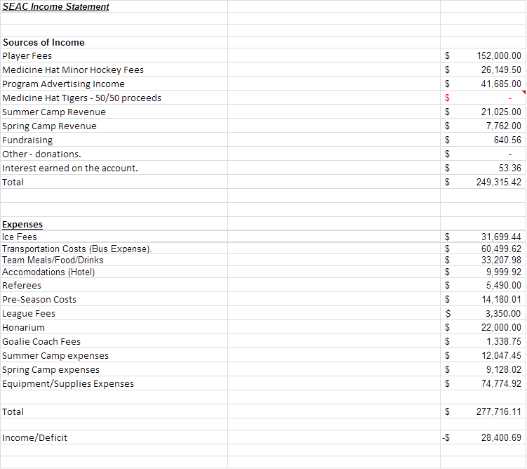



SEAC has not received the Tiger 50/50 monies at the time of completing our annual report.  We are expecting a little less than $22,000, which will result in our loss dropping to 6,446.69 for the year.

As of March 31, 2018 (our fiscal Year End) our equity position sits at $58,696.43. The F18 Year End represents a loss of $28,400.69 but we refer to the financial statement for additional details on the same and note the following key items explain the loss:

We have not received our Tiger 50/50 monies of $21,954 – adding this back to the income in F18 and our loss would be $6,446.69.

Ice, food and travel costs were higher than budgeted.

Jersey expenses – the invoice related to the Midget 15 AAA and Midget AAA Jerseys purchased for the 16/17 season was not paid for until late 2017.  The invoice was for $21,424.20 and is included in General Expenses this year.  We have always budgeted roughly $10,000 each year for jerseys.

The Bantam AAA playoff expenses were covered in full and additional paraphernalia purchased for the player's mid-season that wasn’t built into the original budget was covered.  However, while this expense was higher there was additional "other" fundraising which allowed for the same.

In summary, our financial position remains strong heading into the 2018/19 hockey season and as such SEAC will not be making any changes with our fee structure at this time even though we are anticipating further increases in ice and travel expenses plus the addition of other expenses to grow the program.

**Club Comparisons**

|  |  |  |  |  |
| --- | --- | --- | --- | --- |
|  | Okotoks  (Jamie Steer) | Lethbridge | Airdrie | SEAC |
| Fee Structure | $8000.00 | $4500-$5000 |  | $4250-$5000 |
| Do parents ride the team bus? | No | Coach decision  (usually 2/year) |  | No |
| Do parents stay at the same hotel as the team when on the road? | Yes | Yes  (separate floor) |  | Recommended not |
| How many players to a room? | 4 | 2 |  | 2 |
| Do they play in other centers/cities for some home games? | M15 based out of Chestermere  Bantams/Midget - never | No |  | Yes |
| Do they do any recruiting in their zone for players? | Because of proximity to academy schools they have started too, prior to that no | Yes  Send letters of camps, word of mouth and knowing where to go |  | Make contact with  Players and parents |
| How does the billeting process work? (or is it up to families to find their own?) | Jr. A Oilers help with their billet pool  $350/month | If necessary, but otherwise families find their own billet, rate negotiated |  | Billet Coordinator  $400/month |