Self-care |  | - July 21, 2016  - Self-care resources in times of grief, rage, and mourning

Just Healing Resources: Healing Justice for Black Lives
The following three documents (to the left) were created in solidarity with Black Lives Matter and the Baltimore Uprising. Our intention is to assist communities who are rising up and fighting back against anti-Black state and state-sanctioned violence to care for themselves, move through grief, heal from trauma, and attend to their emotional and physical safety in protest spaces.
- Emotional + Physical Safety in Protests
- Practices for Moving Through Grief
- Self-care for Trauma, Grief + Depression
Lovingly crafted by Adrienne Maree Brown, Naima Penniman, Adaku Utah, Mark-Anthony Johnson, and Autumn Brown.

Self-care for People of Color after Psychological Trauma
From Just Jasmine Blog
  - July 21, 2016
  - Self-care resources in times of grief, rage, and mourning (cont’d)

How to Engage in Self-care in Times of Black Trauma

Randi Gloss for The FADER.
Gloss spoke to The FADER on Wednesday morning over the phone from Washington D.C. She explained how to honor wellness in mourning and ways that black people can indulge in self-care through times of black trauma and death.

We Can Help Each Other Cope: One Simple Way to be With Each Other Through Pain Right Now
CarmenLeah Ascencio for BGD
The load that Black people and QTPoC are carrying is way too heavy to bear alone. We took care of each for thousands of years through tragedy and loss before therapy was invented. What I want to offer today are some simple steps we can take to be with each other through pain.

Poems & Songs |  | - July 21, 2016  - Self-care resources in times of grief, rage, and mourning (cont’d)

“We Gon’ Be Alright”: A Collaborative Mixtape for Black Healing

This is for my people who have spent all day at work trying to put on a brave face while it feels like the world burns around them.
This is for my people who feel like they didn’t get enough time to mourn the last one before the next one happened.
…

This is for my people in the streets, on the front lines, and in the trenches.
This is for my people who just want to be free.

17 Poems to Read When the World is Too Much
So it is better to speak
remembering
we were never meant to survive
Actions  26 Ways to be in the Struggle Beyond the Streets  This list is designed to celebrate all the ways that our communities can engage in liberation. |  | July 21, 2016  For those who heal through action.  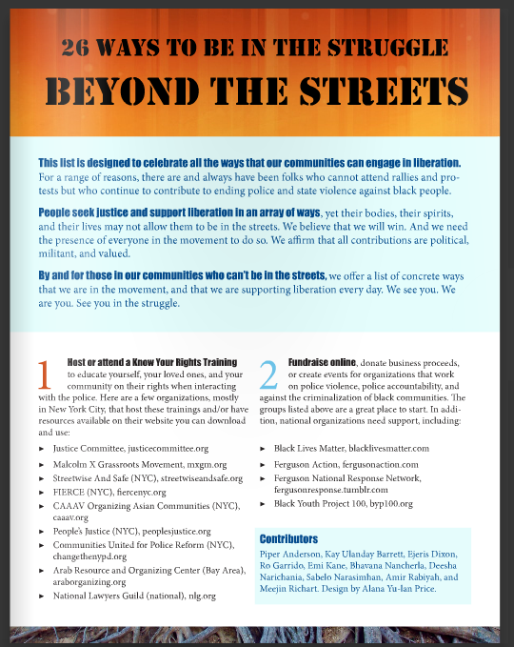

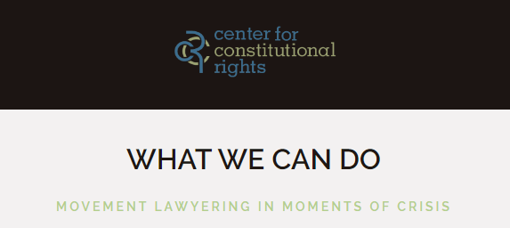What can we do: Movement Lawyering in Moments of Crisis
This list is designed to celebrate all the ways that our communities can engage in liberation.

Action Strategy: a how-to guide
Actions can empower a generation, catapult an issue onto the international stage, and force political change. Yet, actions can also be poorly executed or harmful to your group and goals. This handout is here to help you design a strategic action. The Ruckus Society de!nes direct action as the strategic use of immediately e"ective acts to achieve a political or social end and challenge an unjust power dynamic.

