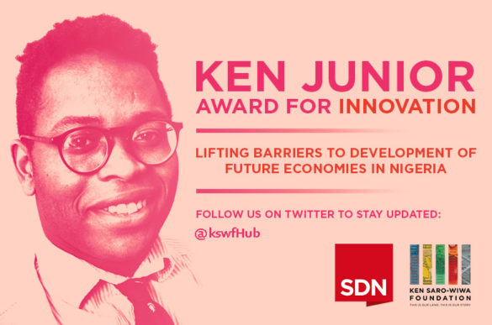

The Ken Jr. Award for Innovation
APPLICATION FORM

SECTION 1
PERSONAL INFORMATION
Name

Date of Birth

Nationality/State of Origin
Gender

Medical Disability?

SECTION 2
CONTACT DETAILS
HOME ADDRESS

MOBILE NUMBER
Email
Skype ID

Social Media Handles
SECTION 3
BUSINESS PROFILE

Business/Company Name

Business/Company Address
Street Address:
City/Town:
Country:
Postal Code:

Website/Company Pages

About Me

Leadership skills and Experience

Personal Achievement

Elevator Pitch

Detailed Description

What is new, interesting or different about your product/service/idea?

Problem Solved

How does your idea/product/service leverage on technology?

Business Stage

Sustainable Development Goals

Business Impact

Challenges

Explain briefly what you hope to achieve from participating in the KEN JR. AWARD program

SECTION 4
COMPANY STRUCTURE

Is your company registered?
Yes |  | No

Do you have any business partners?
Yes |  | No

What is your primary role?

What is the strength of your team?

SECTION 5
MARKET POTENTIAL

How big is the market your idea/product/service intends to address?

How will you get revenue?

Marketing strategy

List your top 3 competitors

Differentiating Factors

What is your current milestone for your business?

What is your next milestone and how long will it take you to reach it?

SECTION 6
FINANCIALS

What is the total amount of cash invested to date in this startup?

What are your current monthly cash expenses?

How much revenue has your startup generated since inception?

How much profit has the business made since inception?

What is the projected break-even volume (quantity) for the business?

What is the projected break-even revenues for the business?

SECTION 7
ATTESTATION

How did you hear about the KEN JR. AWARD?

If accepted into the program, will you work full time on this business/idea?
Yes |  | No

Please explain how your startup will use the NGN 500,000 seed funds.

If you cannot commit to working full-time on this startup if accepted, please explain why.

Have you taken part in any incubation program within the last year?

If successful in your application, what impact would winning the award have on your business within six (6) months?

