EMPOWERING ABE SUPPORT STAFF
Professional Development for
ABE Support Staff

November 30 - December 1, 2017

Minnesota Department of Education
Conference Center B
1500 Hwy. 36 W., Roseville, MN 55113

Sponsored by:

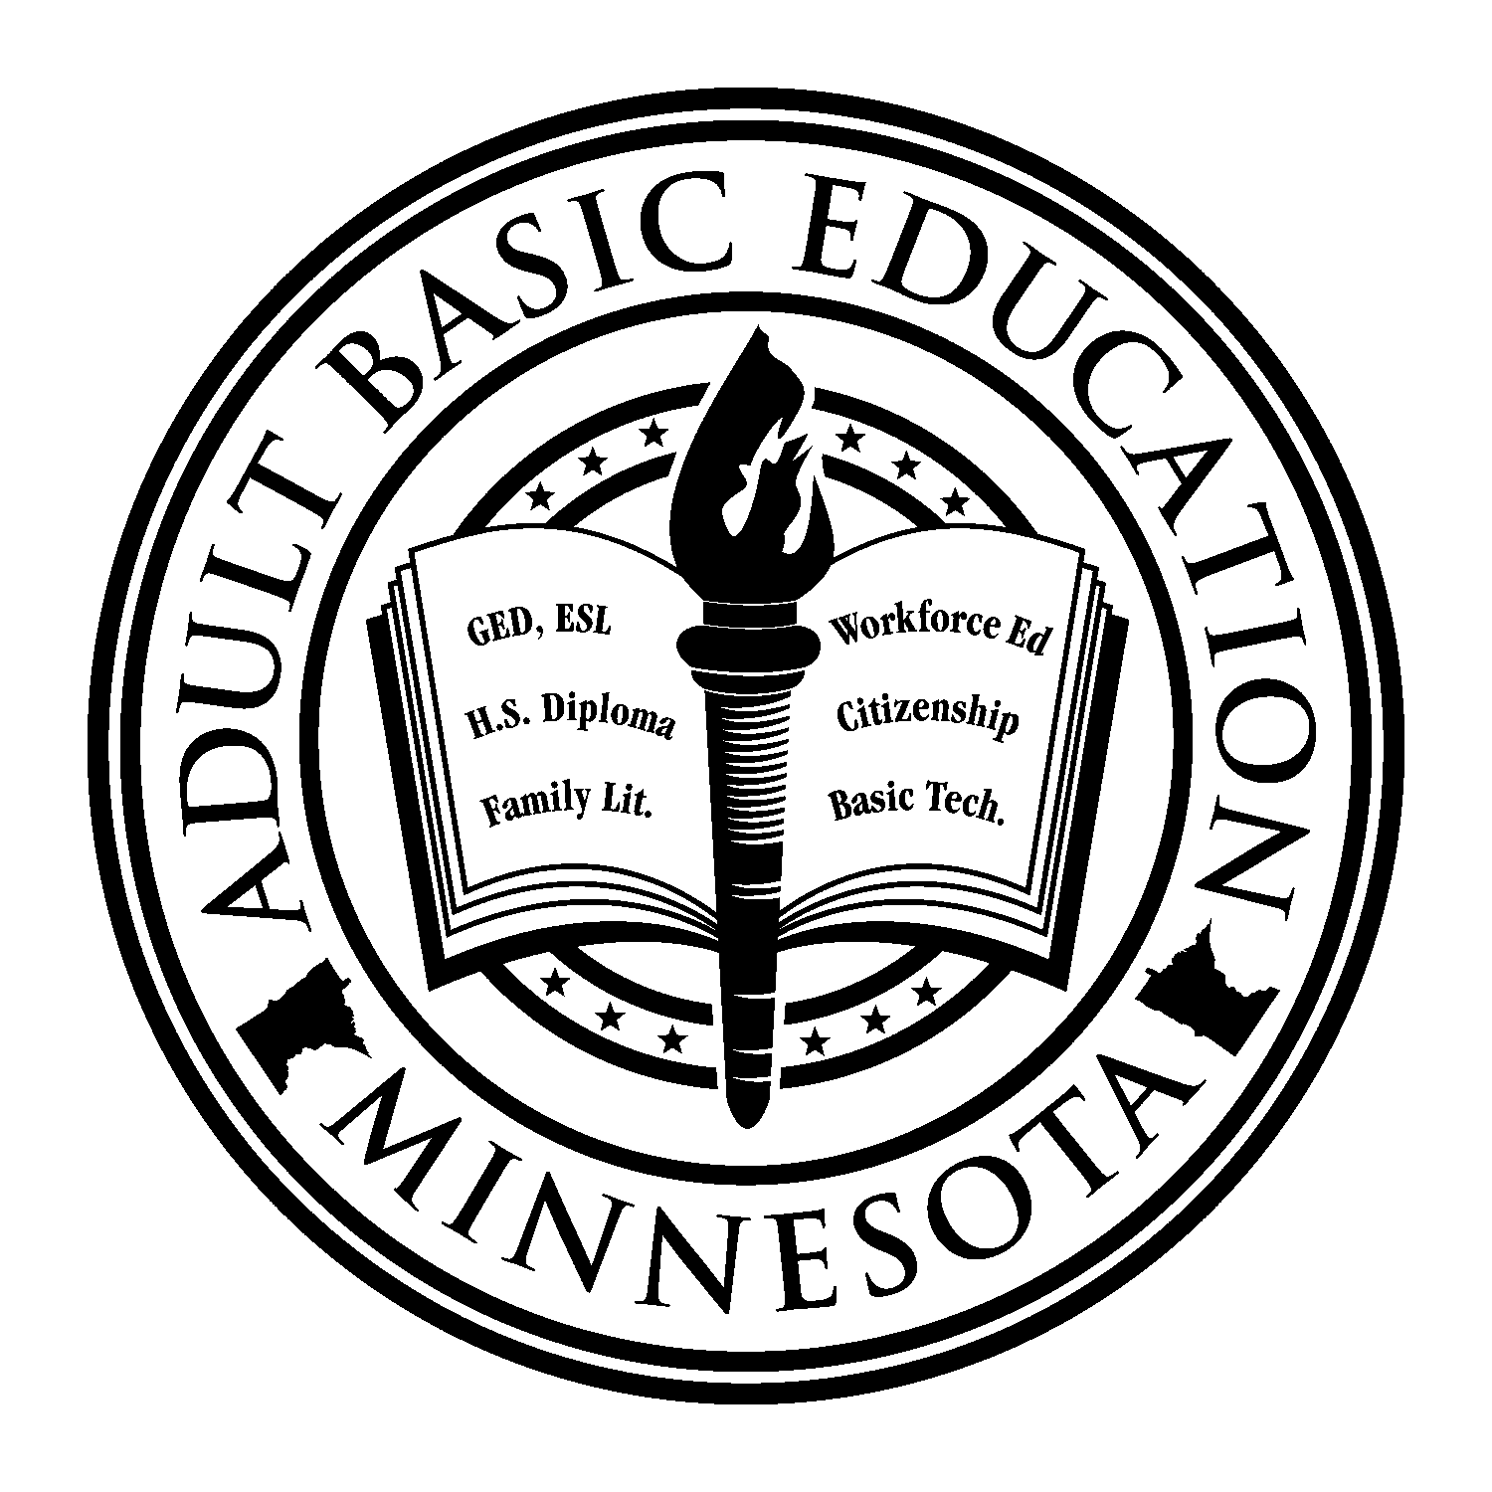
Minnesota Adult Basic Education Assessment Training –
Southwest Adult Basic Education

Minnesota Adult Basic Education –
Department of Education

Visit the ABE Support Services resource page on the mnabeassessment.com website: http://www.mnabeassessment.com/ click on the SPARC tab.

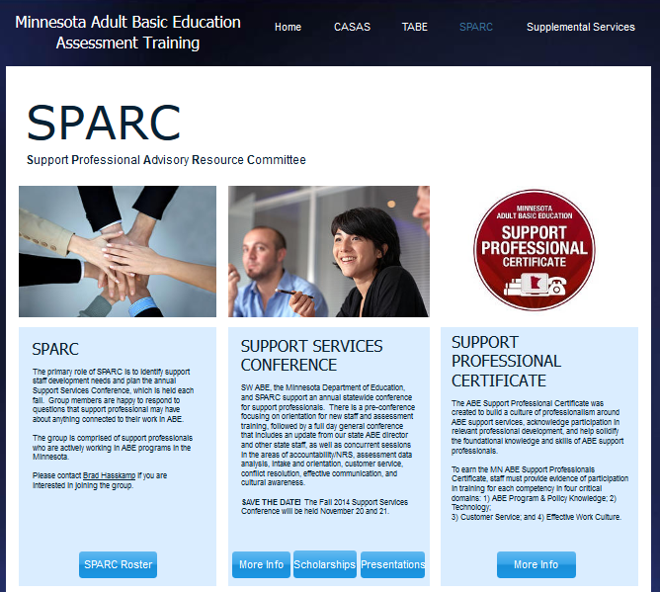
- The www.mnabeassessment.com website has resources and information on ABE in MN, accountability and NRS, assessment, teaching resources, Supplemental Services, and more
- The SPARC tab has information and contacts for the Support Professionals Advisory & Resource Committee (SPARC)
- There is also information regarding the annual Support Services Conference
- Learn more about the Support Professional Certificate

Visit the UPDATED MN ABE website http://www.mnabe.org/

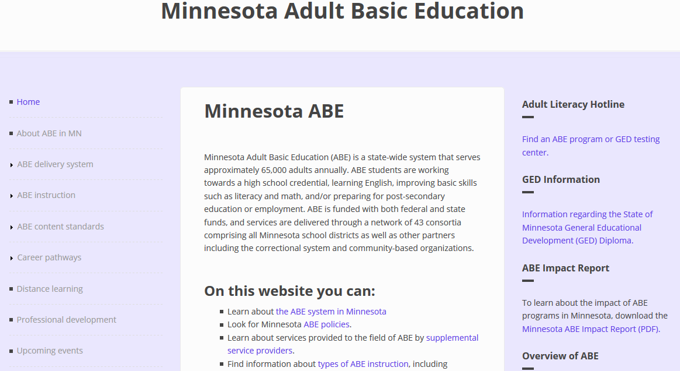

Resources and information on:
- ABE system in Minnesota
- ABE law and policy
- Accountability and NRS
- Contacts and directories
- Professional development
- Supplemental Service providers
See also the ABE Supplemental Services page on the SW ABE Assessment website:
https://www.mnabeassessment.com/supplemental-services

ABE Supplemental Service providers offer assistance to all approved ABE programs for activities such as professional development, volunteer training, low-incidence needs, and technological innovation.

Conference Agenda

Thursday, November 30 – MDE Conference Center B (CC-16, 17)

8:30 a.m.-9:00 a.m. |  | Registration/Refreshments
9:00 a.m.-12:00 p.m. |  | *ABE Support Staff Orientation – Becca Bair, Heather Williams and Dave Haugen
12:00-12:30 p.m. |  | Lunch (for those who pre-registered for lunch)
12:30-3:30 p.m. |  | *CASAS Implementation – Linda Keller and Kellie Hoyt  This session covers selecting and using the appropriate CASAS test, interpreting test scores, and measuring student progress. Discussion will focus on CASAS appraisals, pre‐ and post‐tests, and introduce online instructional resources. Participants who complete this session are authorized to order and administer CASAS multiple-choice assessments. Participants will received a copy of the CASAS Handbook.
3:30-3:45 p.m. |  | Break
3:45-5:45 p.m. |  | *TABE Implementation – Marty Olsen and Dave Haugen  This session covers selecting and administering the appropriate TABE test, interpreting test scores, and measuring student progress. Discussion will focus on best practices for using the TABE Locator, and pre‐ and post‐tests. The use of the Individual Diagnostic Profiles to determine instructional needs will be explained. Print and online instructional resources will be discussed. Participants will receive a copy of the TABE Administration Handbook.
* NOTE: These sessions are intended for anyone who is not CASAS or TABE certified,
or is new to ABE. This means that you are welcome to attend this portion of the conference even if you do not have program support duties.

Friday, December 1– MDE Conference Center B (CC-15, 16, 17, 18)

8:30-9:00 a.m. |  | Registration/Refreshments
9:00-9:55 a.m. |  | Welcome/Opening Session
9:55-10:05 a.m. |  | Break
10:05-11:30 a.m. |  | Concurrent Session 1 (descriptions on following pages)
11:30 a.m.-12:10 p.m. |  | Lunch
12:10-1:35 p.m. |  | Concurrent Session 2 (descriptions on following pages)
1:35-1:45 p.m. |  | Break
1:45-3:10 p.m. |  | Concurrent Session 3 (descriptions on following pages)
3:10-3:25 p.m. |  | Closing Session & Evaluations

Session Schedule, Descriptions & Locations: DECEMBER 1

TIME | SESSION | ROOM
8:30-9:00 | Registration and Refreshments
9:00-9:55 | Welcome – Todd Wagner, MN Department of Education; Marty Olsen, SW ABE - Worthington and MN ABE Assessment Supplemental Services Grant; Dave Haugen, Minneapolis ABE, SPARC Chair | CC-15
9:55-10:05 | Break
CONCURRENT SESSION 1:
10:05-11:30 | Google Makes Online Forms a Breeze - Susan Wetenkamp-Brandt  Google forms – a feature of Google Docs/Drive – allow you to create online forms to collect information through the internet and email, and display it in a spreadsheet. Surveys, evaluation forms, information requests, training registrations, and volunteer applications are just a few of the uses of this powerful, yet easy to use, application. We’ll work hands-on, so please bring your Google account login information so you can fully participate. | CC-17
 | Measuring our Progress: State ABE Discussion - Todd Wagner, Brad Hasskamp, Jenny Schlukebier  Join state ABE staff to take a deeper dive into accountability topics like measurable skill gain, give input on the state assessment policy, and raise your questions about reporting, data, WIOA and other ABE hot topics. | CC-18
 | Understanding Immigration in Challenging Times - Michele Garnett McKenzie  Recent changes to federal policy, including the announced end of DACA, travel bans, and increased detention and deportation capacity have increased the challenges faced by immigrant and refugee learners. Learn immigration basics, how new policies impact Minneapolis learners and their families, and how to connect to trusted legal resources. | CC-15
 | How to Reduce and Defuse Classroom Conflict - Colleen Crossley  Adult education classrooms are made up of students from many backgrounds and cultures, often with different expectations, goals, and levels of educational experience. How can we promote equity and inclusion while recognizing each student’s individuality? This workshop will cover the roots of conflict, differing types of conflict, and the role of communication skills.  This workshop addresses re-licensure for Positive Behavioral Intervention Strategies. | CC-16
11:30-12:10 | Lunch and Networking | CC-15/16

TIME | SESSION | ROOM
CONCURRENT SESSION 2:
12:10-1:35 | SiD Reports/Excel – Jenny Shlukebier Urban Planet  Take a look at reports available in SiD, from attendance to testing information, level gains and goals. Share ideas about how to put this information to use. Learn tips and tricks for exporting and organizing information in excel. There will be time for questions and answer. | CC-17
 | What’s New at GED Testing Service? - Jim Afdahl, Jane Bledsoe, Mellissa Hulltstrand  We will discuss and review new GED offerings, including GED Live, a program to supplement classroom instruction, partnering with Kaplan, and GED Flash, a digital flash card program, developed in conjunction with Aztec. We will also reserve some time for the participants to Ask GED Anything. | CC-16
 | Considering Poverty in ABE - Jodi Versaw, Julie Dincau  Poverty and socioeconomic disparities are key issues that affect ABE students across Minnesota. In this session participants will consider history and information about poverty, as well as recommendations for working with individuals experiencing poverty. Information and resources from this session are drawn from work by Dr. Donna Beegle, an author, leader, and expert trainer in addressing poverty nationwide. | CC-15
 | Bridges to Benefits - Presenter name, Children's Defense Fund of Minnesota  Bridge to Benefits improves the economic stability of low-income families by connecting them to several public work support programs and tax credits that can fill the gap between low wages and a basic needs budget. The project relies on a website that is a one-stop shop for information and includes a screening tool that lets families know which programs they appear eligible. There is also a referral process that connects families to application assistance. | CC-18
1:35-1:45 | Break

TIME | SESSION | ROOM
CONCURRENT SESSION 3:
1:45-3:10 | SiD Barriers to Employment/Goals and NRS Tracking - Jenny Schlukebier  Question and answer time on tracking items required by state and federal guidelines as well as information for your local program reporting. Discuss best practices for both gathering and using this information in SiD. | CC-17
 | Bearing Witness: Traumatic Stress and the Helping Professional - Angie Lewis-Demello  Participants will learn to identify and monitor indicators and symptoms of secondary traumatic stress conditions and their impact. Participants will learn to recognize important differences among vicarious trauma, secondary traumatic stress, compassion fatigue, and burnout and their implications for job performance. We will address strategies to prevent and diminish the effects of secondary stress conditions. This course will address organizational culture and environment and provide meaningful methods for addressing workload and organizational response strategies. | CC-16
 | Advice on Advising - Central MN East, Dept of Corrections, Austin ABE, and Detroit Lakes ABE  Advising is an integral part of serving all Adult Basic Education students, from low-level English language learners up to those students who are transitioning into college. We may not be experts on advising, but our panelists will give you some advice on how to advise your students. Hear from several unique programs who have created and are using different models and strategies for advising. | CC-15
 | Critical Issues in Assessment – Linda Keller and Marty Olsen  Does your program offer the 50 Hour Club? Do you have a 40 Hour Passport? This session will provide information on best testing practices, updates to current assessments, CASAS and TABE validity charts, review of program practices for returning students, along with information on the new data system. Bring all of your testing questions. | CC-18
3:10-3:25 | Closing Session & Evaluations (in concurrent session rooms)

Many Thanks
to those who planned and/or supported this conference!

- Becca Bair, South Washington County ABE Program
- Shannon Drew, Osseo ABE
- Marylynn Dvorak, Metro South ABE
- David Haugen, Minneapolis ABE
- Jennifer Hennes, Southwest Metro ABE
- Maiyia Her, St. Paul ABE
- Linda Jacobs-Buse, South Suburban ABE
- Linda Keller, Metro North ABE
- Kristen Loken, Adult Options in Education
- Marty Olsen, Southwest ABE
- Jenny Schlukebier, Urban Planet
- Heather Williams, Robbinsdale ABE
- Todd Wagner, MN Department of Education
- Brad Hasskamp, MN Department of Education
- Jodi Versaw, MN Department of Education
- Cherie Eichinger, MN Department of Education

Introducing Our Presenters

Jim Afdahl is the Minnesota State Relationship Manager for GEDTS, the main contact for all strategic and operational testing aspects between Minnesota’s state and local ABE agencies and GEDTS.
James.afdahl@GEDtestingservice.com
Becca Bair attended Southwest Minnesota State University in Marshall, Minnesota, majoring in social work. She has worked as the Program Assistant in the South Washington County Schools Adult Basic Education Program since August 2011. bbair0@sowashco.k12.mn.us
Jane Bledsoe, as Senior Product Manager, is responsible for the rollout of all new and existing products to the market place, including GED Ready, GED Manager, GED Live and GED Flash. Jane.bledsoe@GEDtestingservice.com
Colleen Crossley teaches at the Robbinsdale Adult Academic Program. Colleen has completed STAR, MNI, and UDL training. She has been a consultant and presenter for PANDA-Minnesota ABE Disability Specialists since 2015. colleen_crossley@rdale.org
Julie Dincau is the ABE Transitions Specialist at the Minnesota Department of Education.
julie.dincau@state.mn.us
Amy Fish is the ABE Program Coordinator for Detroit Lakes Adult Basic Education. She taught special education and vocational education from 1998-2005. On returning to her hometown, she accepted a position at Detroit Lakes ABE. Adult Basic Education is her dream job! afish@detlakes.k12.mn.us
Brad Hasskamp is the ABE Policy and Operations Specialist at the Minnesota Department of Education. His past roles include Literacy Minnesota President, SPCLC Professional Development Advisor, MLC ABE Learning Centers Manager, and Neighborhood House ELL/Family Literacy Manager. brad.hasskamp@state.mn.us
Dave Haugen is the assessment coordinator for MPS and a state certified TABE assessment trainer. He has worked with Minneapolis ABE since 2013 and serves as the chair of the 2017 SPARC conference.
david.haugen@mpls.k12.mn.us
Kellie Hoyt is a site coordinator for MPS and a state certified CASAS trainer. She has worked with Minneapolis ABE since 2006, after starting with the program as a volunteer. kellie.hoyt@mpls.k12.mn.us
Mellissa Hultstrand is a member of the GED Technical Operations Team and is often the go-to person for operational questions. Mellissa also leads many GED webinars on many topics.
Mellissa.Hultstrand@GEDtestingservice.com
Linda Keller is the ABE Accountability Coordinator for Metro North ABE and manages SiD for the consortia, as well as provides CASAS and TABE Implementation Training locally, and through the Supplemental Services Grant with MN ABE Assessment. Lindam.keller@ahschools.us
Angela Lewis-Dmello, MSW, LICSW, is the Family Services Director at CornerHouse, Community Adjunct Faculty at the University of Minnesota School of Social Work, and the founder of Transforming Trauma, PLLC. Transformingtraumamn@gmail.com
Theresa Luther-Dolan leads transitions education efforts for the Minnesota Department of Corrections, including coordinating the MN Department of Education’s state standard adult diploma pilot program at 5 correctional facilities. Her experience working with adults in transition spans over 25 years as an Adult Basic Education educator and program manager, Chief GED Examiner, workforce development counselor, and Community Education Director in greater Minnesota. She’s been passionate about adult basic education and transitioning adults to careers since she began teaching ABE in Northeastern MN in 1992. theresa.luther@state.mn.us
Stacy Mason is the Navigator for the Adult Learning Center in Austin, Minnesota. stacy.mason@austin.k12.mn.us
Michele Garnett McKenzie is the Deputy Director of The Advocates for Human Rights. An expert in immigration, asylum, and human trafficking, Michele leads AHR's advocacy on domestic priority issues. She holds a J.D. from the University of Minnesota and a B.A. from Macalester College. mmckenzie@advrights.org
Caroline Nerhus serves as the ABE Coordinator for Central MN-East Adult Basic Education and serves as a Regional Transitions Coordinator for Mid-Central Transitions region. Advising has become an integral part of orientation and everyday interaction with students in her one-room schoolhouse setting. cnerhus@c-ischools.org
Marty Olsen is the manager for SW ABE–Worthington and Jackson regions. She is a nationally-certified CASAS assessment trainer and state-certified TABE assessment trainer. martha.olsen@gmail.com
Jenny Shlukebier previously worked at the St. Paul Schools Adult Basic Education program (Hubbs Center) and recently moved to the Urban Planet Software Company where she is working to build the new data system. jenny@urbanplanet.com
Jodi Versaw is the ABE Program Quality Specialist at the Minnesota Department of Education.
jodi.versaw@state.mn.us
Todd Wagner is the State Director and the Assessment and Evaluation Specialist for Adult Basic Education at the Minnesota Department of Education. todd.wagner@state.mn.us
Heather Williams is the Student Data and Assessment Specialist for Robbinsdale Adult Academic Program. She has been working in ABE for three years, coming from a marketing and higher education background.
heather_williams@rdale.org
Susan Wetenkamp-Brandt has been working with technology and online learning in ABE for 15 years. She provides training, technical support, and consultation to ABE practitioners on best practices in technology integration, digital literacy, and distance learning. swbrandt@mnliteracy.org

