Bird Species Selection

Name:

Period:

Select a species native to- or migratory through- our region.

Species Common Name:

Scientific Name:

On a separate drawing paper, make a sketch of the species that includes identifying features and color. Use colored pencils.

Write a physical description:

Conservation Status:

Bird Family:

Migration:

Habitat:

Feeding Behavior:

Diet:

Nesting:

Eggs:

Young:

Sources:

Construction Plan:

Type of structure (bird house, nesting box, feeding station)

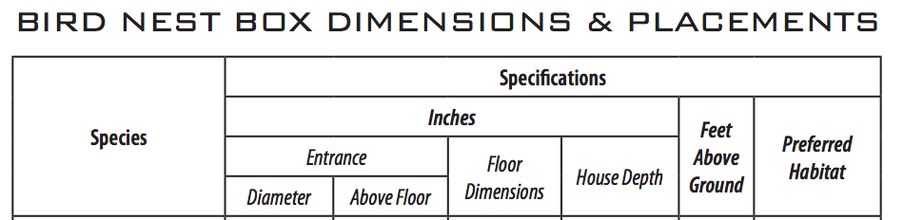

|  |  |  |  |  |  |  |
| --- | --- | --- | --- | --- | --- | --- |
|  |  |  |  |  |  |  |

Make a diagram of basic layout. This may change later as your architectural features change but should reflect minimum requirements of basic dimensions.