Accessing My School, Office 365, Email and Teams from home – Help sheet for pupils & parents
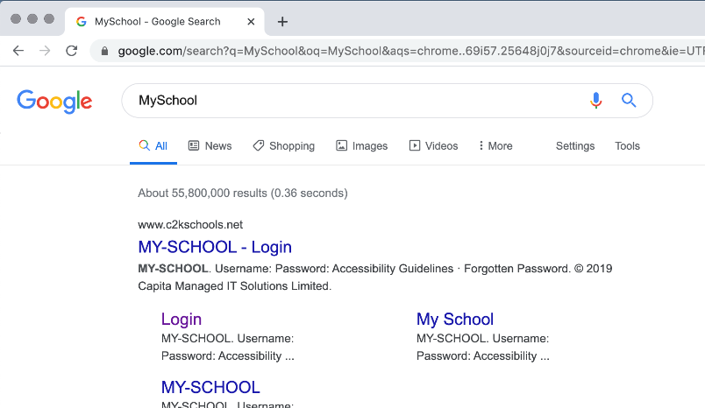
Please follow the steps illustrated below to access school work from home. The screenshots which follow are taken from the Chrome browser.

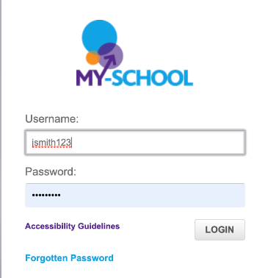
- Search for MySchool and select the link to login to My School

- When prompted, enter the pupil username and password
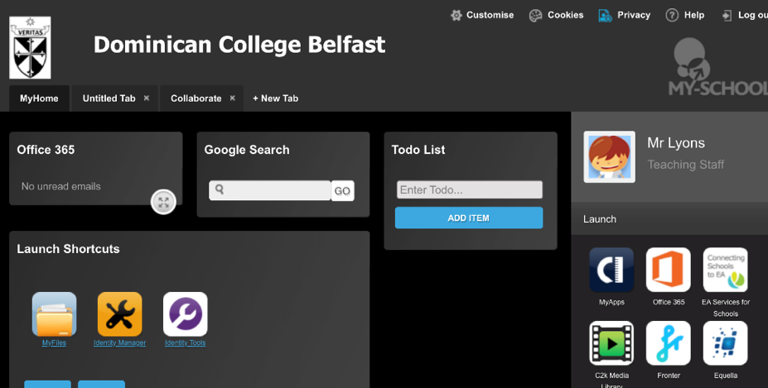
- The normal MySchool window will now load.

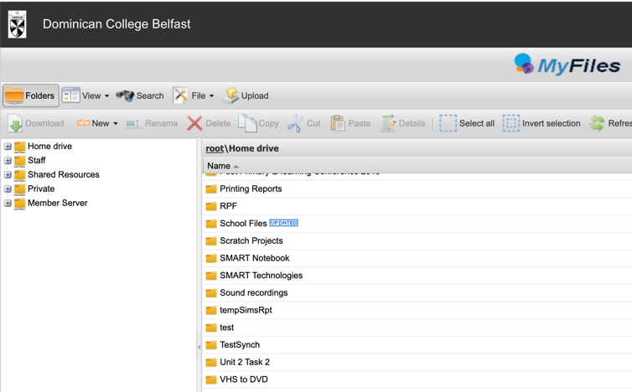
- The ‘MyFiles’ tile can be selected to enable access to a pupil’s ‘My Documents’ folder in school.
NOTE – this enables files on the school network to be downloaded to a home computer. If these files are updated at home, the updated version will NOT automatically be saved back to the school network.
Pupils should also be aware that the ‘MyFiles’ facility works very slowly

- To access school email and Office365 applications like Teams, pupils should use the same MySchool window (above) and select the ‘Office365’ tile.
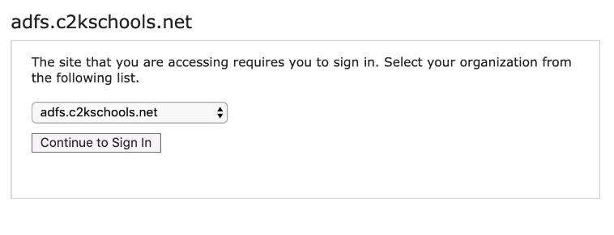

- At this stage press the ‘Continue to sign in’ button and you will be prompted to enter the relevant login details again.

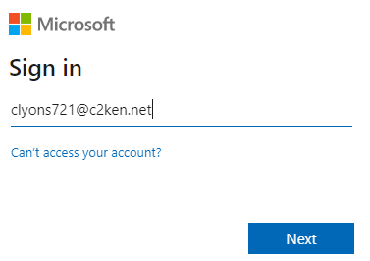
- The Office365 suite of applications should now be available from within the browser window. Included here are online versions of the main Microsoft applications as well as Teams which many departments are using as an e-learning solution.
jsmith123

- The Outlook application enables pupils to access their email from home.

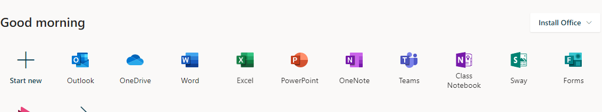
- Pupils and parents are reminded that they can use the ‘install office’ option to install the full versions of Word, Excel, etc on their local computer. For this, and any other time that pupils are prompted to enter their full email address, please use the format jsmith123@c2ken.net as illustrated.

- Pupils are reminded that all activity and interactions within the MySchool/Office365/Teams environment is monitored. Pupils are reminded that any interactions with staff should follow the same protocols and standards of behaviour that apply in school.

