Workshop prepares youngsters for employment
Posted by Indian Newslink
Date: January 13, 2018
in: Latest Stories
Leave a comment
21 Views
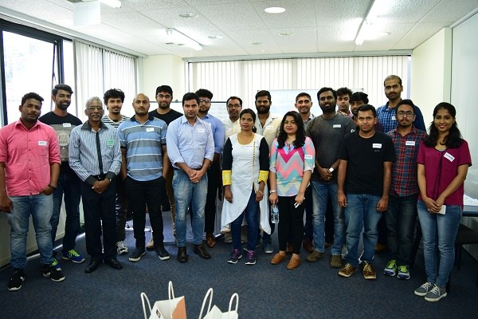
Staff Reporter
Auckland, January 14, 2018
More than 15 Tamil migrant students attended a four-hour Employment Workshop in Auckland on Sunday, January 7, 2018.
Organised by the Auckland Tamil Association, the Workshop was conducted by Adon Kumar, an Auckland based English Language Coach and Lecturer.
The attendees acknowledged that their current CVs and Cover Letters were not effective as they received either no responses or the usual “Sorry, decline or unfortunately….” reply emails.
Inappropriate CVs
Mr Kumar gave examples of migrant CVs where the language, content, format and presentation of one’s credentials did not meet the employers’ requirements or expectations. He demystified the assumption of many migrants that qualifications alone will secure a good job.
He said, “it is not what you have but what you can actually do that makes an employer want to hire you.”
Mr Kumar said that the purpose of a CV is not to get a job but to convince the employer to provide an opportunity to attend a job interview.
He taught them how a CV and Cover Letter should be written to attract employers New Zealand and how get invited to a Job Interview.
During the practical and interactives sessions, a number of students were asked to participate in Mock Job Interviews where they learned how to answer open questions that Kiwi employers normally ask. They learned a specific model that they could use to confidently answer situational, hypothetical and behavioural questions.
Auckland Tamil Association President Vai Ravindran said that the evaluation of the Workshop by the attendees gave high scores for the quality, content and usefulness of the sessions.
“As a result, a number of students have already made appointments with Mr Kumar for career advice and to help write their Kiwi CVs and Cover Letters,” he said.
*
Photo Caption:
Adon Kumar (third from left) and Vai Ravindran (Backrow, Centre) with the attendees at the Auckland Workshop held on January 7, 2018. (Picture Supplied)
*
