Sergei V. Lavrov
Minister of Foreign Affairs Smolenskaya-Sennaya pl, 32/34 121200 Moscow, Russian Federation, Fax: ( 7 095) 244 2203

Vladimir V. Ustinov Minister of Justice
ul. Vorontsovo pole, 4
109830 g. Moscow, Russian Federation Fax: (7 495) 955 5779

July 24, 2007

Dear Minister Lavrov and Minister Ustinov,

Human Rights First urges the Russian government to immediately release defense attorney Mikhail Trepashkin. The July 20, 2007 decision of the European Court of Human Rights holds that the conditions of Trepashkin’s detention amount to inhuman and degrading treatment and are a violation of Article 3 of the European Convention on Human Rights.

This judgment validates numerous letters and appeals by Trepashkin and his lawyers referring to his deteriorating physical and mental state while in detention. However, financial damages awarded by the Court cannot adequately compensate Trepashkin for his wrongful imprisonment and the denial of his human rights.

The conditions under which Trepashkin is being held in Nizhny Tagil are inhumane. He has been deprived on countless occasions of sleep, denied adequate medical attention for his severe asthma, and subjected to harassment by prison staff and authorities. As late as March, 9, 2007, a district court in Nizhny Tagil ruled for Trepashkin’s transfer to a prison colony, where conditions only worsened. Moreover, the judge refused to hear requests to transfer Trepashkin to a prison hospital to receive treatment for his severe asthma. Trepashkin's conditions of detention are in clear violation of the U.N. Standard Minimum Rules for the Treatment of Prisoners, which specifies that: "Sick prisoners who require specialist treatment shall be transferred to specialized institutions or to civil hospitals." (Article 22) Trepashkin has also been imprisoned far from Moscow, his place of residence, which is a violation of Article 73 of the Russian Corrections Code.

Many Russian and international observers have expressed concerns that the judicial system is being misused in this and other cases to silence peaceful critics of the Russian government such as Trepashkin. Human rights defenders have an important contribution to make in all societies. The Russian government should support them rather than persecute them for their legitimate, beneficial activities. Releasing Trepashkin will show that the Russian government is upholding the basic rights to freedom of expression without unreasonable government interference. These rights are guaranteed in the Russian constitution and international human rights treaties that are binding upon the Russian Federation.

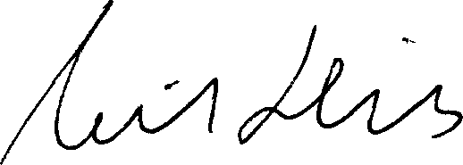
Thank you for your prompt attention to this serious matter. Sincerely,

Neil Hicks Director
Human Rights Defenders Program

cc:

Riina Kionka,
Personal Representative for Human Rights to the
E.U. High Representative

Thomas Hammerberg,
Commissioner for Human Rights of the Council of Europe

2 / 2

