Basic Photoshop Tutorial
The following will demonstrate how to edit images and add text in Photoshop. Photoshop is freely available as part of the Adobe Creative Suite available for staff to download at CCCU.
Tasks:
- Open Photoshop. Go to File – New (top left of the Photoshop window). On doing this, enter the pixel dimensions into the width and height dimensions (980 X 196 pixels is ideal for a Blackboard banner). Set the resolution to 72dpi (dots per inch) – this is the standard resolution for online images.
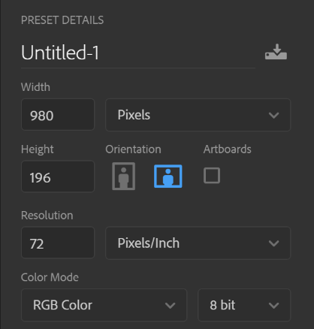
Click on the Create
- After doing this, use the Move tool to drag any images already open in Photoshop into your workspace.

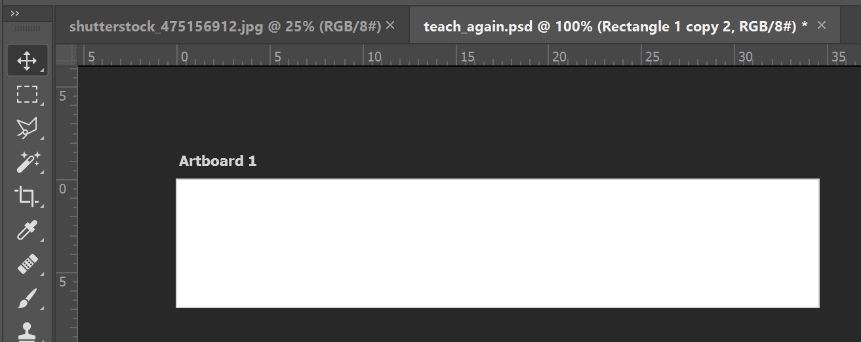
- Use the Move tool to alter the size of the picture within your Photoshop space.

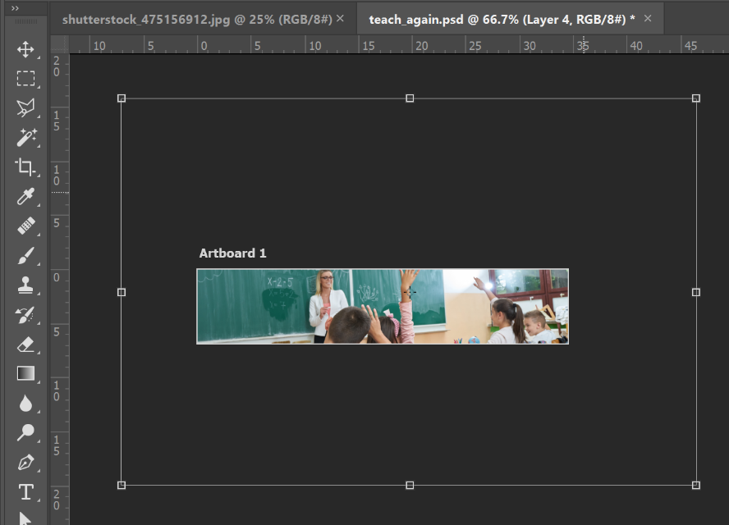
Adding Text to a Photoshop document

- Once you are satisfied with your image composition, we can add text. Select the Text (Horizontal Type) tool and drag over the image space.

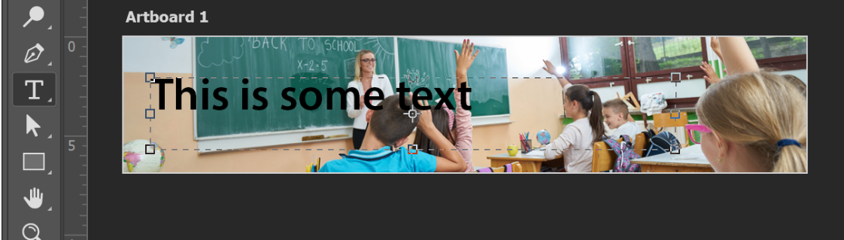

After doing this, type in some text. Use the options at the top of the Photoshop window to alter the font style and size of the text.

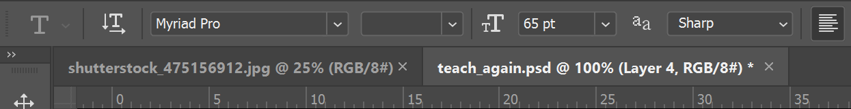

- Go to File – Save As. Ensure that you save your document as a .psd (photoshop) document. To save a version that can be imported to Blackboard, ensure that your also save a .jpg (JPEG) version too.

