Playposit online learning guide.

Playposit allows you to produce interactive videos that can challenge learners with a series of questions at different levels of learning.

Tasks:

- Go to Youtube and find a video relevant to your chosen learning theme. After you have done this, copy the Youtube video link at the top of the browser.

- Go to www.playposit.com

- Click on the Join Now button.

- Fill in the Sign Up form. Enter your name, email address and chosen password. Click on the Submit button.

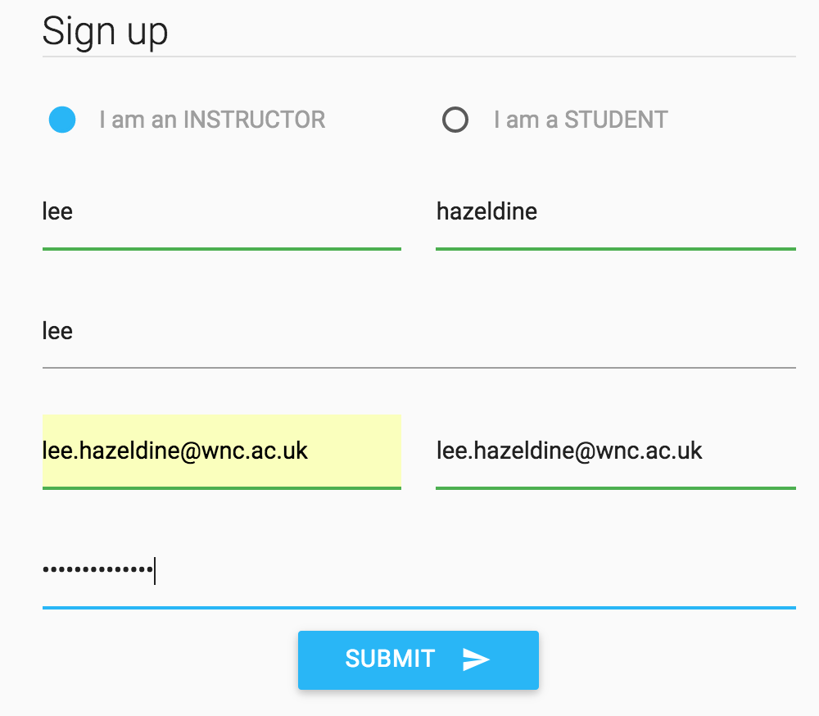

- Click on the Higher Education option within the Profile Setup section.

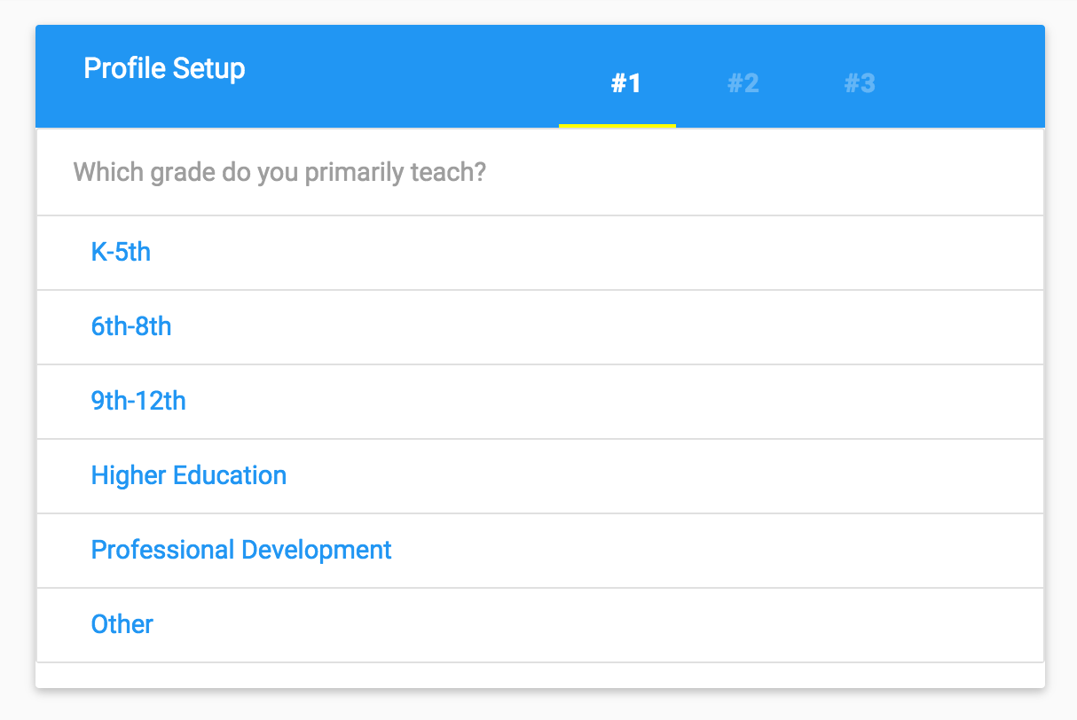

- Select the appropriate subject area (it does not matter if your subject choice is not entirely accurate).

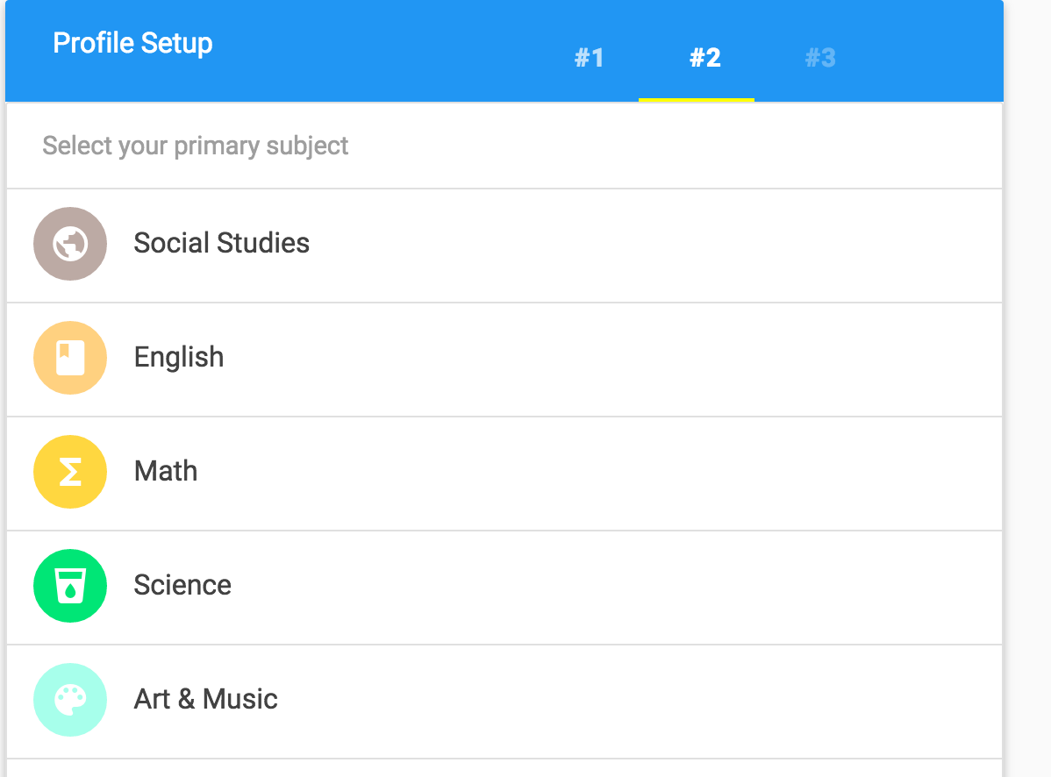

- Click on the ‘I plan to build lessons on videos I create’ option.

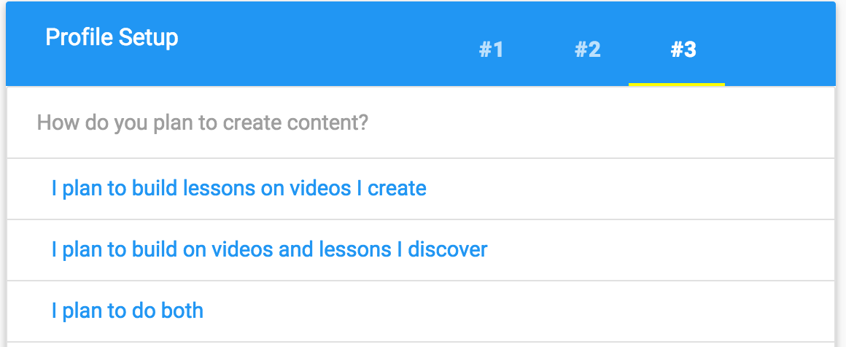

- Select the Design Video Bulb option.

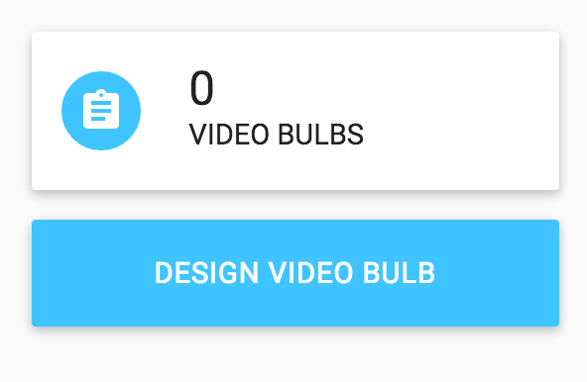

- Paste your Youtube video link into the Video URL box. Click on the Continue button.

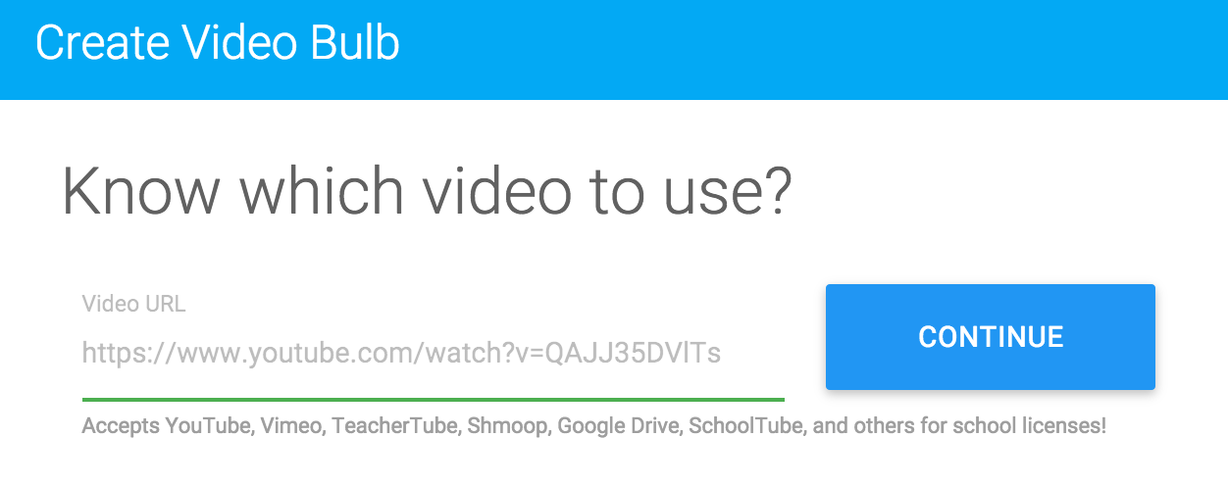
- Enter a learning title and learning outcome for your video lesson. Select a grade level, subject and subtopic. Click on the Begin Building button.

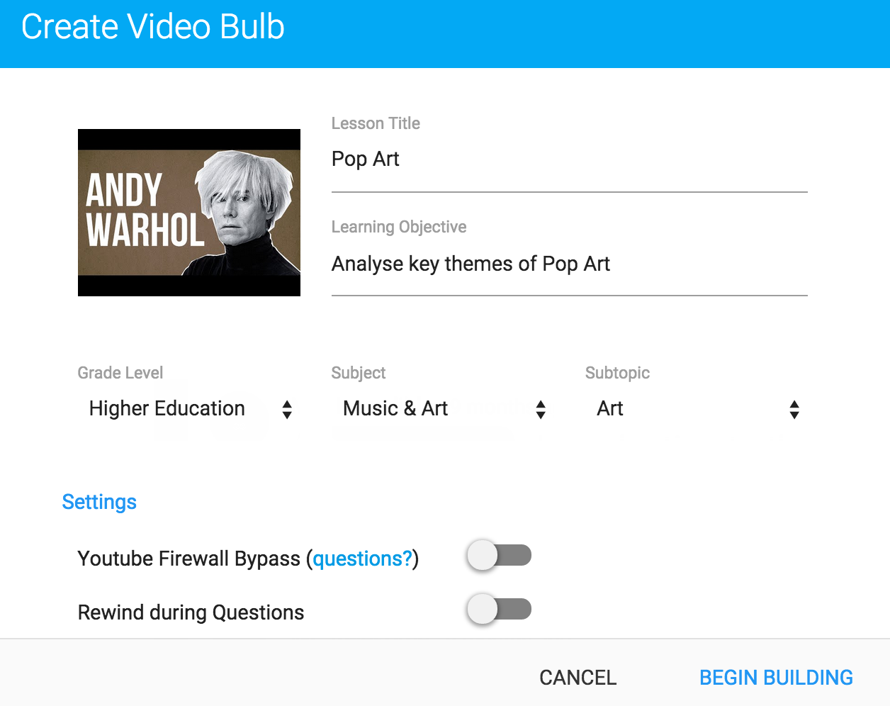

- We are now going to crop our video. Click on the Crop Video button and adjust the points on the blue bar to define the start and end for your video.

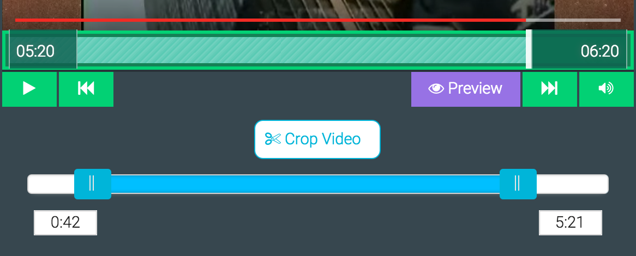

Once you are happy with your adjustment, click on the Crop Video button again.

- Select a point upon your video timeline that you wish to add a question. After you have done this, click upon the Add Question button.

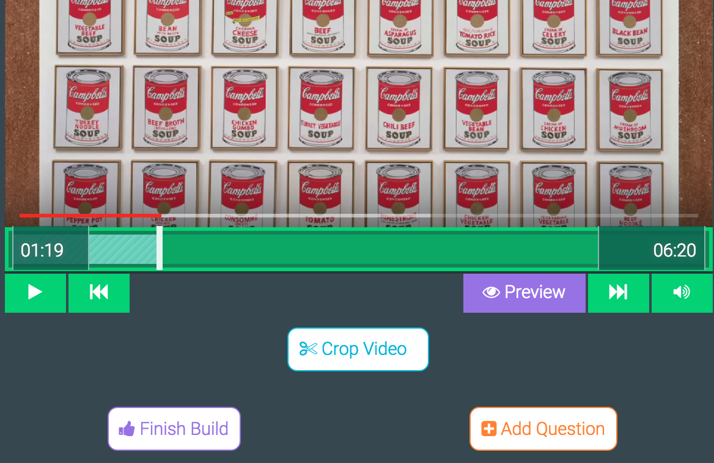

- Select a question type to add. In this case, we have chosen the multiple choice option.

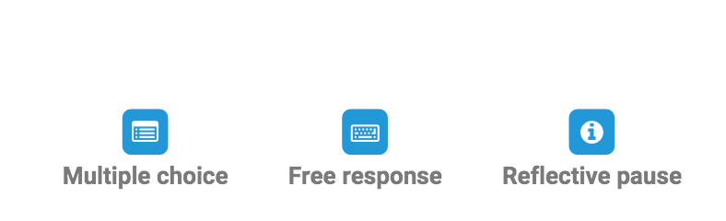
- Type in a question for the learner to address. Notice that you have the opportunity to type multiple answers with an explanation as to whether they are true or false. Remember to highlight which answer is correct (indicated by a button to the left of the answer).

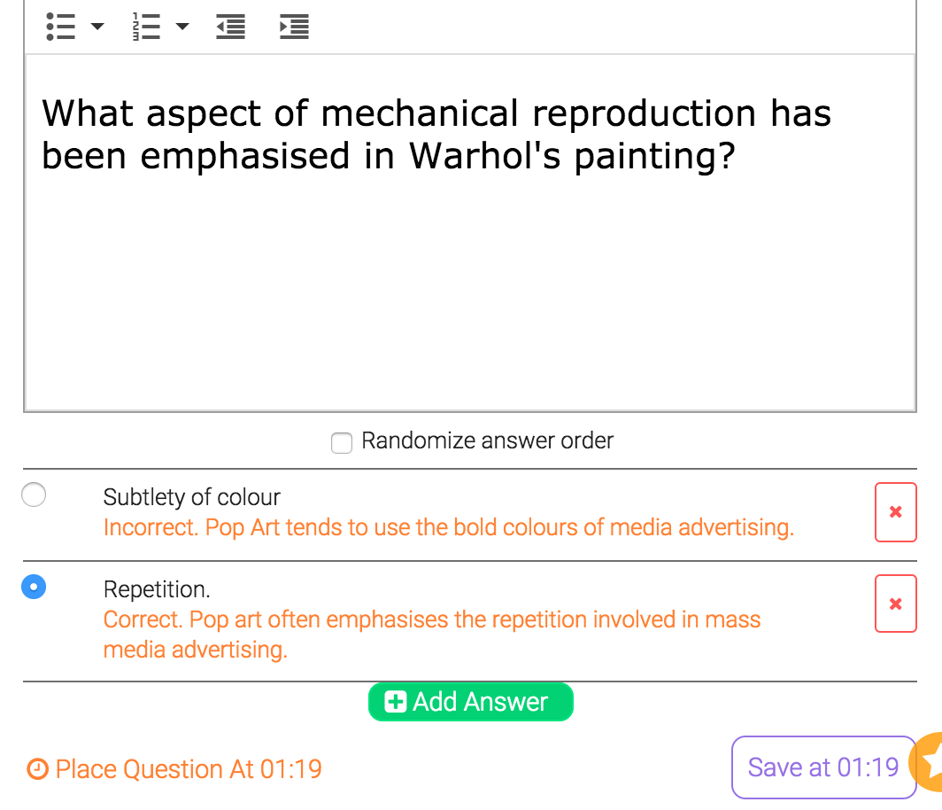
Answer

Explanation

‘Correct’ button

Question
Click on the Save button.

- After you have entered a series of questions and completed your video quiz, click on the Save and continue button.

- Click on the Save button.

Turn off the ‘Require students to register’ button, then click on the Manage Bulbs option.

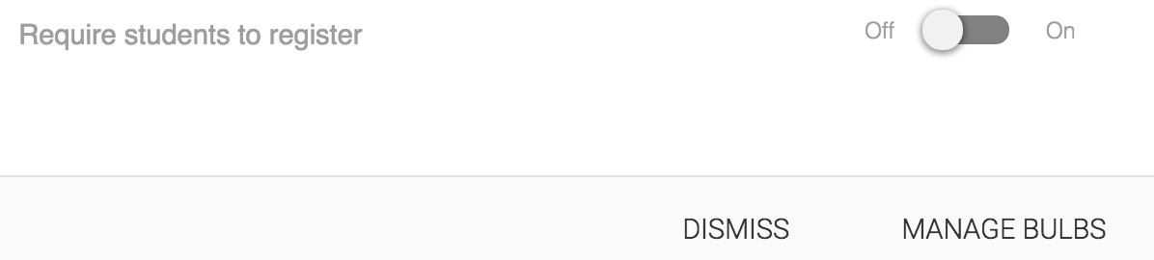

- Click on the Share option.
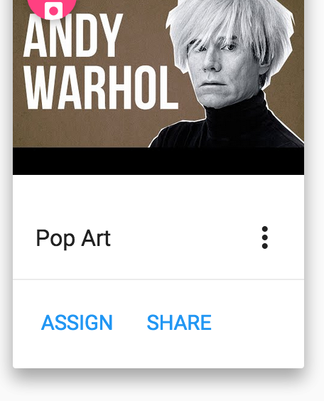
- Select the Colleagues option and copy the Embed Code.

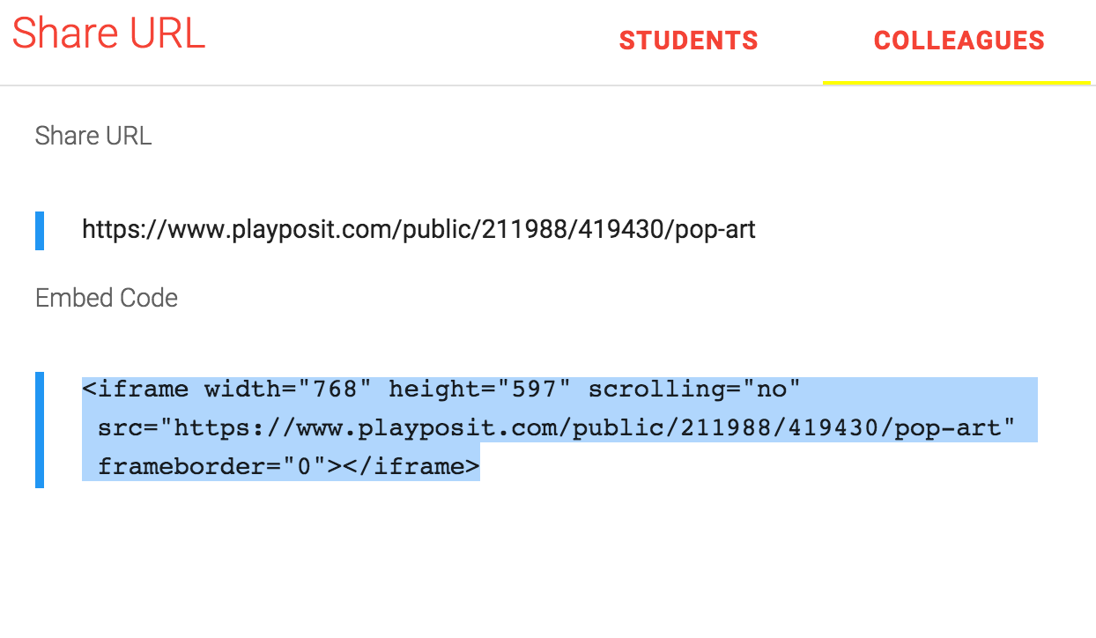
Your code is now ready to be embedded into Moodle.

