Aurasma and Augmented Reality

Aurasma makes it easy for you to embed augmented reality content into learning sessions. Augmented reality allows you to supplement images and physical environments with digital content such as images, videos and text.

Tasks:

- Go to http://www.aurasma.com

- Sign up to a new Aurasma account by clicking on Sign Up.

- Click on the Create New Aura option.

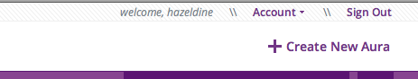

- Select the Click to Upload Trigger Image (this will be the image that triggers your augmented reality image).

Give your trigger image a Name and Description, then click upon the From File option to select your trigger image (remember to click upon the browse button).

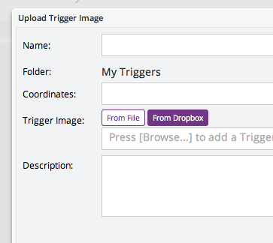

- Add overlay images / videos to create the Augmented Reality effect. Firstly, click upon the Click to Upload Overlay option.

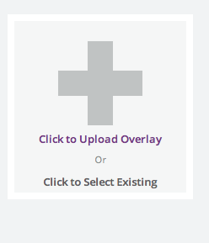
Give your overlay image a Name and Description, then click upon the From File option to select your trigger image (remember to click upon the browse button).

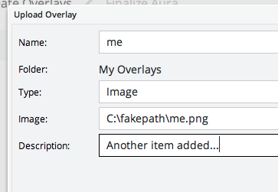

- On completing your Augmented Reality images / videos, click upon the Simulate button to test it with the Aurasma App upon your Smart Phone (you may need to log in with your username and password).

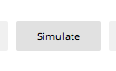
9) Print out your background image and test your Augmented Reality creation.

