Creating a blog using Wordpress

Tasks:

- Using Google Chrome, go to www.wordpress.com

- Click on the Start a Blog option.

- Click on the Get Started option.

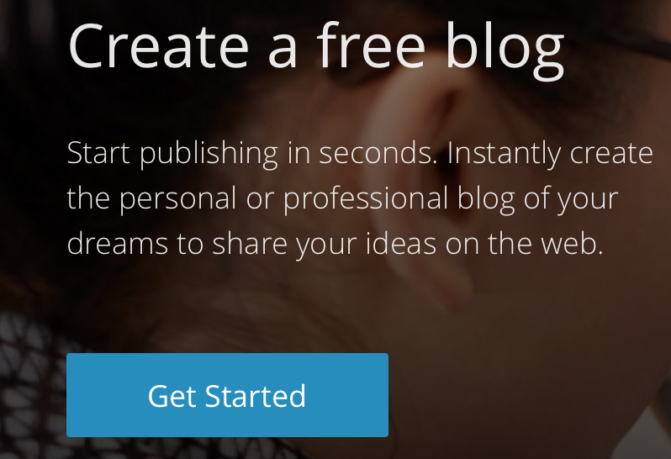

- Choose the Minnow blog style theme (subject to tutor approval, this might be able to be change at a later stage).

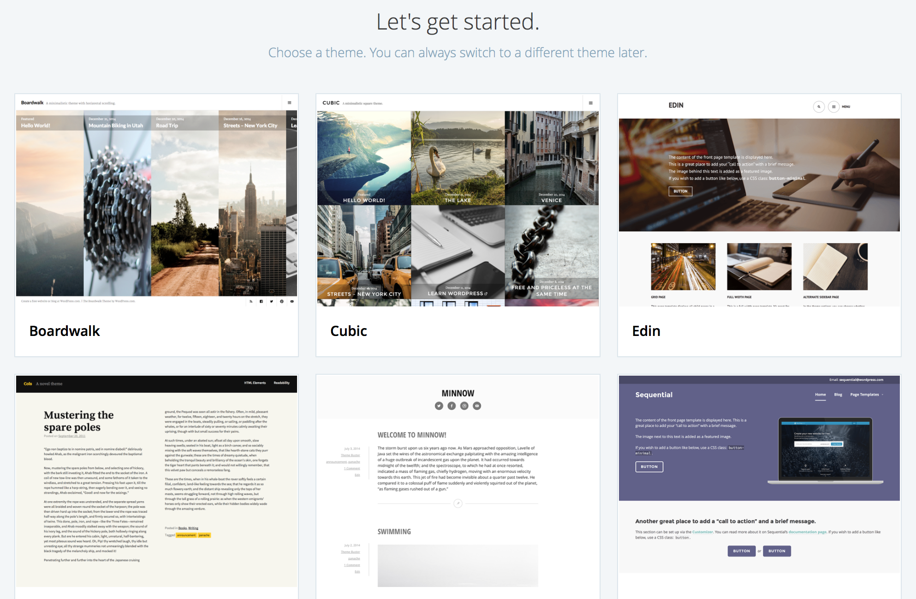

- After doing this, select a website address for your blog – use your name for your blog address. See below:

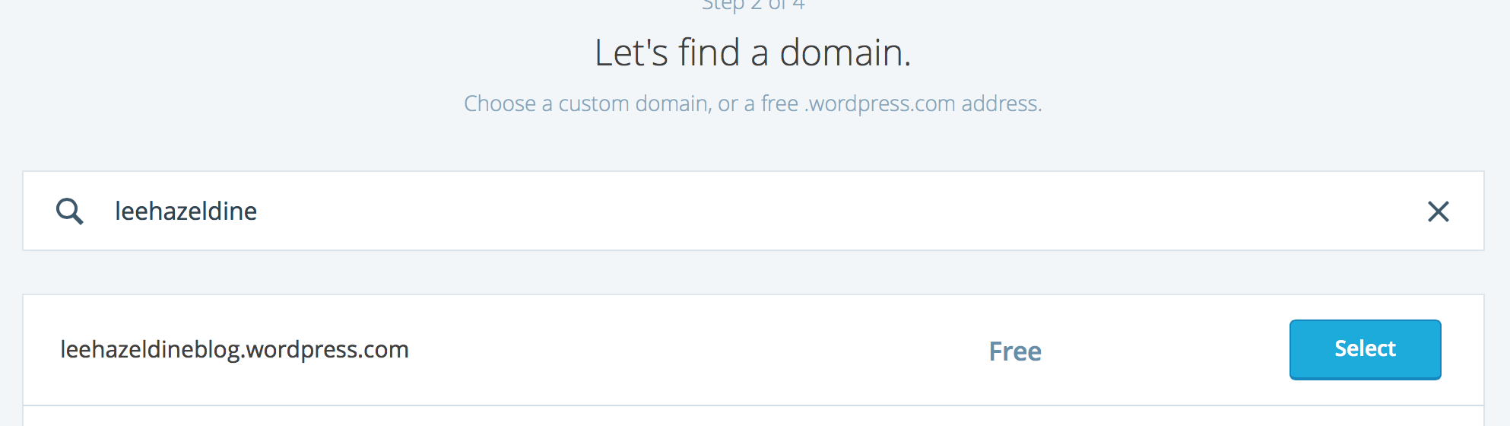

- Select the Free Plan.

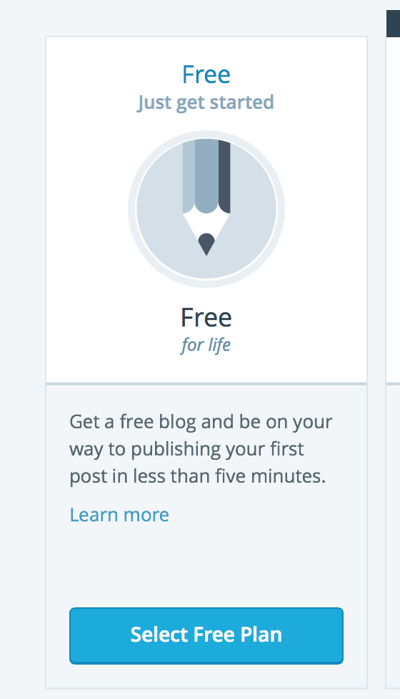

- Finally, create your blog account by entering your email address. On doing this, choose a username and enter a password (remember to write down your password somewhere safe so that you will remember it).

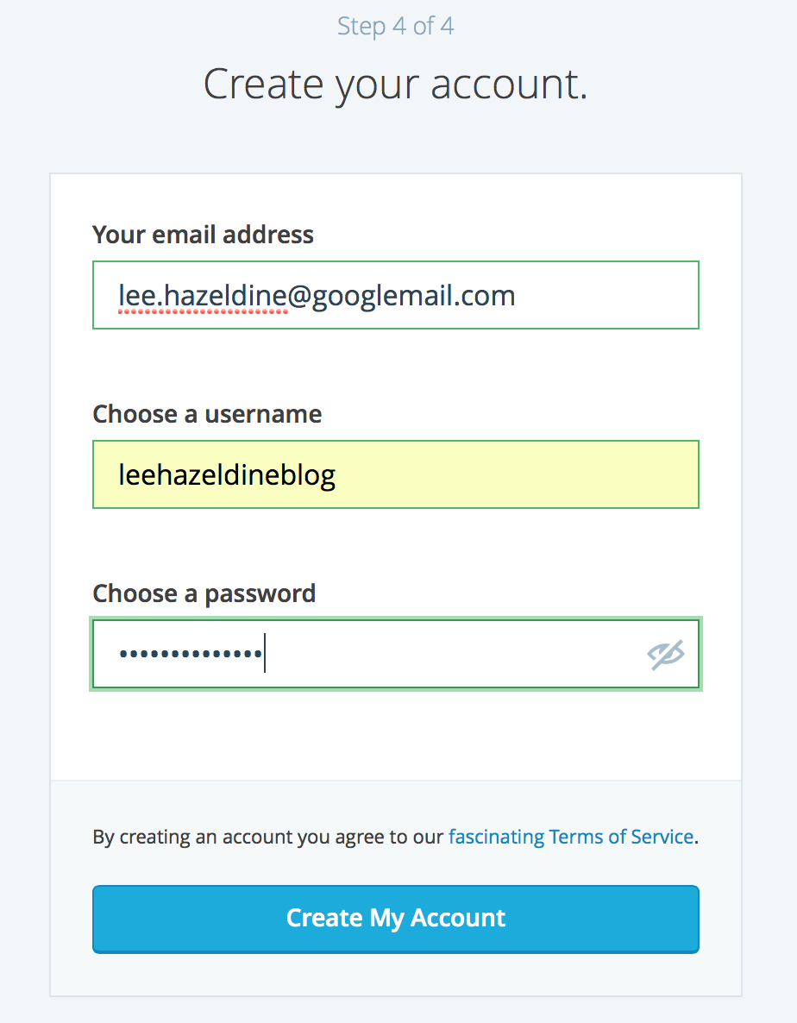

Adding Blog posts

We are now ready to add our first blog.

- Click on the Add blog post button.

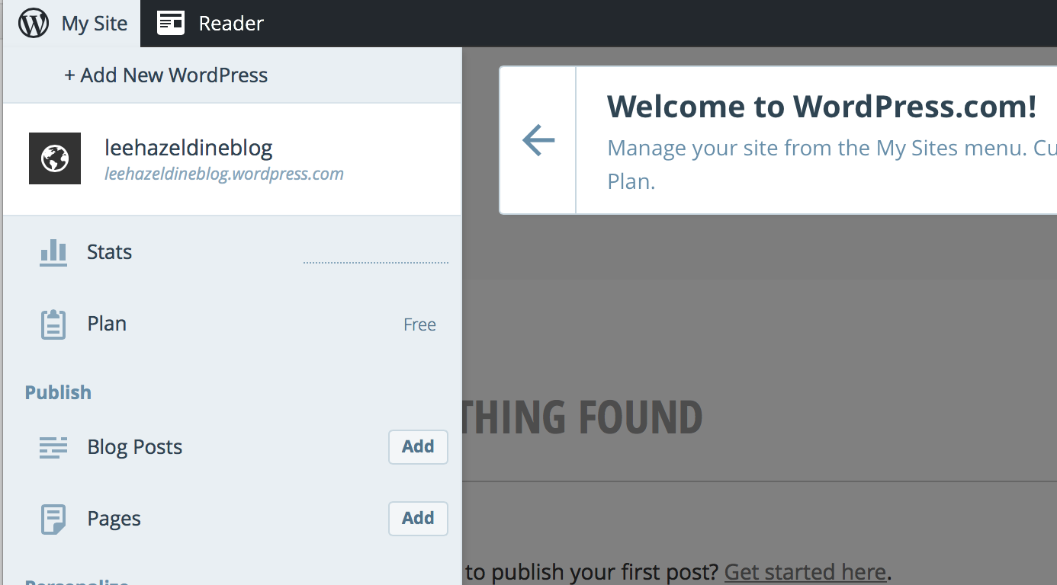

- We can now add a title to our blog and begin wring the content to our first blog post.

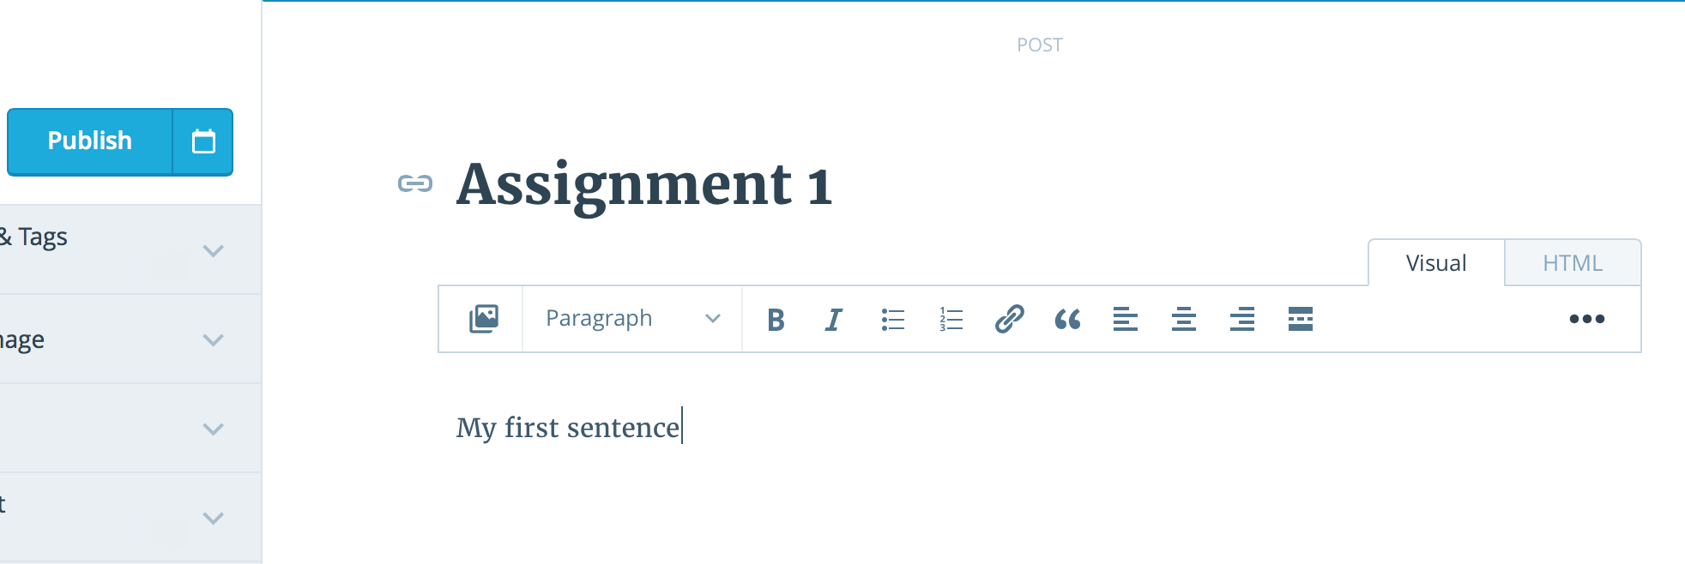

- To add images or documents, simply click on the add media icon:

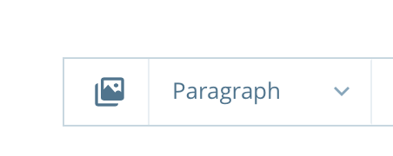
After doing this, select Add New to choose either images or documents.

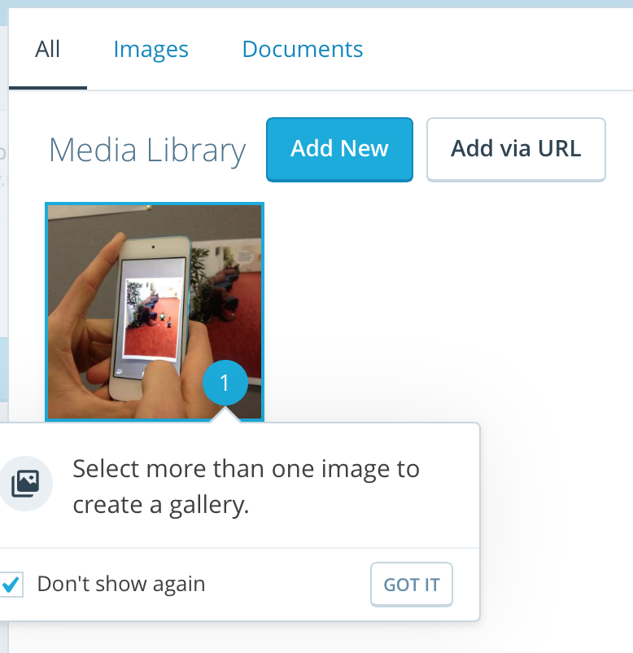

Adding video

- Go to www.youtube.com. Identify a relevant video (this will often be a video you have uploaded yourself). Copy the web address of the relevant video and paste it into your blog.

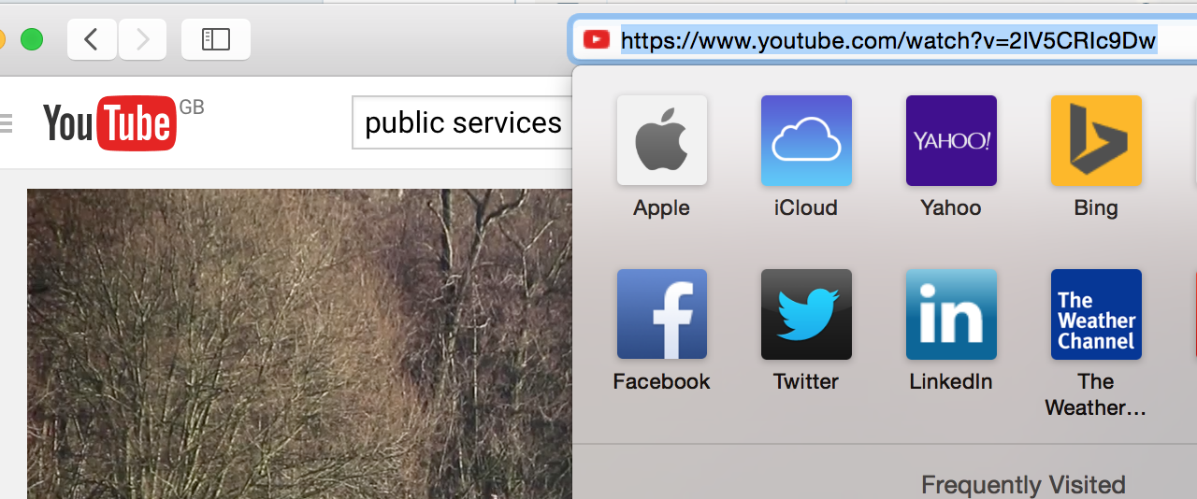

The video will now automatically appear within your blog space:

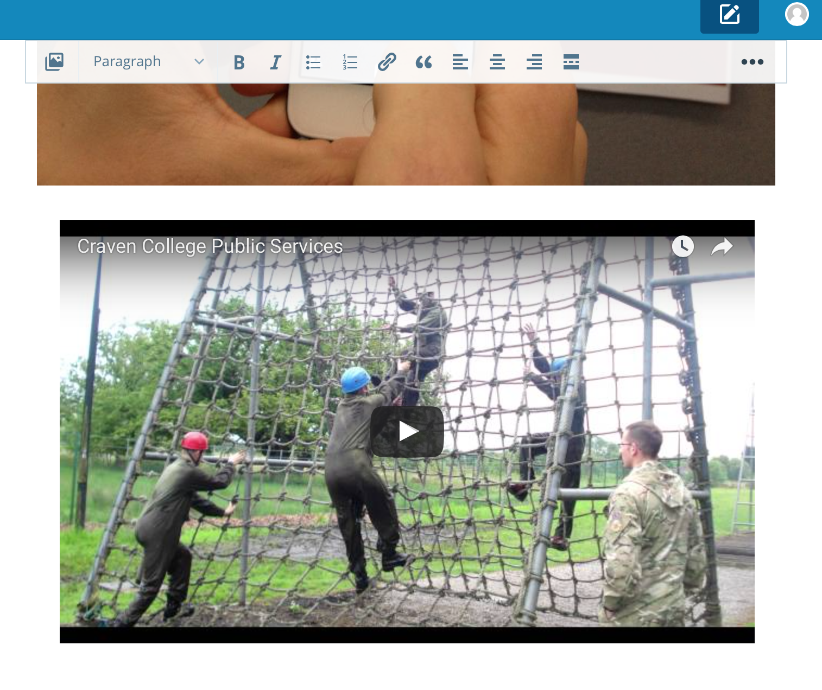

Publishing your blog

- To publish your blog, simply click on the Publish button.

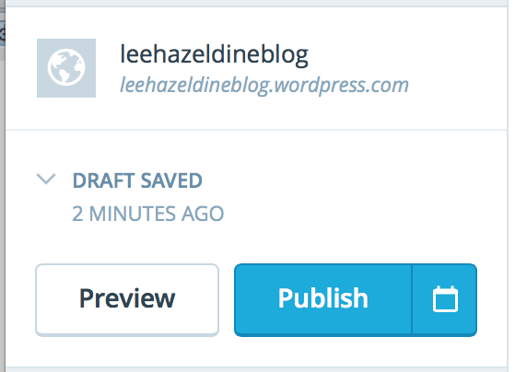

Setting the Privacy settings

- Click on Settings.
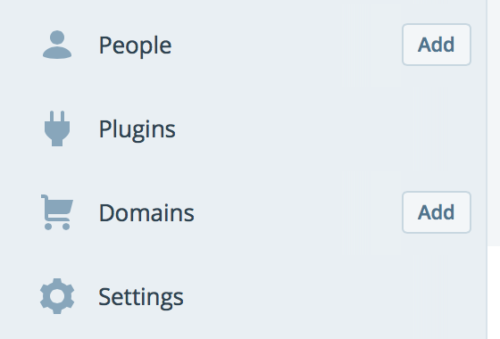

- Go to the Visibility section and select the ‘I would like my site to be private, visible only to users I choose’. On doing this, choose the Save Settings option.

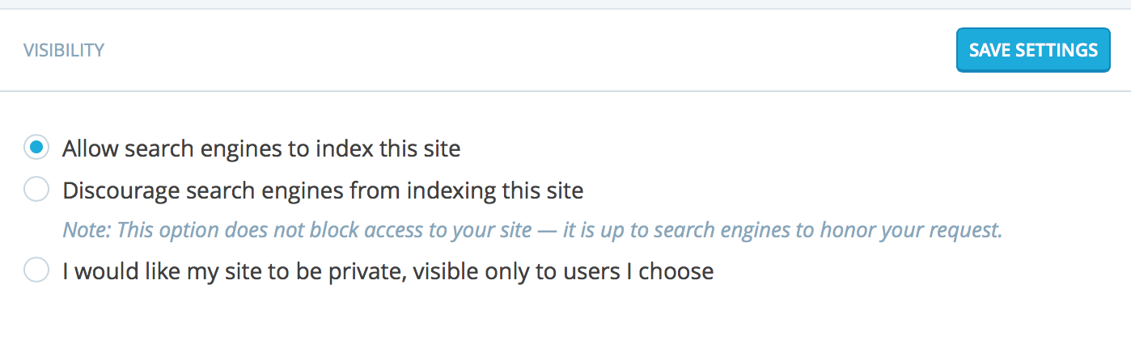

- Click on the name of your blog.

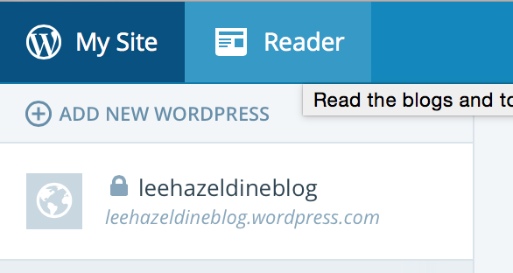

On doing this, click on the My Site option.

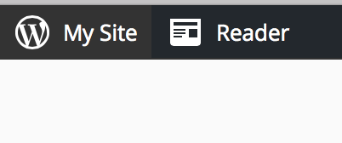

Go to the Configure section within the left hand column. Select the Add People option.
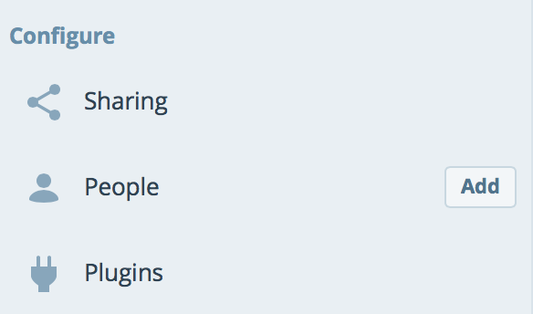

Enter your tutor’s email address and choose Author as the Role.

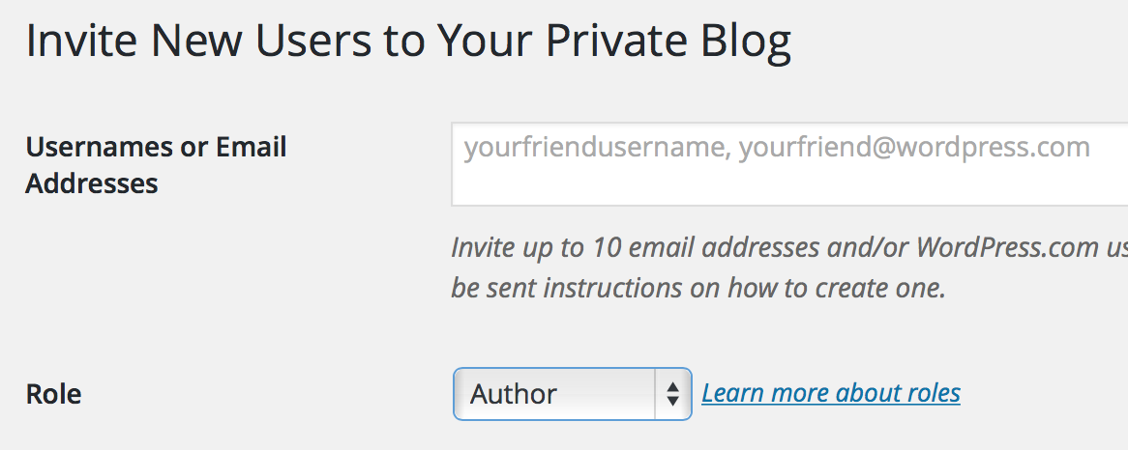

Finally, click upon the Send Invitation option.

