Creating a Tackk online discussion
Tackk is a web application that allows you to generate online discussions and blogs that can be embedded in websites or the Blackboard VLE.
Tasks:
- Go to www.tackk.com.
- Register for an account by entering your Email and generating a username and password.

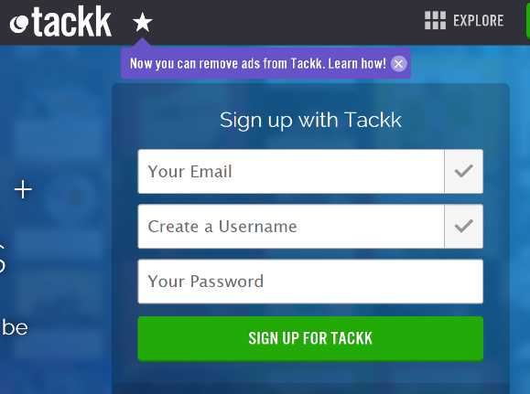

- After registering, you will be asked to enter profile information – much of which can be skipped (you may need to indicated TEACHER as an account type). At the end of this process, you will be ready to create your first Tackk – click on the green pencil button and scroll down the options until you find the CHAT option.

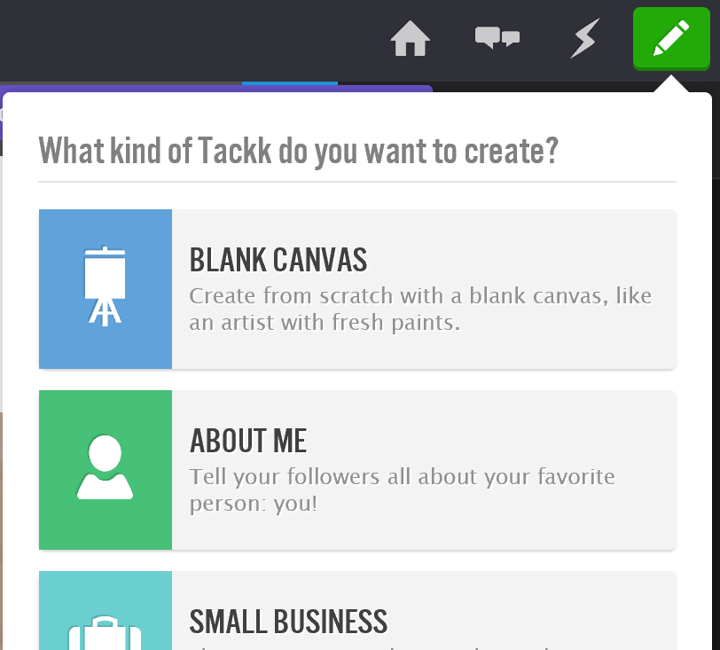

- After selecting the CHAT option, type a discussion topic or question you wish students to engage with.

- Once you have entered a relevant question, you are ready to embed your discussion into Blackboard (or a website). Click on the Options icon and choose Private (this will stop the discussion board being found by search engines).

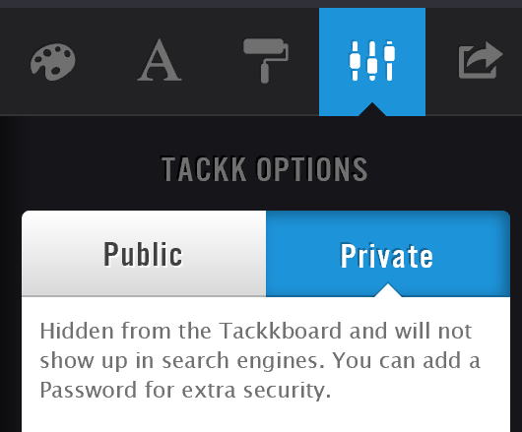

Click on the Share option, then select the Publish button at the bottom of the column, followed by clicking the Embed button.

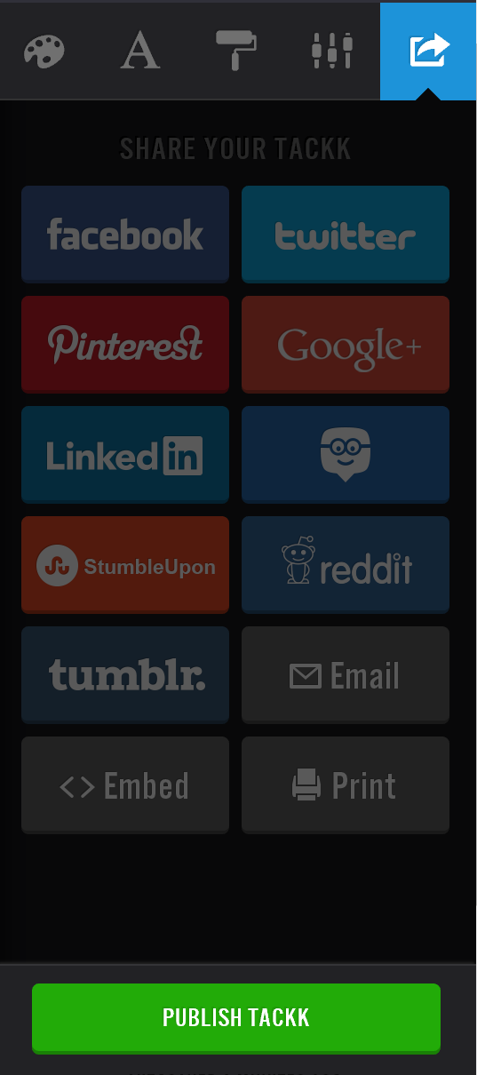

- Copy the embed code at the bottom of the pop-up window – this is now ready to be pasted into Blackboard.
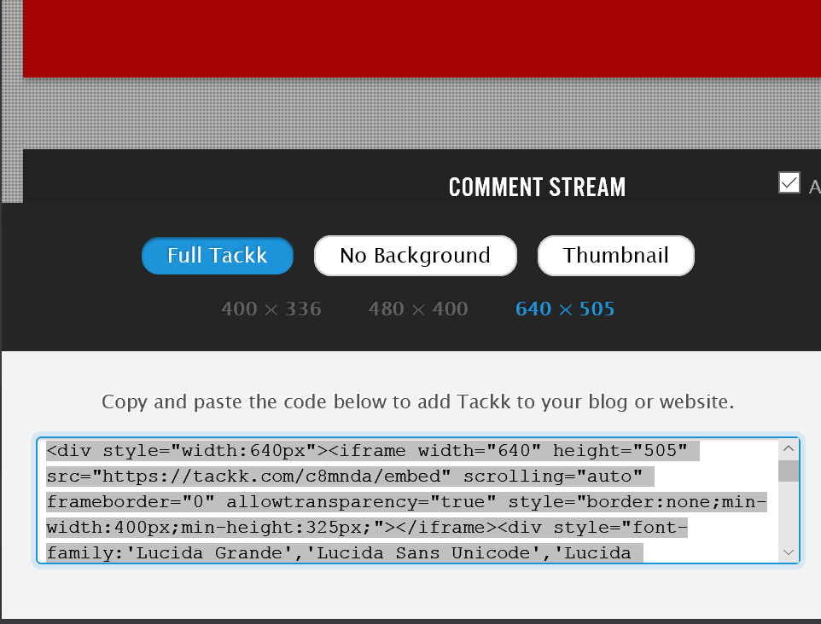

Embedding Tackk into Blackboard.
In Blackboard, click next to the area you wish to embed the code, then click on the Edit option.

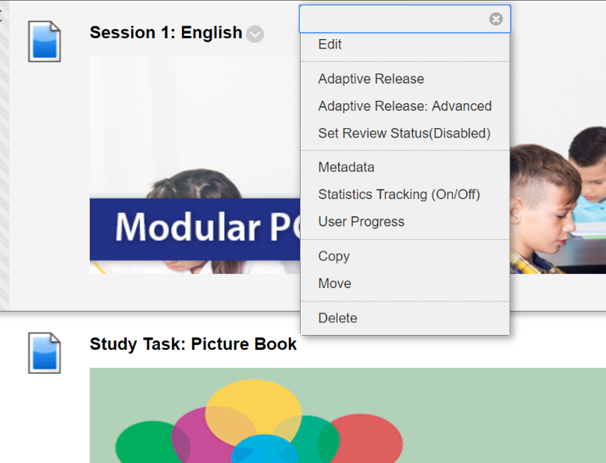

Click on the HTML option and paste in the embed code.

