Creating a Genial.ly Infographic
Genial.ly is an easy to use application that allows students and tutors to produce digital poster designs and interactive presentations and images. It is also versatile enough to allow the embedding of other media, such as Twitter feeds or Youtube videos.
Tasks:
- Go to Genial.ly in your web browser.
- Click on the Register button.
- Create an account by entering your email and generating a password. Click on the Register button.

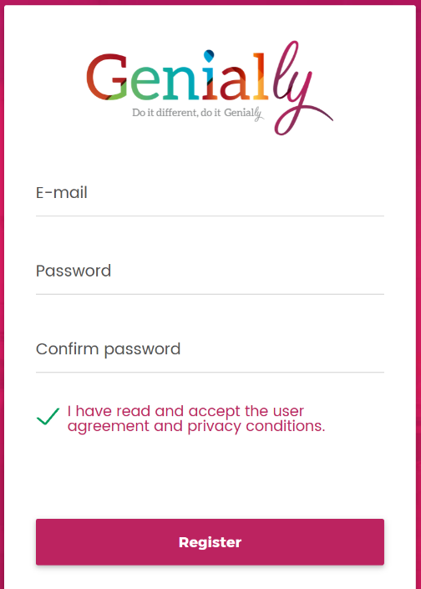

If asked, select a profile by clicking on Teacher or Student.

- You can now select the type of digital document you would like to create – on this occasion, choose ePoster.

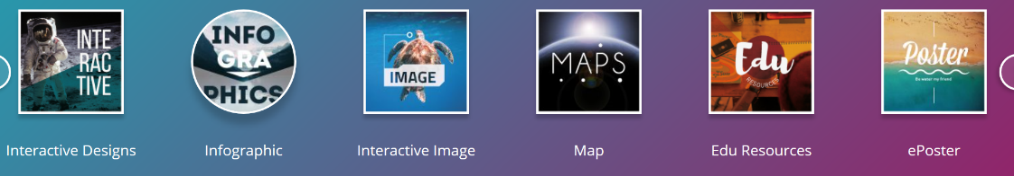

- On doing this, select the Create Genially from scratch option.
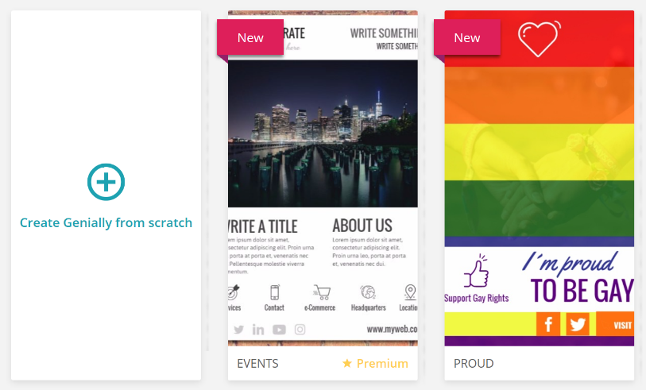

- You will now be presented with the design interface, select the Background option.

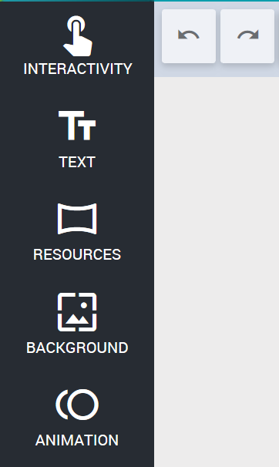

- Click on the Upload an image option and select an image to use (you can download the ‘football’ image to use by clicking below the poster example on Blackboard).

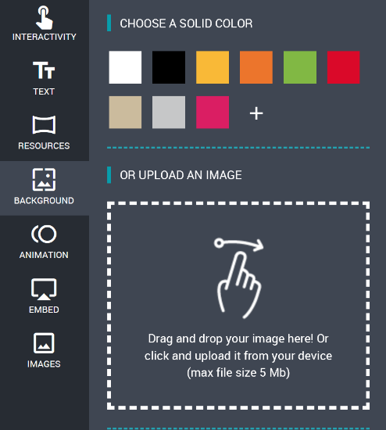

After an image has been selected, click on the Use this image as your background option.

- Click on the Text option within the tool menu. Drag the Add Title option onto the background image.
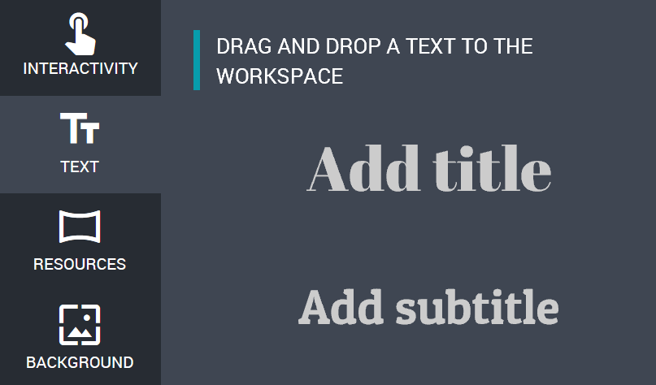

- Double click inside the text box, or click on the edit icon to enter text format the style.

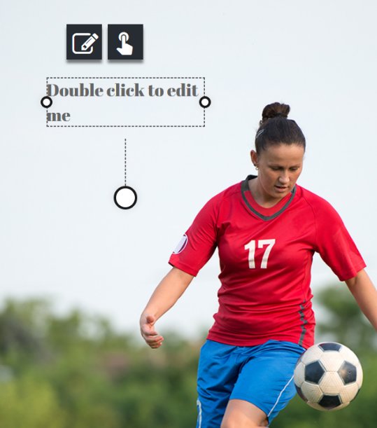

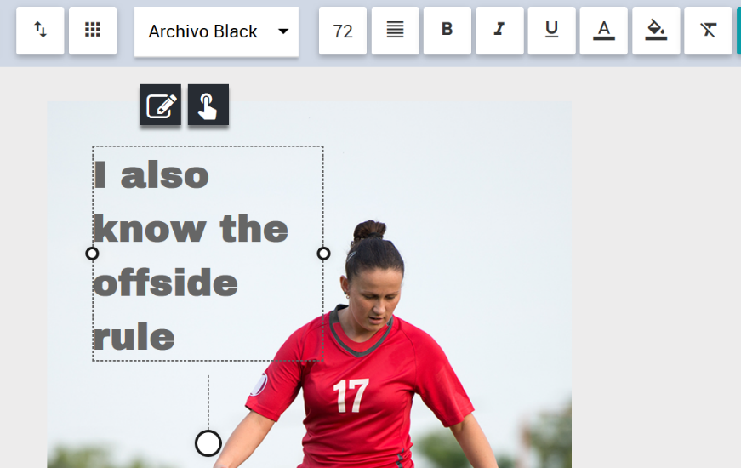

- Click on the Interactivity option and choose Animated. Select an animated icon and drag it onto the image.
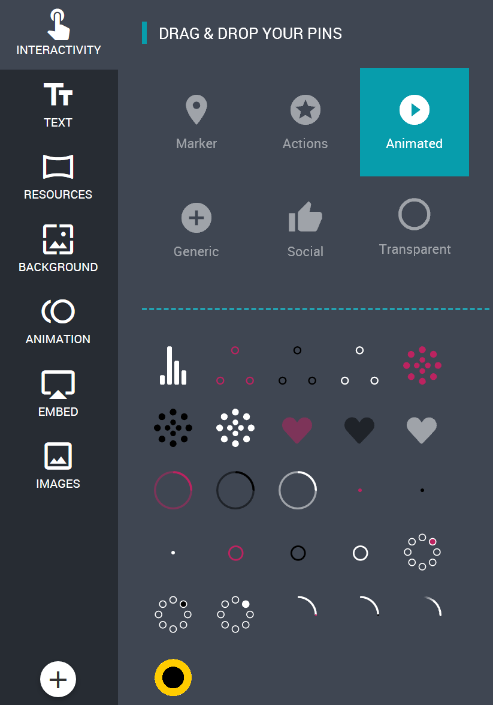

- Click on the action icon.

- Select the Tooltip option and enter some text to direct you towards a website (you will also notice that there are image and embed option too for video). Select your text and choose the link option.
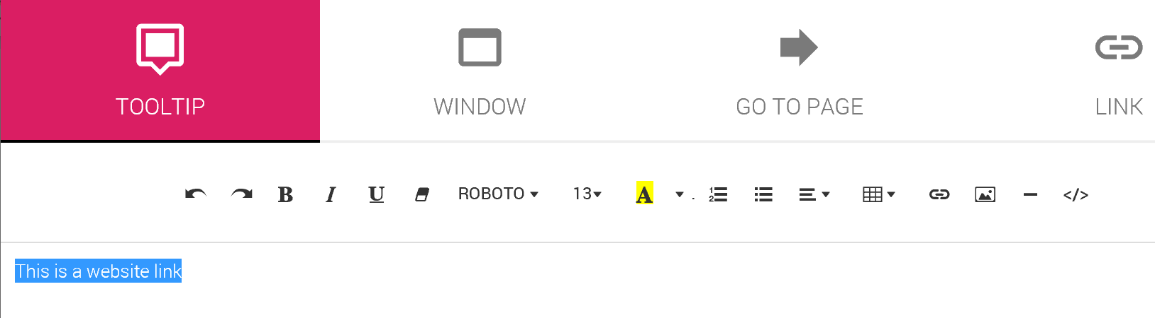

- Enter a website address into the URL space and select the Open in a new window option. Click on the Insert Link button.
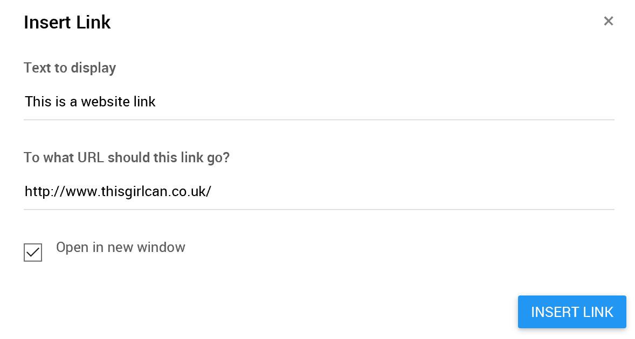
Click on the Save button.

- Finally, click on the Share option and select the embed icon.
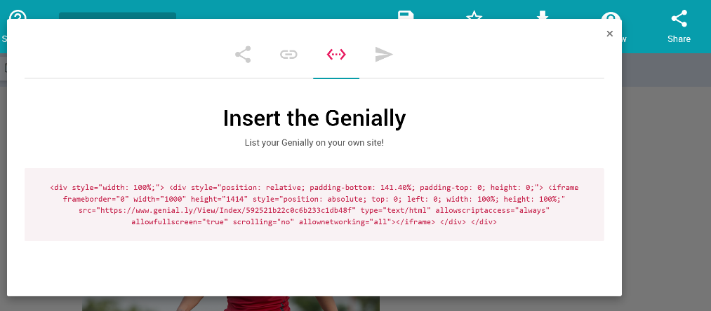
Copy and paste the embed code into your Blackboard VLE.

Embedding your Genial.ly document into Blackboard
In Blackboard, click next to the area you wish to embed the code, then click on the Edit option.

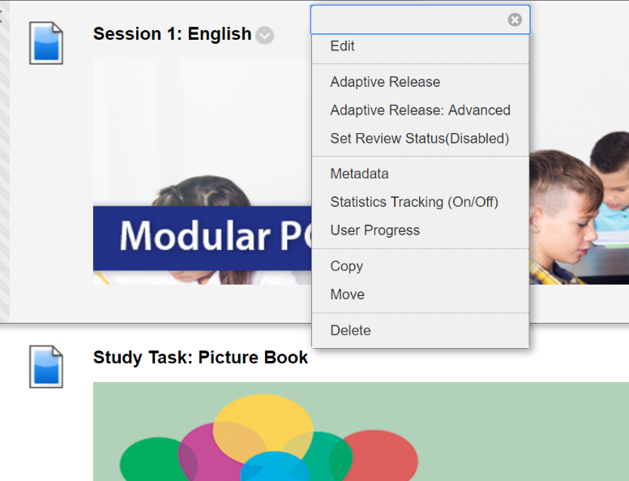

Click on the HTML option and paste in the embed code.

