Creating a TedEd lesson.

TedEd allows you to incorporate educational videos into your lessons. It also allows you to contextualize the video with assessable questions and additional learning resources.

Tasks:

- Go to ed.ted.com.

- Click upon the Create New Lesson option.

- At this point, we can find a video to incorporate into our lesson. In this example, we’re going to use a Youtube video on brick laying. Type ‘Brick laying’ into the search option.

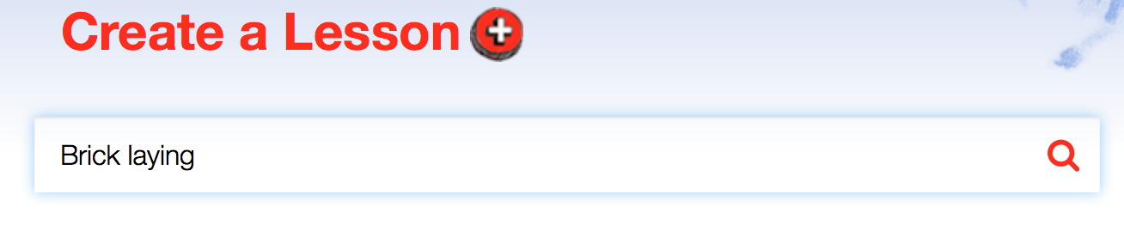

- On doing this, select a video. I chose ‘The Art of Laying Brick’. Once an appropriate video has been selected, click on the Launch Lesson Editor option.

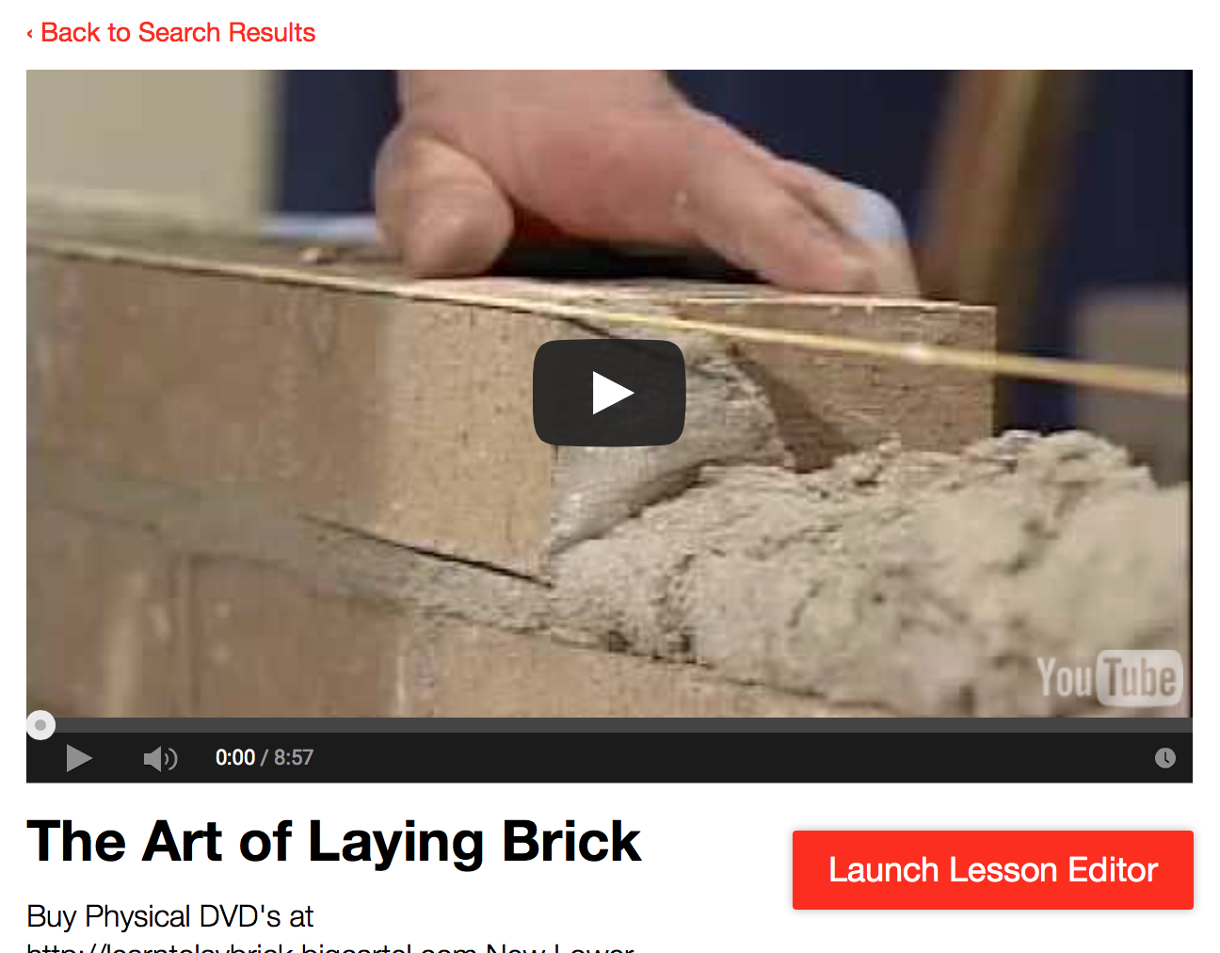

- You will now be given the option to either Log in or Register. If it is your first time using TedEd, select the Register option, alternatively, choose the Log in option.

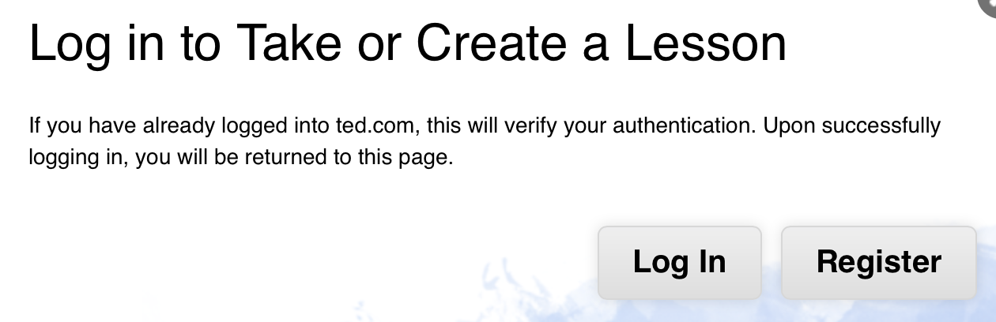

- After you have logged in or registered, you will be given the option to change the title of the lesson and add a description – this is an opportunity to add a lesson aim and learning outcome. Add a title and description.

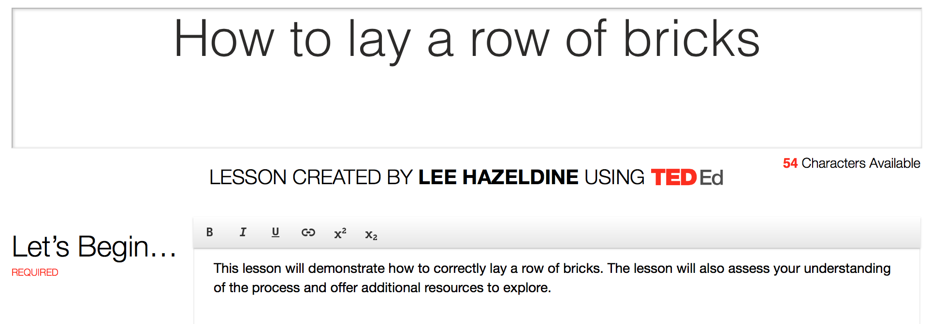

- After doing this, select the Think option to add questions about the video.

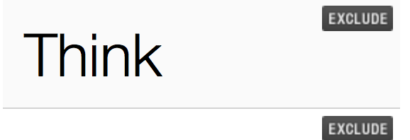

- You will now be given the option to choose a type of question. In this example, I have chosen the multiple choice option.

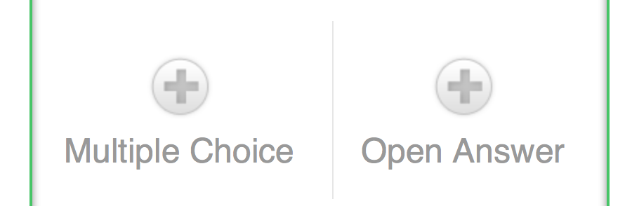

- Type a question into the text box, then indicate the time at which the relevant information is discussed within the video – this will prevent the student from having to restart the video again if they get the question wrong.

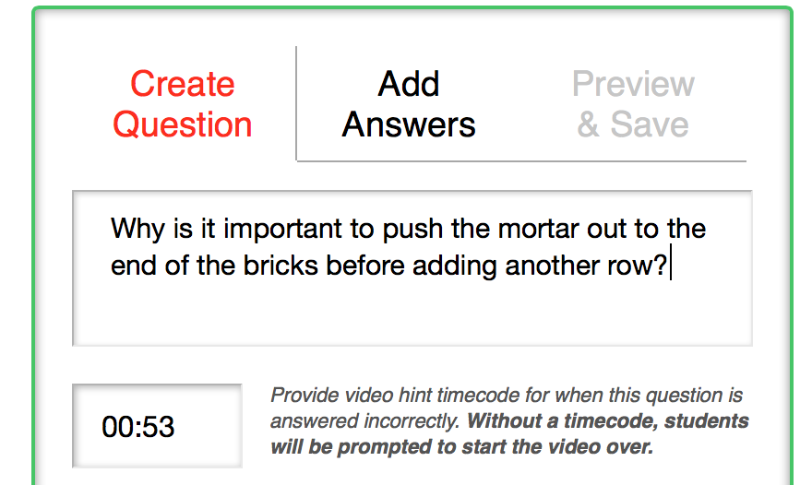

- Select the Add Answers option. On doing this, enter a series of possible answers and indicate which one is correct.

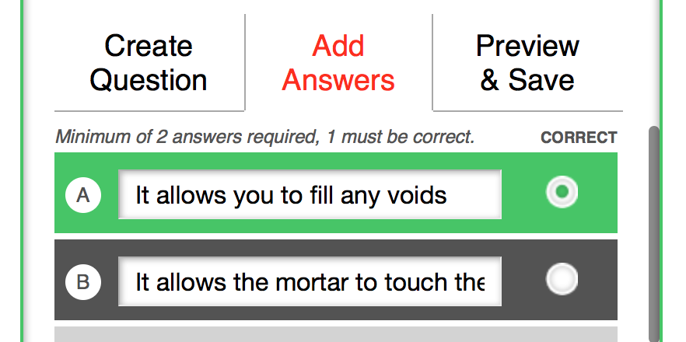

- Select the Preview and Save option, then click upon the Save button.

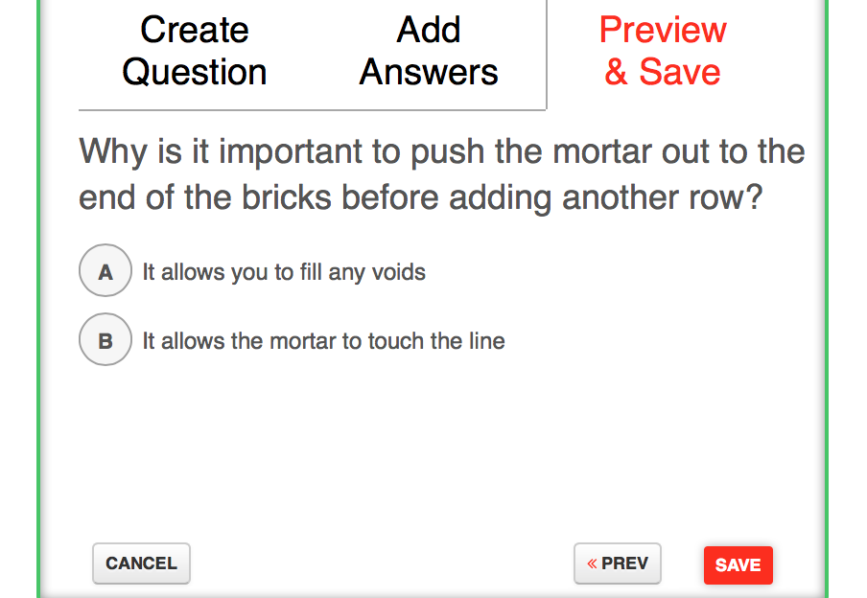

- Click upon the Create your Own Question option to add another question.

- This time we are going to add an Open Answer question.

- Add your question then click upon the Save button.

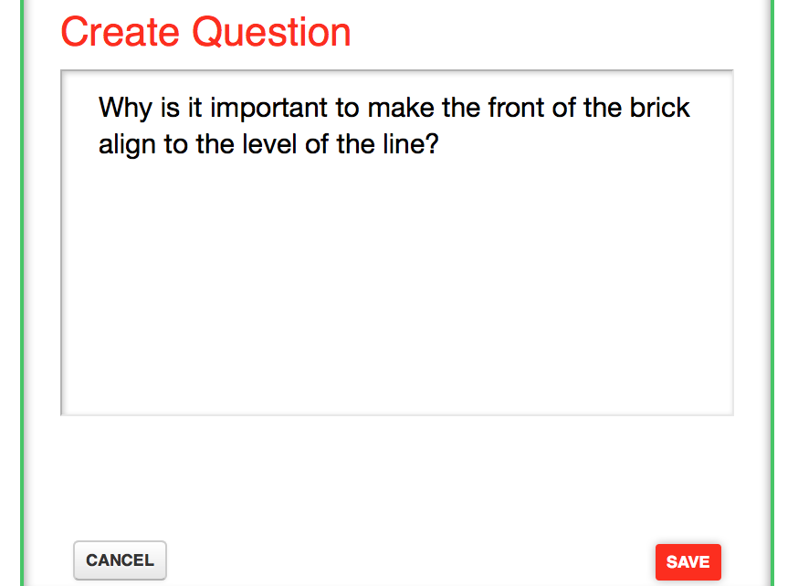

- After adding all your question (you can add 15 in total), click upon the Dig Deeper option – this will allow you to add additional resources for your students to explore.

- On doing this, add additional information relevant to the topic – this is a great opportunity to provide additional material to extend learning and stretch and challenge students. In this example, a word has been selected to add a link to another website. To do this, click upon the link option at the top of the text box.

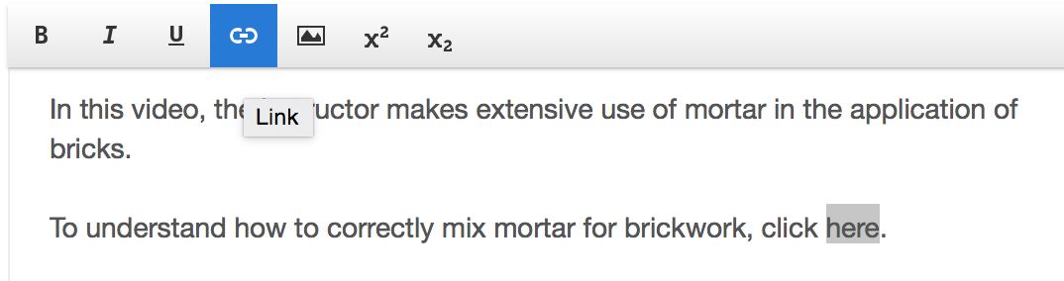

- Once you have selected the link option, enter the web address that contains the additional resources for students to explore. Remember to select the Open link in new tab option to make sure the material opens in a separate window. After doing this, click on the Insert option.

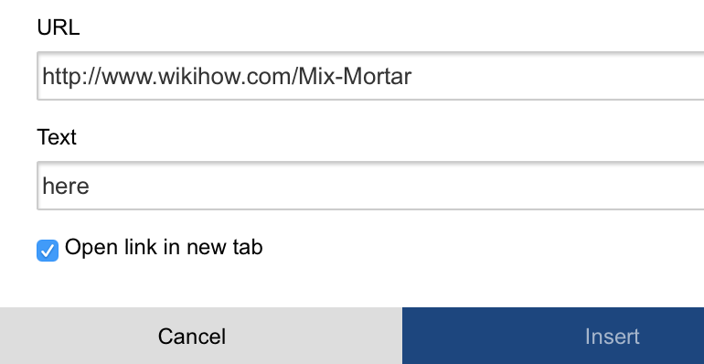

- Click on the Discuss button and select the New Discussion option.

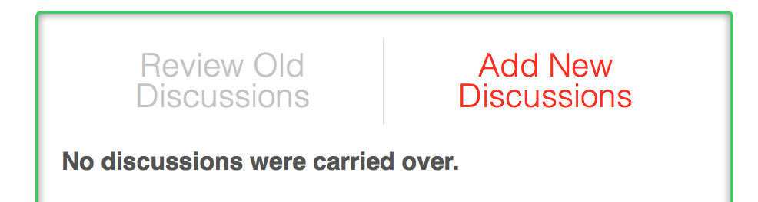

- Add a title for your discussion and give an explanation of what the discussion is about. The discussion section provides a good opportunity for learners to raise any issues or ask any additional questions about the process. Once you have done this, click upon the Add this Discussion button.

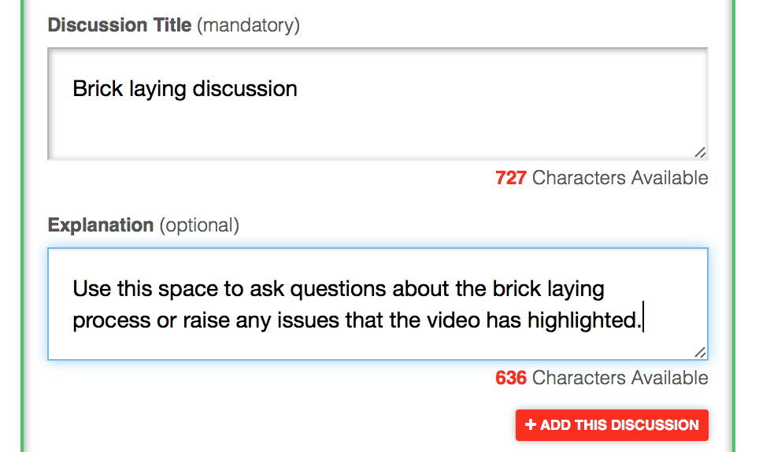

- Click on the …And Finally button.

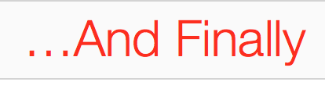
- Type into the text box either a lesson summary and / or a link to the next lesson.

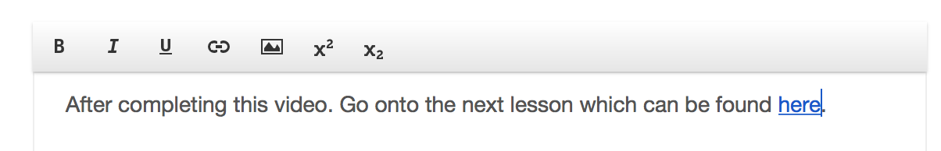

- Finally, click on the Publish button to complete the lesson.

- Copy the web address to give to your students.

http://ed.ted.com/on/byvGVfoe

