How to create content using Blendspace.
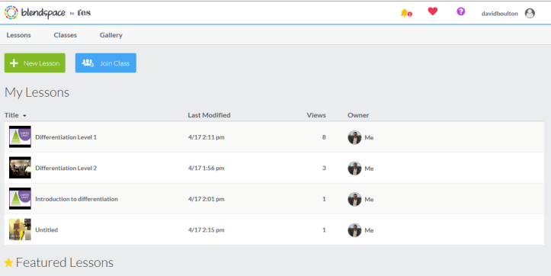
Go to www.blendspace.com and sign up for an account.
At your home page click create new lesson.

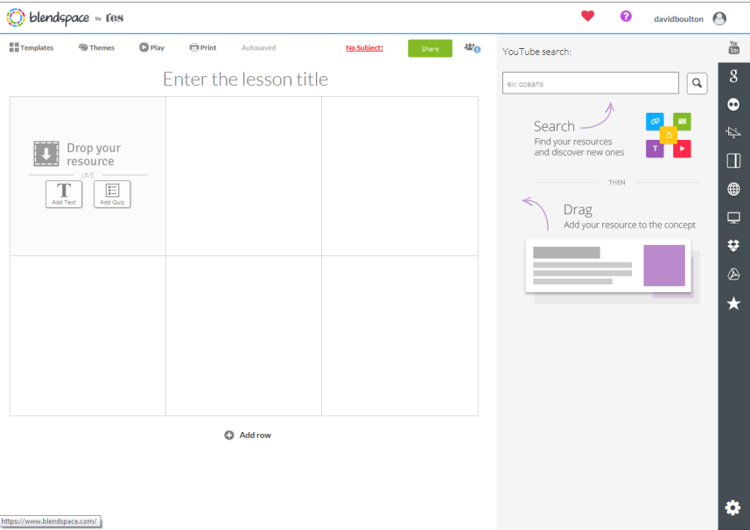

The lesson editor looks like this. Hovering over the menu bar will indicate what the links do. For example, you can search YouTube, Google, Flickr and a host of others sites for content.
Add a session title and drag content into the boxes. You can add rows at the bottom if you wish.
Search the web for your content.
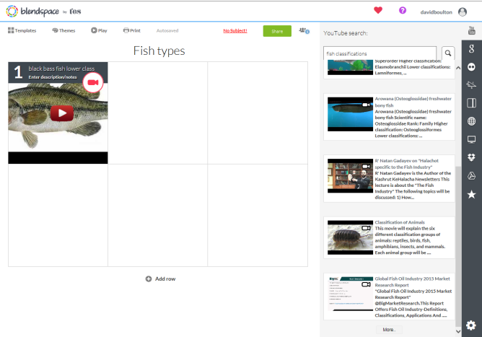
Once you have found your content drag it into a spare box.
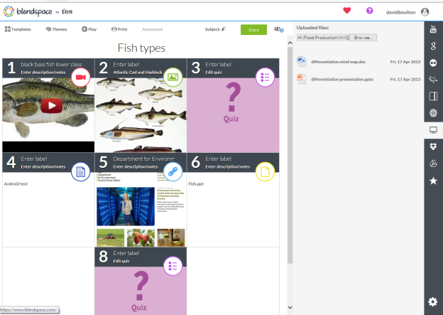
Continue adding resources and then share when done. This will allow you to embed into Moodle or create a link to the page.

