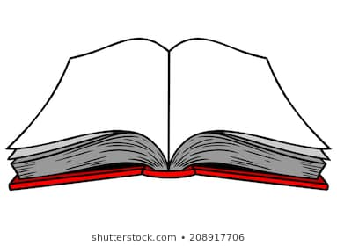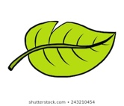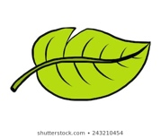 

**Our theme this term is**

Who was Rudyard Kipling?

**English**

* We will be exploring character description and specifically using the characters from Kipling’s “The Jungle Book” to help us develop our characterisation skills.
* We will also be designing our own products and writing persuasive letters to relevant companies to introduce them to our ideas and persuade them to use them.
* Spelling tests are on a Thursday. Do not forget to practise your spellings together and to make sure to use your spelling in a sentence to check its meaning!

**Theme**

* We will be exploring who Rudyard Kipling was and looking at his “Just so” stories. We will be writing our own stories about animals and creating our own books, with illustrations!
* We will explore why Kipling was and is still seen as a significant author. We will also look at what period of history he was writing in and key events from this era.
* At home, you could think about who you think is a significant author and bring in a fact file about them!

 

**French**

* We will be learning the different names for different animals, numbers 0-20 and colours.
* We will also be learning some simple grammatical rules to start speaking in simple sentences.

**Maths**

* As mathematicians, we will continue to be exploring multiplication and division, and looking at formal methods.
* We will also be investigating types of measurements, including perimeter, length and area. We will be looking at how to convert between different measurements, when to use different types.
* At home do not forget to practise your times tables together, and to use “TimesTable Rockstar” to practise online. Timestable tests are on Fridays.

**PE**

* We will be developing our gymnastics skills, including developing our flexibility.
* We will also be learning to perform a range of movement and dance techniques.

**Art and DT**

* As artists, we will be designing our own illustrations for our own “Just So” stories, to be included in our published class books.
* We will have a visit from a local artist and illustrator to help us develop our illustration skills.





**Science**

* As scientists, we will be exploring different living things and their habitats.
* We will be investigating different animals and plants and looking at their characteristics, and how different animals are classified.
* At home, you could explore   
  different habitats for animals around where you live!

**RE / PSHE**

* In RE will be learning about different Muslim traditions and how festivals and worship show what matters to a Muslim.
* In PSHE, we will be learning how to stay safe at school and at home (including physical hazards such as leaning out of window as well as, stranger danger and peer pressure).

**Music**

* As musicians, we will continue to develop  
  our skills playing the tenor horn, and continue to expand our knowledge of musical theory using the tenor horn!

