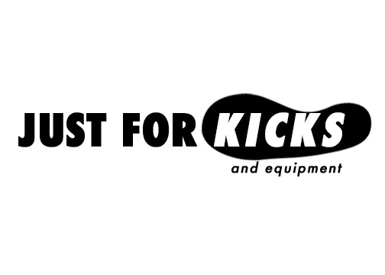



Mission Statement

Enabling athlete sport participation by providing shoes and equipment at affordable prices through the promotion of physical activity.

JUST FOR KICKS

Introduction:

At Just For Kicks our mission is to provide under privileged athletes with proper shoes and equipment through the promotion of physical activity. This will be achieved by hosting events such as 5k races and sports tournaments. In order to participate in these events the donation of funds or equipment will be strongly recommended of all those that enter. All proceeds will then go toward the purchase of shoes and equipment that will be distributed to athletes in need. Just For Kicks events will be regional, sport, and athlete specific depending on area needs and wants. It is our goal to eventually have enough donations to set up a business that operates similar to a sports thrift store where athletes can buy, donate, and trade in shoes and equipment. The number of financial donations will be displayed in store in the form of a paper shoe donation wall. The paper shoes will be used as currency for those who are in need of financial assistance. This way if an athlete comes to our store and does not have the money needed to pay all they have to do is grab a donation shoe off the wall and they will receive their “kicks”/equipment free of charge.

Becoming the best athlete you can be starts with having the right equipment. If you are training for basketball you don’t want to be practicing and hitting the gym in your high tops. Ideally you need to have a pair of practice, training, and game shoes. Practicing in the wrong shoes can lead to injury and poor performance on the field. One pair of basketball shoes alone will cost on average $70.34 (Statistic). Other sports like baseball, hockey, and lacrosse can cost upwards of $500 just for basic equipment such as helmets, bats, and sticks. Recently there has been a decreasing amount of ethnic diversity in sports like baseball, this can be attributed to the amount of money and equipment required to play the game. These high costs of equipment are creating barriers to entry for athletes who either come from low-income families or live in urban areas. Contributing to the high cost of equipment is sport participation fees. 61% of middle to high-school athletes now have to pay anywhere from $93--$150 or more to participate in school sports (Trends, 2012). These barriers to entry are resulting in a decline in team sport participation making it even more important that kids have access to sports outside of school. However, individual sports like running and general exercise have seen increases in participation. This increase in participation means the need for running shoes is growing, as each mile put on a pair of shoes shortens its lifespan and consequently the runner’s need for new shoes. Just For Kicks will help alleviate the burden of paying for sporting equipment by providing new and used shoes and equipment at affordable prices and in the process help break barrier to entry to sports for underprivileged athletes.

What sets Just For Kicks apart from our competitors is that we specialize in affordable community focused athletic gear. Our organization not only sells shoes and sporting equipment, but also promotes the sports themselves through sponsored events. Also, athletes are more likely to find products at Just For kicks cheaper than they are at retail stores and can come to us without feeling embarrassed like they would visiting a consignment shop. Our job is to make sure everyone has access to the basic requirements for an active lifestyle by promoting physical activity and by doing what no other store does, give out free equipment, just for kicks. By choosing to invest in Just For Kicks you are also placing stock in the health and well being of local communities. Communities that are healthy and more physically active tend to get sick less and be more productive than those who are not (Cadilhac, 2011). Therefore, a by-product of investing in Just For Kicks is a healthier lifestyle and economy.
JUST FOR KICKS

Operational Plan
About Us
Just For Kicks is an innovative new organization with the purpose of serving less fortunate people around suburbs of mid to large sized cities. We are based out of Greenville, North Carolina where we plan to start up our organization. When we had the idea to develop Just For Kicks, our initial thoughts were how we could give less fortunate families the opportunity to participate in community sporting events by just providing a pair of shoes or used sporting equipment donated by people in the community.

SMART Goals
As an up and coming organization, we must make goals for ourselves to grow both resourcefully and financially. Every business has SMART Goals that reflect what the company wants to complete over the course of time. The great part of an organization developing SMART Goals is that someone could determine the success of that business based off the goals set forth by management. The five elements of SMART Goals are Specific, Measurable, Actionable, Relevant, and Time bound. When a company is determining goals they want them to be as specific, realistic, time-oriented, and the goals need to be able to be acted upon. At Just For Kick’s, our members have developed our own SMART Goals for the progression of the organization.
- After the first two 5K Races of the four this first year, we would like to have raised over 500 products which include shoes and various sports equipment, by having people either pay $20 to race or donate a used piece of equipment or pair of shoes that is still usable in order to race.
- For all four events this year, we want to provide three levels of sponsorships- Gold, Silver, and Bronze. The Gold level sponsor will have a logo on the 5K shirts, a place on the 1 for 1 Card, and provided with a Donation Drop Box. The Silver level sponsor will also have a logo on the 5K shirts and a place on the 1 for 1 Card. The Bronze level sponsor will only have a logo on our 5K shirts.
- By the end of the year, our goal is to have sold a minimum of 429 products to break even or make a profit of at least $6,000.00 by successfully running our 5K events and receiving a lot of equipment and shoes in the process.
Action Plan
In order to accumulate enough gear and shoes we will hold 5K Races that require an individual to either pay $20 or donate a pair of shoes or piece of equipment to race. We believe that with enough participants during each of our events we can accrue enough equipment and shoes to help these families. At Just For Kicks our main goal is to give back to the community. By just donating an old pair of shoes at one of our events, you are providing shoes for someone that has financial trouble whether it be a family with children, or a homeless man on the street. In order to fulfill these duties first we need to determine locations for our 5K races while at the same time finding a building that can be used as a storage for our donated equipment and a store once we have enough products to sell. The following are the steps that will be taken in order to fulfill our objectives as an organization.
- First, in order to prepare for an upcoming event we need to determine how much money it will take to have a location for the event. During this step, our management team will determine the budget for the event and plan accordingly to avoid cash shortfalls.
- The next step for our 5K plan, is to determine the risks of liability. Risk management is highly critical in event preparation because it allows time for the managers to determine every possible risk of liability due to the event or location and assess how we will treat each risk. For example, we will have participants of the 5K sign a waiver form before they race to release Just For Kicks and the location of the event of liability.
- Next, we will configure the schedule of activities for the event day, as well as, determine sponsorship needs. During this step our managers will create a personnel responsibility list and determine how the security will work with members of our organization or volunteers from the community.
- In order to receive all the necessary products we need to be a successful organization, we need a lot of people to participate in our 5K events. We will spread the word of the 5K events well ahead of the actual event by posting flyers, making radio advertisements, and posting on social media sites.
- Then, once we have prepared for the event comes the actual event. The registration process begins before the 5K and helps eliminate products that are not usable and shoes that cannot be worn. However, we should not receive too much defective gear because our advertisements highly encourage potential participants to bring gear that can still be used and is free of any holes. If they still want to compete but do not have an old piece of equipment or pair of shoes worth donating, we encourage people to pay $20. This $20 Pay-it-Forward Policy allows the individual to race and are asked to fill out a “Shoe” with their name and post it on our wall. Once our store is operating, folks with little to no income can come in a pick up a “Shoe” privately, and they will leave with a pair of shoes they could not afford. We ask our participants to put their name on the “Shoe” because it lets that person who now has a pair of shoes know who paid for them.

Our goal is to provide individuals in our community who are lower class citizens with a feeling that other people in the community care about them. In order to carry out these operations, we will need people willing or volunteering to work for Just For Kicks in the following positions.

Jobs | Description
- Money/Equipment Collectors | These people are in charge of collecting the entrance fee of either $20 or a used piece of sports equipment or pair of shoes. Their duty specifically is to make sure the products provided are usable and are not broken, and the shoes have no holes and can be worn again by another person.
- Equipment/Shoe Inspectors | ONLY equipment that is still usable or shoes with no holes and in good condition to be worn will be accepted at our events during the registration process.
- Refreshment Cart Operators | These people are put in specific locations along our races to provide refreshments to the contestants before, during, and after the races. Refreshments include: Water, Gatorade, Granola Bars, and Crackers.
- Security and Safety | The people in these positions will include local police officers and EMS units. They are at our events to prevent theft of our collected products, to prevent entrance without payment, and in case of a medical emergency.

Evaluation Plan
While evaluating our action plan there will be some factors that will influence changes to how we run and operate Just For Kicks. The first step in an Evaluation Plan is to identify standards to measure performance. In our case, we have developed a few performance standards.
- Employees will serve our customers or competitors in the race with compassion and in a timely manner. There is an employee standard of performance that requires them help any customer in need of assistance, whether it be by answering questions regarding locations of a bathroom or the closest refreshment cart.
- Employees are expected to provide a safe and secure environment during the 5K Races. This may include removing alcohol or illegal drugs from the premises, or removing people that are causing harm to other people. Fighting or other forms of violence are grounds for immediate removal from the event and further action will be taken if necessary.
- Just For Kicks is expected to take each donation of equipment or pair shoes and assess whether it is usable or not. Our employees are then expected to account for every single donation and record it on an event log so we can determine how many of each product we have. An overstock of certain products may require us to ask for a differentiation of products from our 5K participants and us to use the money we receive at our events to purchase products in high demand.
In order to measure the performance of our employees during our events, we will conduct personal observation to ensure they are carrying out their duties responsibly and professionally. While our employees may be performing their duties efficiently, we may not be receiving enough products or profit during our events. The next form of evaluation involves reviewing statistical reports of each event that outline how many products we received or how much money we raised. With the intentions of improving upon each event, this will require an effective evaluation of employee performance and the quantity and quality of equipment/shoes supplied to us. Each manager working at an event will be required to fill out a written report regarding employee performance, product accumulation, and overall how the event went for the organization. This report will be conducted during and following an event using personal evaluation. Once we have an idea of our strengths and weaknesses and what we need to improve upon, we will compare the results to our standards and attempt to correct them before the next event. In this step of evaluation, the managers will conduct training sessions to improve employee performance and will identify locations that will attract more participants. If our standards are unattainable or over exceeded, that may necessitate a change in the standards we hold for our employees and events. Nonetheless, the goal of evaluation is to identify problems or weaknesses that need to be improved on and making the necessary changes.

JUST FOR KICKS

Marketing Plan
Just For Kicks mission is to provide quality new and used athletic equipment to athletes in need at affordable prices. Our objective in providing gear at affordable prices is to insure that all athletes will be equipped to receive the benefits of sports. We plan to achieve this objective by promoting physical activity though the sponsorship of 5k races and sports tournaments. The resulting donations from these events will be used to fund and provide inventory for our business.

Product: Our product involves selling athletic shoes and equipment at discounted prices. Examples of shoes and equipment include, but are not limited to, running shoes, cleats, basketball shoes, racquets, bats, balls, gloves, protective equipment, and accessories.

Price: Our shoes and equipment are priced to suit each athlete. All shoes and equipment will be sold at discounted prices. Underprivileged athletes or those who cannot afford to pay are eligible to receive their gear free of charge by grabbing a donation shoe off our donation wall. Athletes will also be able to trade in their used equipment for in-store credit if they do not wish to donate them. Our business is all about enabling athletes to participate in sports and providing equipment at affordable prices is the best way to achieve that goal, it also what will separate us from our competitors.

Place: Just For Kicks is centered out of Greenville, NC with future regional stores being placed in suburbs of large to mid-sized cities. Suburbs provide a large foundation for which to build our market and placing our stores in suburbs outside larger cities gives our business access to extra resources and sponsorship opportunities. Our place of business will have a storefront with a large warehouse in the back used to store our inventory and be large enough to host indoor events.

Promotion: Just For Kicks will be promoted through 5k races, sports tournaments, donation drop boxes, t-shirts, and 1 for 1 cards. Each event will be promoted through social media, flyers and radio advertisements. Just For Kicks will have sponsorship levels available for local business to purchase. Through the sponsorship both Just For Kicks and the sponsors business will be promoted. Gold level sponsors will have the opportunity to have a Just For Kicks donation drop box placed in their store. Other benefits of sponsorship include logo placement on all event t-shirts and their business being promoted through our 1 for 1 cards. All customers who purchase or donate gear will receive a 1 for 1 card, which will promote the sponsors place of business. Just For Kicks will also look to work with area schools by having school specific fundraising events.

Target Market
Just For Kicks target market will consist of driven, self-motivated individuals who are seeking competitive environments, but may lack the resources necessary to compete in sports. Our marketing efforts will target school age children from grades K-12 from lower-income households in cities and rural areas, as youth sport participation numbers are lower among these groups. Out of children ages 6-18 we expect roughly 60 percent of them are boys and the remaining 40% are girls. By age six it is estimated 60% of boys and 40 percent of girls are already involved in sports (Kelley, 2013), but as Our target market will view sport not only as a way to improve their health, but also as an outlet for stress and as a way to achieve personal goals.
JUST FOR KICKS
Marketing Plan

Examples of Marketing Materials
- T-shirts
- Donation drop boxes
- 1 for 1 cards

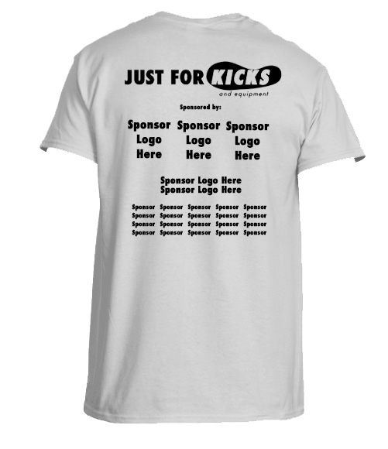
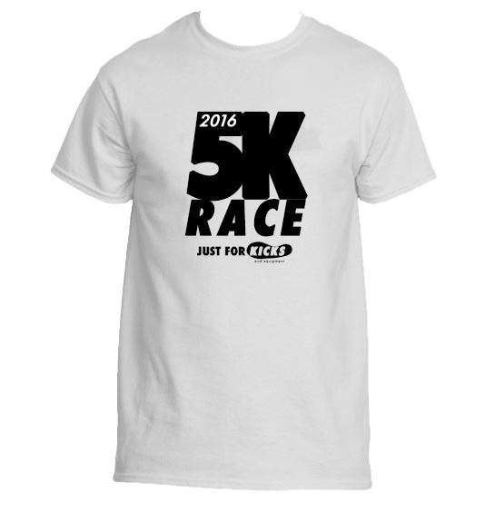

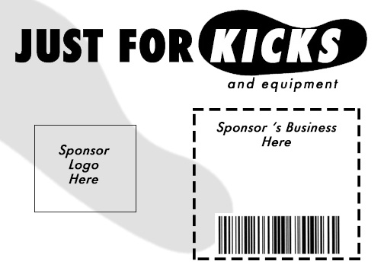
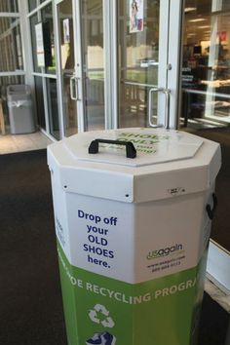

JUST FOR KICKS

Financial Plan
In order to start up our business we expect to require $706,420. This figure includes funds for land and money to build a permanent structure. We plan to purchase land for $449,900 and build a permanent structure to house our business for $143,040. To make our building operational we will need an estimated $18,000 for improvements and equipment. Just For Kicks will require the need of a large truck to bring all donated gear back to our place of business. We estimate that a truck large enough to use for our business will cost $32,000. After our first year we have estimated a profit of $5,969.24 while we need to sell $$7,638.69 (439 units) worth of goods to breakeven.

Required Start-Up Funds |  |  |  | Amount |  | Totals
 | Fixed Assets
 |  | Real Estate-Land |  | $449,900
 |  | Buildings |  | 143,040
 |  | Leasehold Improvements |  | 10,000
 |  | Equipment |  | 3,000
 |  | Furniture and Fixtures |  | 5,000
 |  | Vehicles |  | 32,000
 |  | Other Fixed Assets |  | -
 | Total Fixed Assets |  |  |  |  | 642,940
 | Operating Capital
 |  | Pre-Opening Salaries and Wages |  | 15,080
 |  | Prepaid Insurance Premiums |  | 1,000
 |  | Inventory |  | 15,000
 |  | Legal and Accounting Fees |  | 5,000
 |  | Rent Deposits
 |  | Utility Deposits |  | 500
 |  | Supplies |  | 200
 |  | Advertising and Promotions |  | 1,000
 |  | Licenses |  | 200
 |  | Other Initial Start-Up Costs |  | 500
 |  | Working Capital (Cash On Hand) |  | 15,000
 | Total Operating Capital |  |  |  |  | 58,480
Total Required Funds |  |  |  |  |  | $701,420

JUST FOR KICKS

Financial Plan
Pricing Plan:
Product | Projected Inventory | Projected Sales | Selling Price | Projected Revenue
Running Shoes | 350 | 250 | $30 | $7,500
Basketball Shoes | 350 | 250 | $25 | $8,250
Cleats | 250 | 150 | $15 | $2,250
Equipment
Gloves | 200 | 125 | $20 | $2,500
Bats | 35 | 25 | $35 | $875
Balls | 100 | 90 | $5 | $450
Accessories | 40 | 30 | $1-$10 | $150
Discs | 75 | 50 | $10 | $500
Racquets | 50 | 15 | $15 | $225
Protective Equipment | 45 | 35 | $50 | $1,750
Other | 20 | 10 | $10 | $100
Total | 1,515 | 1,030 |  | $24,550
Sponsorship
Gold |  | 3 | $5,000 | $15,000
Silver |  | 6 | $1,000 | $6,000
Bronze |  | 20 | $250 | $5,000

JUST FOR KICKS
Income Statement
For the year ended 2016
Sales Revenue $24,550
Less Cost of Goods Sold (16,690.76)
Gross Profit 7,859.24
Expenses
Operating Expenses (1,900)
Net Income $5,969.24

Breakeven Analysis
Sales Revenue 24,550
Less Variable Costs (20,000)
= Contribution Margin $4,550
Less Fixed Cost (1,900)
= Net Income 2,650
Breakeven in units 429 units (1,900/(4,550/1030))
Breakeven in dollars $7,638.69 (429 x 17.77)

JUST FOR KICKS

Risk Management Plan

The goal of the Risk Management Plan is to identify harmful risks that could affect the operations of the organization and determine how to treat the risk. Identifying the likelihood of each risk can and consequences for the risk can help you determine how you will treat the risk. For example, if we want to combat the risk of injuries at our events we will identify that they are likely to occur and the consequences could be major. To reduce this risk, we will have at least one EMS unit for any big emergencies, first aid kits for minor bruises or cuts that may result from falling down or tripping on another racer. We identify the consequences as major because if the injury could have been prevented on the part of our staff, then the racer could take legal action that could be detrimental to our organization’s identity. This outline is great for investors because it specifically lists every possible risk at an event and shows how we will combat that risk. The following list includes all potential risks to our organization and how we will treat each risk.

Risk | Likelihood of Risk (Rare, Unlikely, Possible, Likely, Certain) | Consequence (Insignificant, Minor, Major, Catastrophic) | Treating the Risk (Avoid, Reduce, Transfer, Accept)
Lack of equipment/shoes | Possible | Major | We will reduce the risk by purchasing used equipment and pairs of shoes with the additional money from the events.
Regular injuries (cut/bruises from falling, heatstroke, dehydration, etc.) | Likely | Minor | We will accept the risk by having an EMS unit for emergencies and first aid kits for cuts or bruises. We will reduce the risk of dehydration and heatstroke by having large fans blowing mist on hot days and refreshment carts throughout the event.
Weather related injuries (broken bones, lightning strikes, etc.) | Unlikely | Catastrophic | We will avoid the risk by cancelling events in the likelihood of bad weather. In the event of sudden bad weather, we can still avoid the risk of liability by having each participant sign a waiver relieving us and the location of the event of liability. We will reschedule events if necessary.
Defective Equipment/Worn down shoes | Possible | Major | We will avoid this risk by emphasizing to people that the equipment must be functional or usable, and the shoes must be wearable and have no holes or missing the soles. The equipment and shoes will be inspected to ensure they are usable, safe for use, and have no holes.
Theft | Unlikely | Major | We will avoid this risk by having police units on hand as security to combat anyone trying to steal our equipment/shoes or money.

References

Average retail price of basketball shoes in the U.S. 2007-2014 | Statistic. (n.d.). Retrieved February 26, 2016, from http://www.statista.com/statistics/244291/average-retail-price-of-basketball--shoes-in-the-us/

Cadilhac, D. A., Cumming, T. B., Sheppard, L., Pearce, D. C., Carter, R., & Magnus, A. (2011). The economic benefits of reducing physical inactivity: An australian example. International Journal of Behavioral Nutrition and Physical Activity, 8(1), 99-99. doi:10.1186/1479-5868-8-99

Kelley, B., & Carchia, C. (2013, July 16). Hidden demographics of youth Sports. Retrieved March 22, 2016, from http://espn.go.com/espn/story/_/id/9469252/hidden-demographics-youth-sports-espn-magazine

Sport participation trends. (2012). Journal of Physical Education, Recreation & Dance, 83(8), 3-56. Retrieved from http://search.proquest.com.jproxy.lib.ecu.edu/docview/1095615952?accountid=10639

