26 November 2017

Beloved Benefactors & Friends of the Decani Monastery Relief Fund,

May our gracious and loving Lord God always bless you!

While preparing to write to you, three phrases kept repeating in my mind,

• KEEP LOOKING UP

• FOCUS ON THE GOOD

• BE A BLESSING

Whenever I make a humanitarian trip to Kosovo (my tenth trip to the region), I remind myself to KEEP LOOKING UP. Why? Because it is God who is working to sustain the Christian people who live in impoverished conditions there. They are not lazy; they suffer oppression by political enemies. They would love to change their circumstances for the better. However, for now, it appears that God is allowing things to be as they have been for some years running.  The needs remain the same, albeit amplified. Even so, the Christian people continue to look up to God Who is their sustainer and upholder day by day.

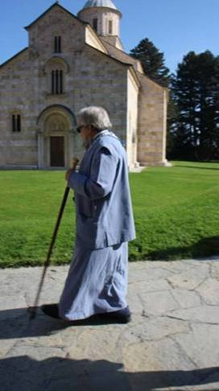

How is it that the Christians remain steadfast when their political and spiritual enemies prefer they be uprooted from their homeland? Because they look up to God. They pray. They live with the expectation of God’s goodness, mercy, and care where little exists they can do to improve their situation. And, God sends them assistance.  He moves the hearts of others with compassion and generosity over their plight. Then, there is relief and joy! This is why the DMRF exists. This is why we partner with you to bring relief and sustenance to the oppressed Serbians of Kosovo. People continue to live in vibrant Christian faith because you help make it possible.

I cannot tell you how many people asked me to give thanks to the supporters of the DMRF during my recent visit to Kosovo. Such gratitude expressed—it humbled me to receive it. I replied, “It is not me who provides, it is all those who are benefactors of the DMRF!” With sincerity I pass on their message to you, HEARTFELT THANK YOU’s from the faithful Orthodox people of Kosovo!

Four women’s monasteries comprised of holy strugglers asked me to especially thank the benefactors of the DMRF for the blessings they’d received from the Fund. In some cases, this meant not only food and fuel, but also appliances—a cook stove, a refrigerator, a washing machine. Monasteries and individual families receive new appliances according to need.

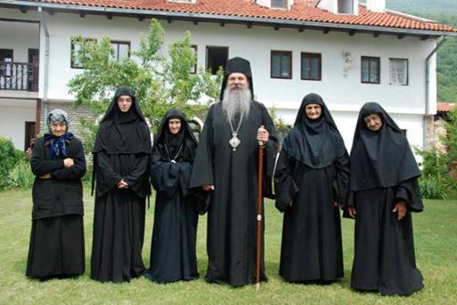

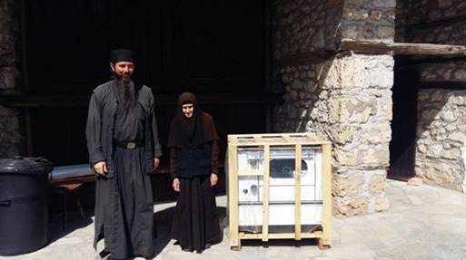

We take so many things for granted here in the West. Essential home devices mean so much for those who’ve lived without them. The Decani Fund gladly provides efficient home tools so life can be less harsh and more efficient. Someone wrote, “We live in deprivation, but with the hope of expectation.” This is very much how it is in Kosovo today.

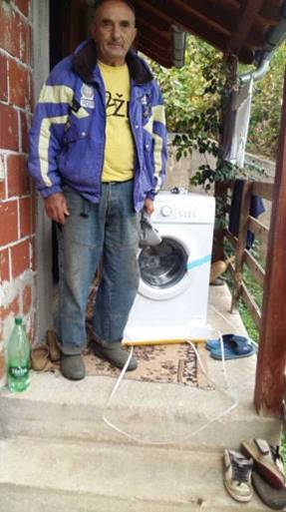

Let me now FOCUS ON THE GOOD from my recent trip that I hope will inspire you as it has me:

During one of my meetings with Fr. Sava, Abbot of the Decani Monastery, I learned something new.  Six students from Kosovo seek to serve the Church and enter the seminary in Prizren. What a blessing for the Church!  Even with a population under spiritual and physical oppression, God is raising up young men in Kosovo to serve His Church. Glory to God! These seminarians have financial needs anywhere from $250-$360 per month to undertake their continuing education.  If anyone would be willing to support a seminarian on a monthly basis, please contact me, and I will supply details.

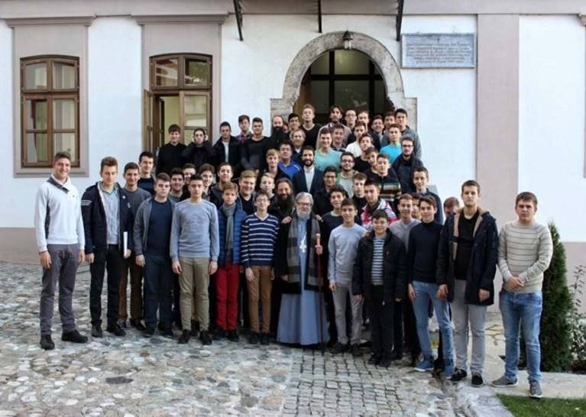

Fr. Nektarios and seminarians

Up until recently, there were six soup kitchens supported by the DMRF routinely serving the impoverished of the area. Now, I can report there are SEVEN soup kitchens, the most recent one opened in Prekovce. It serves approximately 800 men, women & children daily. More people fed; more needs met.  Thank God for this provision! Thank God for all the people who keep the soup kitchens up and running, day after day!

Most recently, Serbian TV (outside Kosovo) began giving focus to the humanitarian work offered through the Kosovo soup kitchens. As a result, awareness has heightened, and another source of support is cultivated. How this will manifest long term is yet unknown. I can say we are hopeful for the future. Wherever God is, wherever compassion is, the makings of miracles exist.

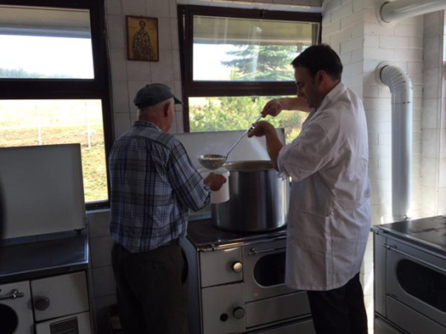

Earlier this month, I had the pleasure of meeting students while making a stop to distribute cold weather wear.  Over 300 scarves, hats & gloves were given out—the result of our early autumn scarf drive.  How generous and kind you were, dear benefactors!  About 80% of the clothing fit children and 20% fit adults.  I’ll say this--it would’ve cost a bundle to buy all these items new.  Instead, you gathered, laundered and mailed me beautiful pieces to bring over.  It was your loving effort which made this possible.  I was glad to deliver many ready to wear items in such fantastic shape!  Again, THANK YOU!

See this cold weather gear video captured at a school in the village of Osojane:

<https://www.youtube.com/watch?v=_6XWXuuQUYY&feature=em-share_video_user>.

Food & heating fuel (firewood) is essential for the cold weather months. That is our Fund’s primary focus this season. During the week of November 13, the DMRF transferred just over $5,100 to Kosovo to help cover these needs. Wire transfers are always met with thanksgiving to God by the fathers of the Decani Monastery! It allows them to provide practical assistance while demonstrating God’s consistent care for His people.

Right now, the DMRF is actively securing firewood to keep homes, schools & monasteries supplied with winter fuel. Doing so is essential to keep people healthy, warm and nourished. The Fund recently provided one village with firewood. A second village then asked for the same. In faith, I said yes, we would certainly help. Some people came to me and asked, “Fr., will there be pork roasts for us again for the Nativity Feast?” In faith, I replied, “Yes.” Can I make this happen? No. Rather, **I have faith in the generosity and love of many people who have given before. I’ve seen loving hands unfold with gifts that say, “Here, Fr., let’s bless the brethren. Let us do for them what they cannot do for themselves. It is Christ’s way. Why should we be disproportionately blessed?”**

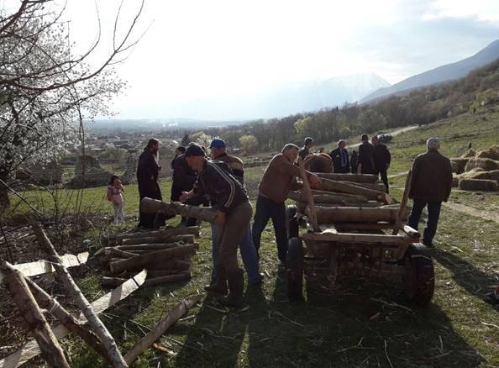

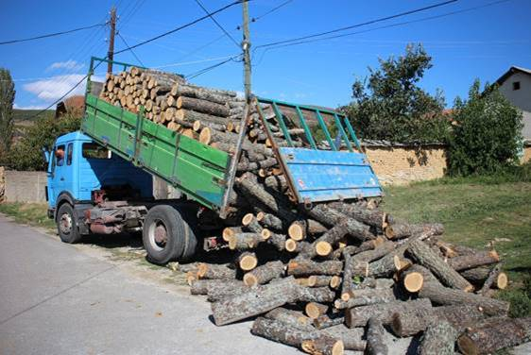

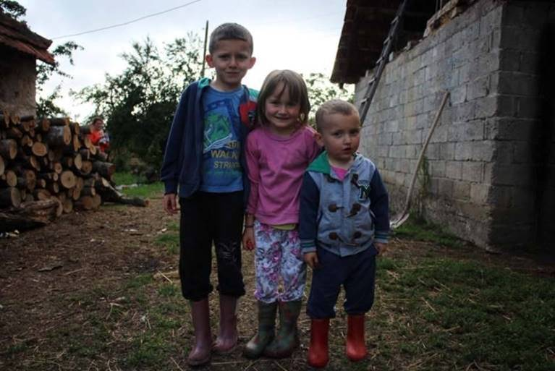

Kosovo kids happy to receive firewood!

Indeed. ***Why should we with more resources be disproportionately blessed?*** II Corinthians 9:7 states that God loves a cheerful giver. The word in Greek for cheerful is *hilarós*. It describes spontaneous, non-reluctant giving. Someone asks, and you respond because you are already inclined to give without reluctance. And, why not? God makes all things possible. Especially for the non-reluctant, spontaneous giver. The giver already knows that he or she follows God’s way and that blessings will ensue. Such is part and parcel of a faithful Christian life.

At this point, I ask those who can and are willing to BE A BLESSING to one or more of 200 families who hope and pray to have meat on their table for the Feast of the Holy Nativity on January 7. These are families who have meat on their table just twice a year. A pork roast that will feed a family of four for one week costs USD 100. Would you be willing and able to provide one or more Christmas roasts for Serbian Christians in Kosovo this season?

These dear people will never be able to repay you monetarily, and you will likely not meet them in this life. Be assured they will thank God heartily for their benefactor(s) and ask God’s blessing on you. What more can we hope for? To bless and be blessed in return? To rejoice the heart of God? To have the good done in faith and love eternally rewarded? To experience genuine joy within? All these things, yes, are available to the person who participates with compassionate love. Is that person you?  Will you help us spread the warmth and peace of true Christian love in Kosovo this season?

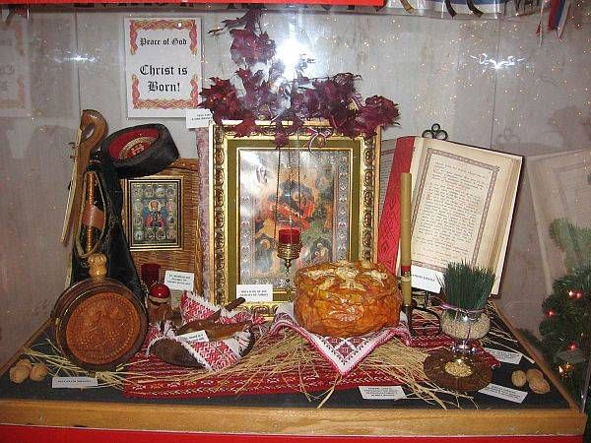

A Serbian Nativity Feast Remembrance

* **GOAL: To put a pork roast (whole pig) on the tables of 200 families in Kosovo for the Nativity Feast.**
* **PURCHASE PRICE:  USD 100. PER ROAST.**
* **PLEASE CONSIDER FEEDING ONE OR MORE FAMILIES FOR THE NATIVITY FEAST IN KOSOVO (JANUARY 7).**
* **WE ASK THAT YOU SEND YOUR GIFT BEFORE DECEMBER 31, 2017.**

Here’s how to partner with us this season:

Donate via **Paypal**

(use the button on our website: [www.thedecanifund.org](http://www.thedecanifund.org))

**OR**

Send a check payable to:

Decani Monastery Relief Fund

2618 West Bannock Street

Boise, ID  83702-4705

The Decani Monastery Relief Fund is a 501c3 tax-exempt charity and issues receipts for donations made.  Please send your gift no later than December 31 to receive a tax receipt for this year.

God love and bless you!  Peace to you and peace to your soul!

Humbly in our Lord Jesus Christ,

+Very Reverend Archimandrite Nektarios Serfes

President of the Decani Monastery Relief Fund

Contact information: Cell Phone 208-860-2479 / Email [father@serfes.org](mailto:father@serfes.org)