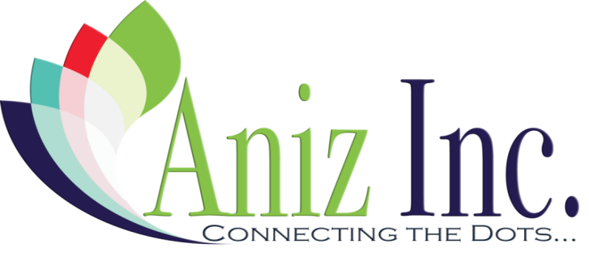
___________________
Unique Identifier

Opiate (OX) Program
Enrollment Form
Date: | Outreach Location: |  | Outreach Worker:
First Name ( if anonymous) |  | Last Name: ( if anonymous) | Date of Birth:
Gender: |  | Race: | Telephone:

How did you hear about Aniz?
Push Card/flier Website Friend Social Media Other: ________________________
What is your HIV status? Positive Negative Don’t Know?
Would you like to be tested today? Yes No
What is your HEP-C Status? Positive Negative Don’t Know?
Would you like to be tested today? Yes No
Preferred drug of use? Other: ____________________ (Check all that apply)
Meth Cocaine Crack Marijuana Benzos Heroin Ecstasy Amphetamines Bath Salts
Preferred method of use? Injection Snorting Smoking Other: _________________________
How often do you use? Daily Weekly Monthly Socially/Recreational Special Occasions
Have you heard of Naloxone/Narcan? Yes No If no, would you like more information? Yes No
Would you like access to Naloxone/Narcan? Yes No
Have you witnessed an overdose before? Yes No
Have you ever been arrested? Yes No
When? _______________ For what reason? ______________________________
Distributed Items
Narcan Kit#:  GA-ANIZ____________________ | Narcan Kit #:  GA-ANIZ____________________ | Narcan Kit #:  GA-ANIZ____________________
OX Kits _____ Cookers _____ Cottons _____ Alcohol Pads _____
Tourniquets _____ Safer Sex Kits _____ .5 ml Syringe _____ 28 Gage Syringe _____

