3.3 – The Inverse of a Quadratic Function

Goals:
- Determine and describe what an inverse function does to the original function
- Graph both functions and their inverses, and make connections between the graphs
- Determine the relationship between domain and range of a function and of the inverse
- Use the function notation of an inverse
- Determine if a function or its inverse are functions are non-functions

What is an Inverse Function?
An inverse function is a function that undoes what an original function did. In other words, the inverse maps values in the range of the original function back to values in the domain of the original function (see Intro to Function Inverses Video on website).
For example, the function $f\left(x\right)=2x-6$ has an inverse of $f^{-1}\left(x\right)=\frac{1}{2}x+3$.
Graph these two functions on the grid provided.
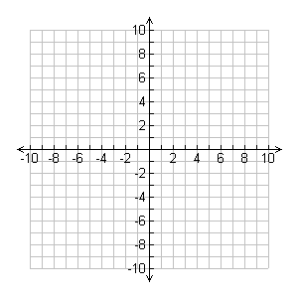

How do these two inverse functions compare?

What is the inverse function of:
- $f\left(x\right)=\frac{1}{3}x+7$ b) $f\left(x\right)=-2x-14$

Investigate (pg. 155)
Complete the Investigation by answering the questions on this sheet.
Cube Side Length (cm) | Area of Each Face (cm²) | Surface Area (cm)
1 | 1 | 6
2 | 4 | 24
3 | 9 | 54
4
5
6
7
8
9
10
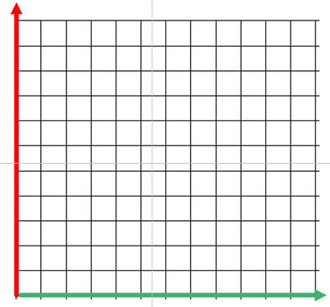
A. B. Draw a graph of surface area (y-axis) vs. side length (x-axis). What type of function is this? How do you know?

C. What is the equation that represents the graph? What are the domain and range?

D. How would you calculate the inverse of this function to describe the side length of the cube if you
know its surface area?

E. Make a table of values for the inverse F. Draw a graph of the inverse. Compare the graph of the
of the surface area function. inverse with the original graph. Is the inverse a function?
Surface Area (cm²) | Side Length
6
24
54
Continue the investigation on a separate sheet of paper.

